**CLIMATE CHANGE IMPACTS ON FIRE REGIMES, PLANT INVASIONS, AND TICK-BORNE DISEASES IN THE SOUTHEAST U.S.**

**RC-2636**

**Interim Report**

**Version 2**

October 9, 2019

**Lead PI: Brian Allan**

**University of Illinois Urbana-Champaign**

**Department of Entomology**

**TABLE OF CONTENTS**

Page #

List of Tables iii

List of Figures iv

List of Acronyms ix

Acknowledgements x

Introduction 1

PART 1: FIELD SURVEYS ACROSS DOD INSTALLATIONS 3

TECHNICAL APPROACH 4

Experimental design 5

Field sampling design 7

Plot design 8

Tree and shrub data collection 9

Ground cover and litter data collection 10

iNaturalist project 11

Tick sampling 12

Estimating host density 13

RESULTS AND DISCUSSION 15

Installation and plot visits 15

Trees and shrubs 18

Understory herbaceous cover and species 20

Litter cover, mass, and moisture content 22

Host abundances 24

Tick abundances 26

Summary 32

PART 2A: TESTIMG THE EFFECTS OF COGONGRASS FUEL STRUCTURE ON FIRE TEMPERATURE AND RESIDENCE TIME: AN EXPERIMENTAL METHOD 34

TECHNICAL APPROACH 35

Experimental apparatus 37

Study site and weather measurements 39

Fuel type 39

Experimental treatments 39

Fire intensity measurements 40

Statistical analyses 40

RESULTS AND DISCUSSION 41

Fuel conditions 41

Fire intensity 41

PART 2B: GRASS INVASION ENHANCES SURVIVAL OF DISEASE VECTOR THROUGH ALTERATION OF MICROCLIMATE CONDITONS 48

TECHNICAL APPROACH 49

Experimental Design 49

Site Description 49

Site Characteristics 49

Assessing Tick Survival 51

RESULTS AND DISCUSSION 52

Site Characteristics 52

Tick Survival 53

PART 3: PATHOGEN ANALYSIS OF TICKS 56

TECHNICAL APPROACH 57

Introduction 57

Tick Collections 57

DNA Extraction 57

Primers 58

Fluidigm 2 Step Access Array Amplification 60

High Throughput Sequencing 62

Sequence Analysis 62

RESULTS AND DISCUSSION 63

Identification of Tick-borne Agents 63

PART 4: ED2 MODELING 67

TECHNICAL APPROACH 68

Modeling Objectives 68

The Ecosystem Demography Model 68

The Predictive Ecosystem Analyzer: PEcAn 69

Objective 4A: Southern Pine Forest Under Different Climate Scenarios 69

Objectives 4B/4C: Cogongrass Plant Functional Type Development and Analysis 72

Objectives 4D/4E: Representation of Disturbance and Management in ED2 73

RESULTS AND DISCUSSION 75

Objective 4A: Southern Pine Forest Under Different Climate Scenarios 75

Objectives 4B/4C: Cogongrass Plant Functional Type Development and Analysis 81

Objectives 4D/4E: Representation of Disturbance and Management in ED2 85

CONCLUSIONS TO DATE 92

Literature Cited 95

APPENDICES 102

APPENDIX A – WEATHER DURING EXPERIMENTAL FIRES 103

List of Tables

Table Title Page #

**Table 1.** Summary of plots visited across all installations to date. 6

**Table 2.** Tree health categories. 10

**Table 3.** Tree canopy positions. 10

**Table 4.** Tree richness linear model results. 19

**Table 5.** Herbaceous vegetation cover model results. 21

**Table 6.** Litter mass model results. 24

**Table 7.** Litter cover model results. 24

**Table 8.** Tick abundance versus fire model results. 30

**Table 9.** Tick abundance versus litter biomass model results. 32

**Table 10.** Time above 100ºC model coefficients. 41

**Table 11.** Maximum temperature model coefficients 43

**Table 12.** Model coefficients for flame height, rate of spread, and proportion of mass consumed. 45

**Table 13.** Information on the amplicons used in this study. 59

**Table 14.** The number of ticks (and percent of total) analyzed for tick-borne agent DNA as of March, 2019, with information on tick species collected from each site. 61

**Table 15**. The number of ticks of each species that expressed specific tick-borne agent DNA. 66

**Table A1.** Weather during experimental fires. Date of fire, fuel structure, amount of biomass, means ± SE of air temperature, relative humidity, and wind speed. 103

List of Figures

Figure Title Page #

**Figure 1.** Study area map showing the location of each installation sampled. 4

**Figure 2.** Typical native and invaded (cogongrass) communities. 5

**Figure 3.** Summary of overall experimental design for field data collection. 6

**Figure 4.** Burn unit map example 8

**Figure 5.** Field plot design 9

**Figure 6.** Sampling 1 m and 25 cm quadrats 11

**Figure 7.** iNaturalist SERDP project https://www.inaturalist.org/projects/serdp-species 12

**Figure 8.** Installing rain shield on tick trap. 13

**Figure 9.** Tick-hosts dung survey and identification. (a) Field technician Elena Meyer surveying for tick-host dung, (b) turkey dung, (c) deer dung, (d) rabbit dung. 14

**Figure 10.** Number of plots established. (a) Number of plots established at each of the DoD installations. (b) Number of plots established in each time since fire. The color shading indicates whether or not plots were in a cogongrass invasion - light blue is uninvaded and red is invaded. 15

**Figure 11.** Boxplots of annual averages (1980-2018) for Daymet climate variables at each installation. 17

**Figure 12.** Number of trees recorded at each installation. The majority of trees belonged to the genus *Pinus* or *Quercus*. 18

**Figure 13.** Tree species richness (a) and shrub and sapling density (b) plotted against time since fire in cogongrass invaded (red) and uninvaded (blue) plots. Points are jittered horizontally to reduce overlap. 19

**Figure 14.** Example stem map for Eglin AFB plot B1. 20

**Figure 15.** Understory herbaceous vegetation. (a) Percent cover versus time since fire and (b) dried mass versus time since fire. The light blue points and line are uninvaded plots and red points and line are invaded plots. 21

**Figure 16.** Understory species diversity. (a) Species richness versus time since fire with a small amount of noise added to the points to reduce overlap. (b) Box-plots of species richness illustrating that plots burned further in the past have lower variation in species richness. Open circles are the data points. 22

**Figure 17.** Litter conditions versus time since fire for (a) dry mass (R2 = 0.24), (b) percent cover (R2 = 0.38), and (c) percent moisture. The light blue color is for uninvaded plots and red is for cogongrass-invaded plots. A small amount of noise was added to the points to reduce overlap. 23

**Figure 18.** Evidence of host species densities at each installation (dung clusters 400 m-2). Note that the y-axis has different scales in each panel. Zeroes (no bars) are installations that weren’t visited during that year. 25

**Figure 19.** Host densities vs. time since fire in cogongrass-invaded and uninvaded plots. Blue indicates uninvaded plots and red indicates cogongrass-invaded plots. A small amount of noise was added to the points to reduce overlap. A constant of one was added to dung counts before log-transformation so that values of zero on the log-scale of the figure correspond to true zeroes in the original data. 26

**Figure 20.** The four most commonly collected tick species. (a) *Amblyomma americanum* (lone star tick), (b) *Dermacentor variablis* (American dog tick), (c) *Amblyomma maculatum* (Gulf Coast tick), (d) *Rhipicephalus sanguineus* (brown dog tick). 27

**Figure 21.** Tick abundances grouped by (a) life stage and (b) species in each sample year. Am. am: *Amblyomma americanum*, Am. mac: *Amblyomma maculatum*, De. var: *Dermacentor variablis*, Rh. san: *Rhipicephalus sanguineus*. Blue indicates uninvaded and red indicates cogongrass-invaded. 28

**Figure 22.** Tick abundances at each installation for each sample year. Blue indicates uninvaded and red indicates cogongrass-invaded. 29

**Figure 23.** Natural-log transformed tick abundance and time since fire for cogongrass-invaded and uninvaded plots. A small amount of noise was added to the points to reduce overlap. A constant of one was added to tick abundance prior to the log-transformation so that values of zero on the log-scale correspond to true zeroes. 30

**Figure 24.** Natural-log transformed tick abundance plotted against natural-log transformed counts of host dung in cogongrass-invaded (red) and uninvaded (blue) plots. A small amount of noise was added to the points to reduce overlap. A constant of one was added to tick and host abundance values prior to the log-transformation so that values of zero on the log-scale correspond to true zeroes. 31

**Figure 25.** Natural-log transformed tick abundance and litter biomass in cogongrass-invaded (red) and uninvaded (blue) plots. A constant of one was added to tick abundance prior to the log-transformation so that values of zero on the log-scale correspond to true zeroes. 32

**Figure 26.** Conceptual diagram of laboratory and field methods used to experimentally manipulate fuel characteristics (fuel type and fuel bed) and their effects on fire intensity. Superscripts indicate aspects of fire intensity that each method is capable of accurately measuring: maximum temperature1, fuel consumption2, temperature duration3, rate of spread4, flame height5. Dashed box indicates areas where observational manipulations to fuel type characteristics can be made, but experimental manipulations are limited. Adapted from tables and figures in Whelan (1995), DeBano *et al.* (1998), Gill and Zylstra (2005). 37

**Figure 27.** Schematic of the fine aboveground biomass incineration organizer (FABIO) (a), and during an experimental burn (b). Schematic legend: 1. 3.18 cm (1-1/4”) punched angle iron holding welded 4 gauge wire with approx. 10 cm x 10 cm openings, 2. 1.91 cm (¾”) metal conduit, 3. flame retardant soaked cotton twine, 4. temperature data loggers (U12 HOBO J,K,S,T thermocouple loggers, Onset Computer Corporation, Bourne, MA, USA), inside of weatherproof cases (Pelican 1010 Micro Case, Torrance, CA, USA) with foam inserts (Pelican 1012 Pick N Pluck), and 5. type K thermocouples (Model TP875, Extech Instruments, Nashua, NH, USA) with braided steel wire leads. 38

**Figure 28.** Fitted regression lines (solid lines) between time above 100ºC (a-c) or maximum temperature (d-f) and fuel load for piled and standing fuel structure at 50 cm, 25 cm, and 0 cm above ground level. The dashed line is the best fit line for the five fires that had both piled and standing fuel. Yellow diamond shows results from the prescribed burn while purple dots show the fuel structure of standing and piled fuels together with varying fuel loads. 42

**Figure 29.** Fitted regression lines (solid lines) plotted over data points for flame heights (a), rate of spread (b), and percent of mass consumed (c) for piled or standing fuel structure across fuel load treatments. The dashed line is the best fit line for the five fires that had both piled and standing fuel. For comparison to natural (prescribed) fires, mean + SE for fuel loads and flame heights are shown in panel (a). 44

**Figure 30.** Tick bags and exclosures (wire mesh cages) along with PVC housing for temperature and humidity loggers in (a) invaded and (b) native plant communities. (c) Study site showing invaded to the left and native plant communities to the right, separated by managed boundary area to maintain distinct plant communities. 50

**Figure 31.** Site characteristics for native and invaded plots. (a) mean (± SE) overstory tree canopy cover, (b) understory vegetation height, (c) understory standing biomass per 25cm2, (d) light availability at the soil surface (μmoles m2 sec-1), and (e) litter biomass per 25cm2. Statistical significance between native and invaded plots was determined using analysis of variance, *** *P* < 0.001. 52

**Figure 32.** Mean (± SE) survival of adult female, adult male, and nymph *A. americanum* in native (blue) and invaded (red) plots over time. 53

**Figure 33.** Average daily minimum relative humidity over time for invaded (red) and uninvaded (blue) plots n=12. Critical equilibrium humidity (CEH) for *A. americanium* (80%) is depicted with a gray line. 54

**Figure 34.** Average daily maximum temperature (°C) over time for invaded (red) and uninvaded (blue) plots n=12. 54

**Figure 35.** Weight change (%) of *A. americanum* ticks exposed to varying relative humidities for 24 hr intervals. Ticks were pre-desiccated at 0% relative humidity for 24 hrs prior to various humidity treatments. Redrawn from (Hair et al. 1975). 55

**Figure 36.** Conceptual diagram of possible effects of plant invasions on tick abundance. (a) increase in tick survival and host abundance, (b) increase in tick survival and no change to host abundance, and (c) increase in tick survival and a decrease in host abundance. 55

**Figure 37.** Diversity and abundance of tick-borne agents detected at each collection site. Most ticks contain more than one tick-borne agent, including nonpathogenic endosymbionts, human pathogens, wildlife pathogens, and microbes of unknown pathogenicity. 65

**Figure 38:** Representation of individual-level fluxes within ED2 from Moorcroft et al 2001. Left is the partitioning of carbon and water among tissues (Ba is active tissue, Bs is structural tissue). *y* is the patch and *t* is time, g is growth rate, **x** is the plant functional type, **z** is the size, and **r** is the resources available to the plant. The lambda represents the fire scheme implemented in the original ED version, which we are not using for reasons discussed below. 69

**Figure 39**: Projected meteorological drivers for projections into 2100. With the exception of CO2, all meteorological drivers are identical up until 2026. In the mean precipitation flux and temperature panels, “Elevated Temp” scenarios and “RCP4.5” scenarios are identical, and closely overlaid. In the CO2 panel, “RCP4.5” and “Elevated CO2” are identical. Drivers that are not plotted include: specific humidity, northward and eastward wind, shortwave flux, longwave flux, and air pressure. Meteorology used to drive ED2 is at 3-hour resolution, plotted here with yearly means. 71

**Figure 40**: Preliminary Root Respiration measurement technique using LI-COR 6400 73

**Figure 41**. Effect of meteorological scenarios on Gross Primary Production in Duke Forest, North Carolina. Fluxes smoothed with ggplot loess function for ease of interpretation (Wickham 2011). 77

**Figure 42.** Temperature Sensitivity by Meteorological Scenario at Duke Forest. 78

**Figure 43**. Water Use Efficiency by Meteorological Scenario at Duke Forest. 79

**Figure 44**. Daily Leaf Area Index by Meteorological Scenario. 80

**Figure 45**. Annual Biomass by Meteorological Scenario. Line textures distinguish the two different plant functional types, Late Temperate Deciduous (ie: *Quercus*) and Southern Pines (ie: *Pinus taeda*, *Pinus elliottii*, and *Pinus palustris*). Lines were smoothed using the ggplot loess function (Wickham 2011). 81

**Figure 46**. Variance Decomposition of Net Primary Production in a Cogongrass Stand 82

**Figure 47**. Variance Decomposition of Gross Primary Production for Cogongrass Stand 83

**Figure 48**. Variance Decomposition of Transpiration in a Cogongrass Stand 83

**Figure 49**. Variance Decomposition of Leaf Area Index in a Cogongrass Stand 84

**Figure 50**. Variance Decomposition of Respiration in Cogongrass Stand 84

**Figure 51**. Examples of CO2 Measurements from two cogongrass root samples taken from BARS 85

**Figure 52.** Adjacency for small disturbances. Edges are labeled as (E)xterior and (I)interior. For size 1, there is 0 probability of self-adjacency (disturbed patches adjacent to other disturbed patches). For size 2 and 3 it is 1/4 and 1/3 respectively, while for size 4 the adjacency is either 1/2 (square configuration) or 3/8 (all other configurations). 87

**Figure 53**. Comparison between adjacency matrices for a stochastic spatial simulation analytical approximation (top), and analytical approximation where a correction was applied to A00. All adjacency matrices are after 1,000 years (steady state). To the right are difference matrices between the simulation matrix and the two analytical matrices. Age class aggregated into 10-year bins ([0 − 9] = 0, [10 − 19] = 1, etc.) with all patches 100 years or older in bin 10. The 10th column of the error matrices was removed because of a summing to 1 constraint. 88

**Figure 54**. Size density plots contrasting ecoregion/state and disturbance type. Colored boxes next to disturbance size density curves show what ecoregion contains the respective disturbance. 89

**Figure 55.** Mean trends of ecoregion within State. Gray hexes are binned-counts of number of disturbance events. Black lines are core and linear bounding cases. 90

**Figure 56.** Mean trends of disturbance type. Gray hexes are binned-counts of number of disturbance events. Black lines are linear bounding cases. 91

List of Acronyms

ALFRESCO: Alaska Frame Based Ecosystem Code

BARS: Bivens Arm Research Site

BGC: BioGeoCehmical

BLAST: Basic Local Alignment Search Tool

CMIP5: Coupled Model Intercomparison Project Phase 5

CO2: Carbon dioxide

CWD: Coarse woody debris

DBH: Diameter at Breast Height

DNA: Deoxyribonucleic acid

DoD: Department of Defense

dsb: Disulfide Oxioreducatse gene

DVM: Dynamic Vegetation Model

ED or ED2: Ecosystem Demography or Ecosystem Demography version 2

EnKF: Ensemble Kalman Filter

FACE: Free-Air Carbon dioxide Enrichment

FIA P3: Forest Inventory & Analysis Phase 3

HPCBio: High Performance Computing in Biology

IPCC: Intergovernmental Panel on Climate Change

MCFIRE: Fire module of dynamic vegetation model MC1

MCMC: Markov Chain Monte Carlo

NCBI: National Center for Biotechnology Information

NFDRS: National Fire Danger Rating System

NGS: Next Generation Sequencing

NPP: Net Primary Productivity

NSF: National Science Foundation

NWR: National Wildlife Refuge

OLS: Ordinary Least Squares

ompB: Outer Membrane Protein B gene

PCR: Polymerase chain reaction

PEcAn: Predictive Ecosystem Analyzer

PFT: Plant Functional Type

PPFD: Photosynthetic Photon Flux Density

PVC: Polyvinyl chloride

RCP: Representative Concentration Pathways

RH: Relative Humidity

RLB: Reverse line blot

rRNA: Ribosomal Ribonucleic Acid

SEM: Structural Equation Model/Structural Equation Modeling

TBAs: Tick-Borne Agents

TBDs: Tick-borne Diseases

UF: University of Florida

VM: Virtual Machine

VMC: Volumetric Water Content

Acknowledgements

The research reported here is funded by the Strategic Environmental Research and Development Program (SERDP Project RC-2636). We are deeply grateful for the invaluable contributions of numerous personnel to this research, listed below. In addition, we wish to thank Mark Band, Chris Fields, Alvaro Hernandez and Gloria Rendon for their assistance in designing a Fluidigm Access Array system for the detection of the numerous tick-borne agents reported here. We also are grateful for the assistance from Penny Broga, Jessi Katterhenry, Betsy Lindsey, Kelly Wilder, and Ryan Chance with budget management and travel logistics. Finally, this work could not have been completed without the generous support of land management personnel and leadership at each installation.

**Project Personnel:**

Co-PIs: Michael Dietze, Luke Flory, Allison Gardner

Project Manager and Postdoctoral Associate: Whalen Dillion

Associate Project Manager: Drew Hiatt

PhD Candidate: Tempest McCabe

Pathogen analysis: L. Page Fredericks

Research technician: Steven Cabrera

Field technicians: Taylor Clark, Christina Harden, Tyler Hedlund, Elena Meyer, Alison Ochs, Manuel "Manny" Perez, Elizabeth White

Introduction

**Context**

Longleaf pine (*Pinus palustris*) was at one point the most ecologically significant tree species in the southern United States. A typical longleaf pine forest can be described as open-canopy, fire-dependent forests with an herbaceous ground layer littered with grasses and diverse showy forbs. Longleaf pine forests are some of the most diverse natural areas in North America, with up to 40 vascular plant species in 1m2 (Walker and Peet 1984). Before major logging and industrial efforts, longleaf pine forests dominated the southeast covering approximately 92 million acres (Frost 2007). The longleaf pine’s native range stretched along the Gulf and Atlantic coasts from Eastern Texas through to Virginia, and as far south as Central Florida (Boyer 1990). By 2005, an estimated 2.6 million acres of longleaf pine forest remained in its native range (Frost 2007). After decades of conversion to agricultural lands and industrial urban developments, the longleaf pine ecosystem is one of the most endangered in the U.S. (Noss et al. 1995).

Prescribed fire has been established as an important ecological process for the restoration and maintenance of longleaf pine systems. Frequent fire, every 1-10 years (Chapman 1932), are vital to reducing fuel loads and promoting understory diversity (Kirkman et al. 2001). Regularly burned and maintained longleaf forests provide essential habitat for many threated and endangered wildlife species, including the gopher tortoise (*Gopherus polyphemus*), Eastern indigo snake (*Drymarchon couperi*), and red-cockaded woodpecker (*Picoides borealis*) (Wade et al. 1989). Without regular fire in this ecosystem, longleaf forests can suffer from invasion of hardwoods and shrubs, resulting in rapid loss of herbaceous diversity (Christensen 1981). However, tree mortality can be an issue when reintroducing fire to long-unburned pine forests. Drier duff layers (less than 55% VMC) during fire exhibit the most consumption of duff and can contribute to up to 20% overstory longleaf pine mortality in historically fire excluded areas (Varner et al. 2007). When restoring fire to long-unburned forests, Varner et al. (2007) argue to implement burn prescriptions at regular intervals and to include effects of duff consumption to minimize tree mortality.

Disturbance events such as fire, hurricanes, and harvesting also have been shown to increase risk of invasion by exotic plants. Cogongrass (*Imperata cylindrica*) is a cosmopolitan grass species that is a weedy pest in at least 73 countries and is especially problematic in the southeastern U.S. where it spreads and dominates in disturbed sites (Holm et al. 1977, MacDonald 2004). It is a successful invader in longleaf pine forests due to its extensive rhizome system, adaptation to poor soils, drought tolerance, and fire adaptability (Holm et al. 1977). Cogongrass rhizomes have been reported to account for 60% of a plant’s total biomass and contribute to its quick regeneration after burning or cutting (Sajise 1973). In areas where cogongrass is already present, locations that have been burned or have had greater biomass removal experience an increase in the number and size of cogongrass patches (Holzmueller and Jose 2012). Once established, cogongrass can outcompete native vegetation creating a large monotypic understory with low species diversity and richness (Brewer 2008). Positive feedbacks between cogongrass and fire have been suggested due to greater fine fuel loads (Platt and Gottschalk 2001) and fire severity that is detrimental to southeastern pine forests (Lippincott 2000, Matlack 2002). Cogongrass may also alter typical fire cycles of southern forests. Fires in sites where cogongrass is dominant show higher maximum temperatures at greater heights, and increased mortality of longleaf pines, which are typically fire-tolerant (Lippincott 2000). Research in Florida sandhill found cogongrass to burn at a maximum temperature of 458 °C with a mean of 260.9 ± 13.7 °C, and native areas burned at a maximum of 318 °C with a mean of 218.3 ± 14.5 °C (Lippincott 2000). The spread of cogongrass is responsible for the loss of thousands of hectares of native habitat in southeastern U.S. forested lands (MacDonald 2004).

**Objectives**

Tick-borne diseases (TBDs) represent a major public health threat in North America, particularly for military personnel training on Department of Defense (DoD) installations. Ecological theory predicts that climate change will alter vector-borne disease transmission both by direct and indirect pathways. A likely consequence of climate change is an increase in the frequency and intensity of wildfires and a decrease in the effectiveness of fire management (Oswald et al. 2007). The forests of the southeastern U.S. are predicted to experience a profound increase in wildfire frequency and severity (Scholze et al. 2006). This region of the U.S. also suffers high human incidence of several TBDs, particularly those transmitted by the lone star tick (*Amblyomma americanum*), an emerging disease vector that is affected significantly by plant invasions (Allan et al. 2010a) and by fire dynamics via direct effects on ticks (Davidson et al. 1994b) and indirect effects on tick hosts (Allan 2009).

We are investigating several of the predicted consequences of climate change, including altered fire regimes and plant communities, and their interactions with wildlife, for human risk of exposure to TBDs in the southeastern U.S. We utilize an integrated research effort to understand the consequences of climate change for TBD risk and human health, and to make specific, actionable recommendations to predict and ameliorate future changes in pathogen exposure pathways. Specific objectives of this research include to:

1. Perform field surveys across DoD installations spanning a climate gradient in the southeastern U.S. to quantify relationships among climate, prescribed fire, and cogongrass invasion, and their interactions, for effects on plant community composition and biomass, wildlife abundance, and tick abundance in longleaf pine habitats.
2. Conduct field experiments to determine the A) effect of fuel structure on fire temperature and residence time of invasive cogongrass, including relationships between fuel load, flame height, and fire intensity, and B) influence of cogongrass on off-host survival for *A. americanum* ticks.
3. Develop a next generation sequencing (NGS) protocol for the identification of a multitude of tick-borne agents (TBAs) associated with ticks in the southeastern U.S. and analyze the prevalence of pathogens that imperil human and wildlife health.
4. Calibrate a vegetation model (Ecosystem Demography 2, ED2) for DoD installations under future climate, fire, grass invasion, and management scenarios. Use relationship between tick abundance and vegetation to couple future vegetation with future TBD risk. Model TBD risk in response to fire-invasion interactions and incorporate simulations of climate change scenarios to examine the responses of fire, plant invasions, wildlife, TBD risk, and their interactions, in southern pine ecosystems.

PART 1: FIELD SURVEYS ACROSS DOD INSTALLATIONS

TECHNICAL APPROACH

To assess the effects of climate, fire management, plant invasions, and their interactions on tick-borne disease risk, we took advantage of existing gradients in climate, fire management, and invasion history across numerous DoD installations spanning the southeastern U.S. Installations typically have multiple larger management units or training areas that are made up of smaller burn units. At some installations the burn units are the same as the training/management areas. There are training and ecological management needs that are considered in the management plan of each area, such as land navigation training for troops and maintaining habitat for species on the federal threatened and endangered species list (e.g. red cockaded woodpecker). The fire management applied to the burn blocks within the larger areas varies based on the vegetation and the training uses and management goals. The variety of objectives results in a range of fire histories across the study region. We obtained fire management history data for each of the DoD installations sampled to date in this study (Figure 1), and selected a representative subset for sampling biological parameters related to the study objectives (detailed below).

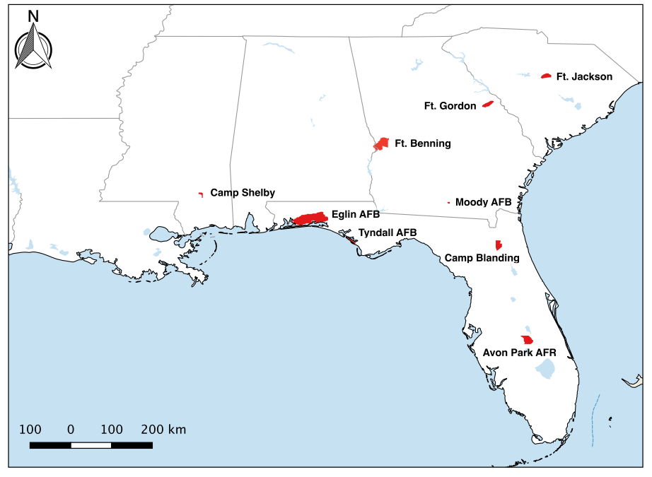

**Figure 1.** Study area map showing the location of each installation sampled.

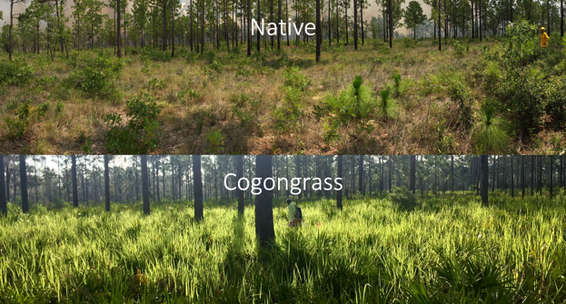

**Figure 2.** Typical native and invaded (cogongrass) communities.

Experimental design

The goal of our experimental design was to assess the potential effects of fire history (e.g., years since most recent burn) and cogongrass infestation (Figure 2) on host availability, plant community composition, and tick abundance across installations throughout the study region. The experimental design is summarized in Figure 3. The study region is defined as five states in the southeastern U.S. (i.e., Mississippi, Alabama, Georgia, South Carolina, and Florida). Within the study region, we collected field data at nine military installations (i.e., Avon Park AFR, Fort Benning, Camp Blanding, Eglin AFB, Fort Gordon, Fort Jackson, Moody AFB, Camp Shelby, and Tyndall AFB). Each installation is divided into burn units, with different histories of controlled and wildfire burns. At least one sample plot was established within each burn unit selected. If part of a burn unit was infested with cogongrass, two plots were established (i.e., one in an invaded area and one in an uninvaded area). These plots were considered the smallest experimental unit of replication for all data analyses. The plots across all installations that have been visited to date are summarized in Table 1.

C:\Users\allie\Downloads\SERDPstatsTerms.tif

**Figure 3.** Summary of overall experimental design for field data collection.

**Table 1.** Summary of plots visited across all installations to date.

|  |  |  |  |  |  |
| --- | --- | --- | --- | --- | --- |
| **Installation** | **Number of Plots** | | | **Years Since Fire** | **Years**  **Sampled** |
| **Uninvaded** | **Invaded** | **Total** |
| Avon Park AFR | 8 | 4 | 12 | 0 – 6 | 2017, 2018 |
| Fort Benning | 10 | 0 | 10 | 0 – 4 | 2018 |
| Camp Blanding | 13 | 0 | 13 | 0 – 10 | 2017, 2018 |
| Eglin AFB | 11 | 0 | 11 | 0 – 11 | 2017, 2018 |
| Fort Gordon | 8 | 0 | 8 | 0 – 9 | 2018 |
| Fort Jackson | 13 | 0 | 13 | 0 – 11 | 2018 |
| Moody AFB | 3 | 0 | 3 | 0 – 11 | 2017 |
| Camp Shelby | 9 | 4 | 13 | 1 – 7 | 2017, 2018 |
| Tyndall AFB | 8 | 1 | 9 | 0 – 6 | 2017, 2018 |
| **Totals** | **83** | **9** | **92** |  |  |

Due to intensive invasive plant management efforts by installation managers, many installations lacked cogongrass infestations; only Avon Park AFR, Camp Shelby, and Tyndall AFB had substantial cogongrass infestations. Thus, to maximize the statistical power of each test, we developed separate statistical models to analyze (1) the effect of cogongrass infestation and (2) the effect of fire history on each response variable; these models guided our selection of burn units in which to collect data. The first model, designed to test the effect of cogongrass infestation on the response variables, is a nested split-plot design that considers the fixed main effects of installation $N_{i}$, burn unit nested within installation $B_{k\left(i\right)}$ (as the whole plot), and cogongrass invasion status $C_{l}$ (as the sub-plot), and the random effect of study year $Y_{j}$ (i.e., 2017 or 2018) on each response variable (Eqn. 1).

$Y_{ijkl}=μ+N_{i}+Y_{j}+B_{k\left(i\right)}+ε_{ijk}+C_{l}+ε_{ijkl}$ Eqn. 1

The second model, designed to test the effects of years since the most recent burn on the response variables, is a randomized complete block design that considers the fixed main effect of installation $N_{i}$, years since the most recent burn $β\left(x_{ij}-\overline{x}\right)$ as a covariate, and the random effect of study year $Y_{j}$ on each response variable (Eqn. 2).

$Y_{ijk}=μ+β\left(x_{ij}-\overline{x}\right)+N_{i}+Y_{j}+NY_{ij}+ε_{ijk}$ Eqn. 2

A major consideration in the overall experimental design was whether to prioritize collecting data at the same plots over multiple years versus collecting data at a larger number of plots for a single time point. In general, we prioritized the latter, because (1) this design increases the power of our statistical tests, which use plot as the experimental unit, and (2) the short duration of the study (i.e., three planned field seasons) precluded a repeated-measures analysis of the response variables over time. However, in the event that a plot that had been visited in 2017 was burned, we revisited the same plot in 2018 to conduct a before-and-after comparison of the immediate impacts of the burn on the response variables. In 2018, we also revisited a subsample of the plots visited in 2017 to estimate inter-annual variation in the response variables, particularly tick density and host availability, throughout the study period.

Field sampling design

Following the experimental design, we established plots to achieve a stratified sampling that covered the range of fire history at each installation. We obtained fire history and known cogongrass invasions as GIS layers from each installation and identified potential plot locations based on time since last fire and history of cogongrass invasion. Potential locations were sent to contacts at the installation to solicit further guidance on selecting the final set of candidate locations and arranging access (e.g., Figure 4). In burn units with a cogongrass invasion we established one plot in the invaded area and one plot in an uninvaded area, with at least 100 meters between the plots. In burn units without an invasion we established one plot in an area representative of the vegetation conditions in the burn unit.

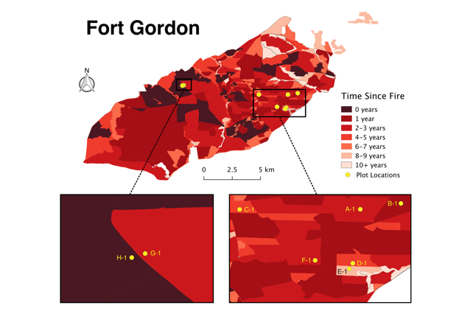

**Figure 4.** Burn unit map example

Plot design

Each plot consisted of a main circular center plot (12.6 m radius, approximately 500 m2), a circular subplot (5.64 m radius, approximately 100 m2), four 1 m x 1 m quadrats, four 25 cm x 25 cm quadrats, four 50 m transects, and four locations for sampling tick abundance (Figure 5). In the main circular plot and subplot we measured trees, saplings, and shrubs. Ground vegetation and litter were measured in the 1 m and 25 cm quadrats located 10 m from plot center in each of the cardinal directions. The 50 m transects originated at the plot center going in each cardinal direction and were used to estimate tick-host abundance. Tick abundance sampling locations were placed 8-10 m from the plot center in the NW, NE, SE, and SW areas. The center of each plot was marked with a flag and GPS coordinates were recorded using a Garmin Oregon 650t GPS unit (Olathe, KS).

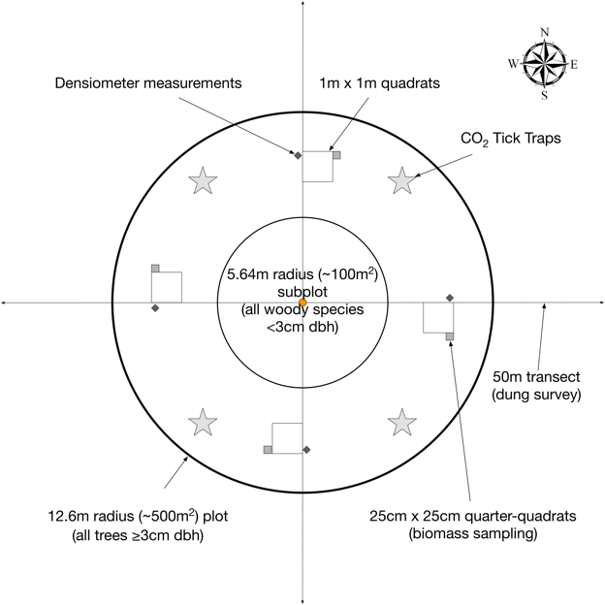

**Figure 5.** Field plot design

Tree and shrub data collection

Within the 12.6 m radius plot we recorded the DBH of all trees ≥ 3 cm DBH to the nearest 0.1 cm, and the distance (nearest 0.1 m) and azimuth (compass degrees) from the plot center to the center of each tree. Each tree was assigned a health category (Table 2) and relative canopy position (Table 3). We recorded the heights of at least 10 trees in the plot (or all trees if fewer than 10) that were representative of each identified canopy position. In the 5.64 m radius subplot we recorded the abundance of woody species (shrubs and tree seedlings/saplings) that were < 3 cm DBH and ≥ 100 cm tall. We also estimated overstory canopy cover for the plot by taking measurements using a spherical convex densiometer (Forestry Suppliers, Jackson, MS) while standing at each 1 m quadrat and facing plot center.

**Table 2.** Tree health categories.

|  |  |
| --- | --- |
| Health code | Definition |
| 0 | dead, nothing living |
| 1 | healthy |
| 2 | relatively healthy |
| 3 | unhealthy, barely alive stem |
| 4 | all stems are dead, but has living sprouts not making DBH |
| 5 | missing tree, the tree can’t be found during resampling |
|  |  |

**Table 3.** Tree canopy positions.

|  |  |
| --- | --- |
| Canopy code | Definition |
| U | Understory, growing beneath the forest canopy, no direct sunlight |
| I | Intermediate, extend toward the over-story canopy but receive little or no direct sunlight from above and none from the sides |
| C | Co-dominant, receive direct sunlight from above but limited sunlight from the sides |
| D | Dominant, extend high into the canopy, sticking out above most other trees, and receive direct sunlight from above and partly on its sides |
| E | Emergent, crown extends well above all surrounding trees (typically mature redwoods or possibly Douglas fir) |
| S | Stump, tree no longer has any stems (dead or alive) that make the DBH cutoff, if it does it’s a snag or dead standing stem. If stump present, but also has any stems ≥3cm dbh it is NOT a “stump.” Assign canopy class of tallest stem even if it does not make DBH |

Ground cover and litter data collection

We identified plant species and measured vegetation and litter conditions in each of the four 1 m quadrats. We recorded the percent cover of each plant species, total plant cover, litter cover, and bare ground, and counted the number of stems of each species rooted within the quadrat. Percent cover was visually estimated and estimates were calibrated among observers to ensure consistency. We measured the three tallest heights of woody species and the three tallest heights of non-woody species rooted within each quadrat. Heights were measured from the mineral soil surface. We also made three measurements of litter depth in each quadrat from the top of the litter level to the mineral soil surface. The 25 cm quadrats were placed adjacent to each 1 m quadrat in an area representative of the conditions in the larger quadrat, and we collected vegetation and litter in order to estimate biomass (Figure 6). We collected all above-ground fine vegetation and litter within the 25 cm quadrat into separate bags. Samples were weighed at the end of the day to estimate fresh weights, then were returned to the BARS at UF, placed in a 60ºC drying oven for at least 72 hours, and then weighed to obtain dry weights. The difference between fresh weight and dry weight was used to estimate moisture content.

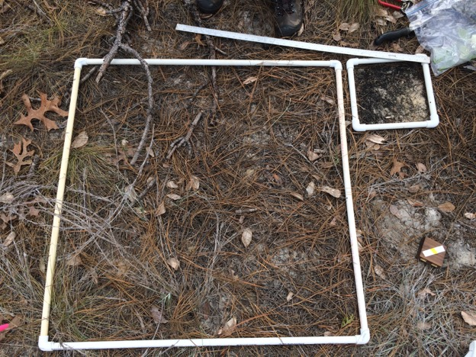

**Figure 6.** Sampling 1 m and 25 cm quadrats

iNaturalist project

In order to improve confidence and consistency in plant identifications, we created an iNaturalist [project](https://www.inaturalist.org/projects/serdp-species) (Figure 7) to enable easy reference in the field for identifying species that were not flowering and would have required a taxonomic key. iNaturalist is a digital platform available via iOS, Android, and a website, where scientists and naturalists can upload observations of plants, animals, and fungi, and offer or seek help in species identifications. Species identifications in iNaturalist may be tagged as “Research Grade” when the specimen was observed in the wild, includes a relatively accurate location and date, and the identification is supported by at least two members of the community. During our field surveys, we identified over 270 species and currently ~50% of these observations have become certified as “Research Grade.” In the cases of rare and protected species, such as pitcher plants, we either excluded coordinates or included coordinates that were imprecise (resolution reduced to approximately 1500 m) using functions built into the iNaturalist application. The “Research Grade” observations are accessible by other databases such as the Global Biodiversity Information Facility, which is used for analyzing species distributions, so a collateral benefit of this effort will be the availability of important data to other members of the scientific community.

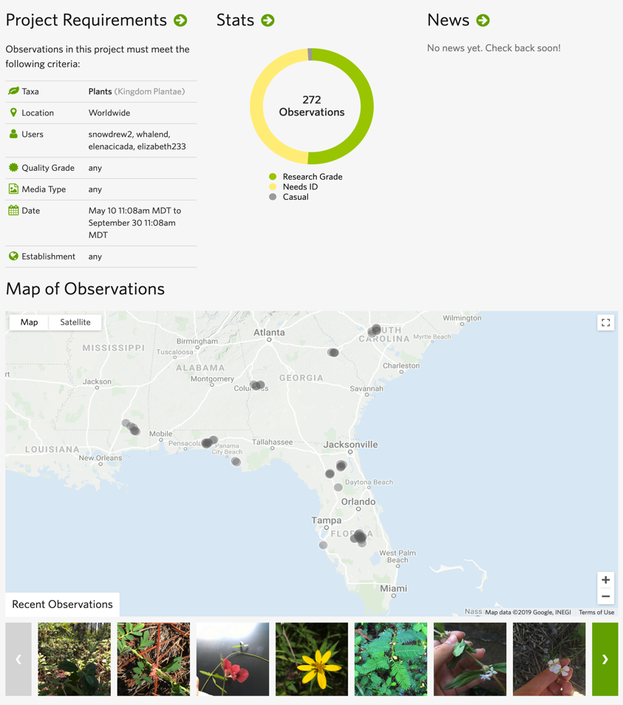

**Figure 7.** iNaturalist SERDP project https://www.inaturalist.org/projects/serdp-species

Tick sampling

We primarily collected ticks using CO2 traps placed in each plot for 24 hours. Tick traps were constructed by mounting 5-quart hard-sided coolers (Igloo, Katy, TX) onto the center of 0.635 cm (0.25 inch) thick plywood pieces cut to 35 cm x 28 cm. There was approximately 7.6 cm between the edge of the plywood and all sides of the cooler. Two 0.48 cm (3/16 inch) holes were drilled through each side of the cooler just above the bottom of the interior. Strips of double-sided carpet tape (DF 545, ShurTape, Hickory, NC) measuring 4.77 cm (1.88 in) wide were attached to the plywood surface surrounding the cooler. Each trap was baited with 1.5 kg of dry ice, which sublimated out through the holes drilled in the coolers. A rain cover made from corrugated plastic roofing cut to cover the entire footprint of the trap was attached to the top of each cooler by drilling a 0.48 cm hole through the center of the cooler lid and securing the roofing using a bolt and a wing-nut (Figure 8).

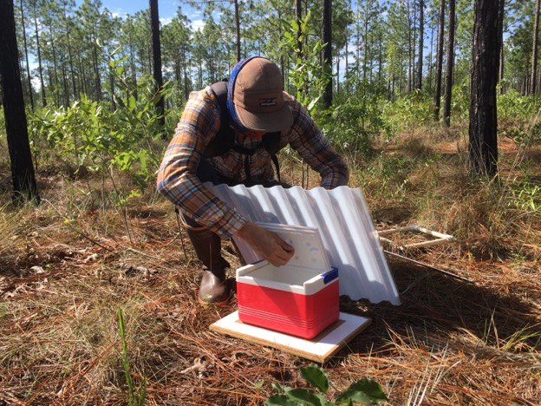

**Figure 8.** Installing rain shield on tick trap.

To collect ticks attracted by the traps but not stuck to the tape, we dragged a 1 m x 1 m white canvas cloth across the area directly below each trap three times. Ticks were also collected off of personnel and were assigned a plot, burn unit, or installation depending on the confidence in where the encounter occurred. Ticks collected on traps were counted and removed from the tape using tweezers, placed in 2 mL vials (Corning 430659) with 70% ethanol, and transported to the Flory Lab at the University of Florida where they were identified, sorted, and counted by species, life stage, and sex. Sorted ticks were then shipped to the Allan Lab at the University of Illinois where they underwent a second round of identification and sorting, and subjected to pathogen analysis.

Estimating host density

We conducted host-dung surveys along each 50 m transect to estimate abundance of tick hosts near the plot area. Observed dung clusters of host species (e.g. white-tailed deer, *Odocoileus virginianus*) were tallied within 0 to 1 m of the transect line, totaling 400 m2 of surveyed area. Species were identified by dung characteristics (Figure 9).

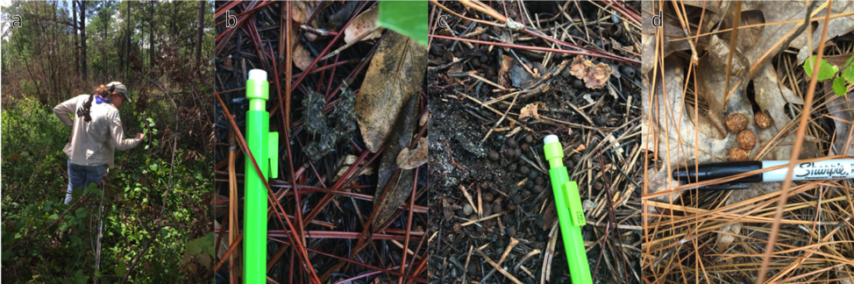

**Figure 9.** Tick-hosts dung survey and identification. (a) Field technician Elena Meyer surveying for tick-host dung, (b) turkey dung, (c) deer dung, (d) rabbit dung.

**Climate Data**

We selected DoD installations spanning a climate gradient across the southeastern U.S. to provide a range of climate conditions for modeling relationships between climate factors and tick-borne disease risk under current and future climate. To characterize this climate gradient, we retrieved daily climate data (1980-present) for each installation from the Daymet dataset (Thornton et al. 2016; <https://daymet.ornl.gov/>), which provides daily values for maximum and minimum temperature, precipitation, solar radiation, vapor pressure, and day length, at a 1 km x 1 km resolution. Values were extracted using the R package ‘daymetr’ and then summarized to annual averages to illustrate the climatic variation and gradient of the study region. We are exploring the influence of these climate factors on tick abundance, host abundance, vegetation, and prescribed fire management. The exploration of these relationships includes testing different variable aggregations (e.g., annual vs. seasonal averages, days above or below threshold values, etc.).

RESULTS AND DISCUSSION

Installation and plot visits

We established 94 total plots at 9 DoD installations across the southeast US. Of the 94 only 10 were invaded by cogongrass (Figure 10a). Fire history varied across the plots, ranging from 0 to 11 years since the last fire (Figure 10b). The small number of cogongrass-invaded plots was due to a high level of awareness and recognition of cogongrass as a problematic species, and diligent management practices that quickly eradicate identified invasions. With relatively few invaded plots sampled at this stage it is important to interpret comparisons between cogongrass-invaded and -uninvaded areas with caution.

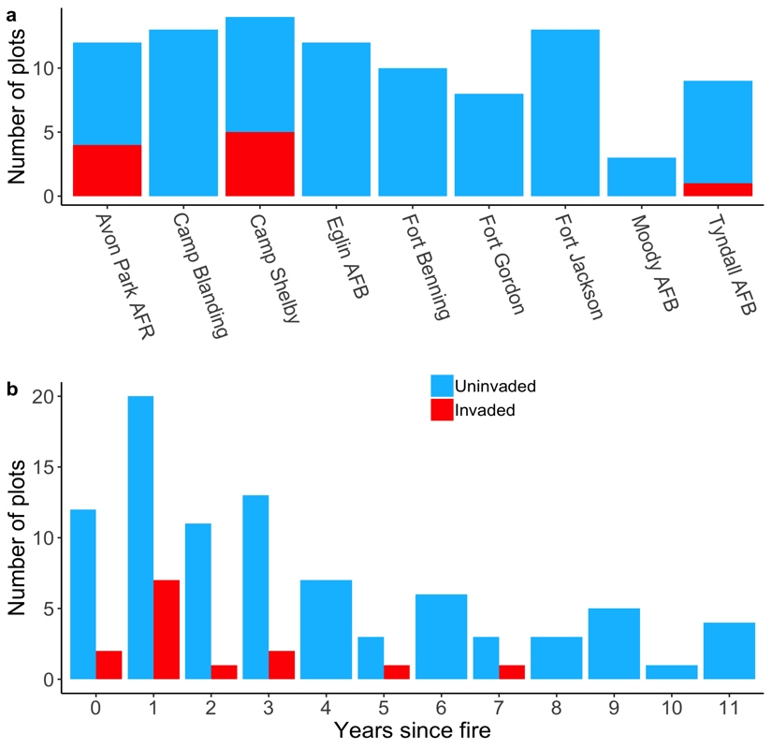

**Figure 10.** Number of plots established. (a) Number of plots established at each of the DoD installations. (b) Number of plots established in each time since fire. The color shading indicates whether or not plots were in a cogongrass invasion - light blue is uninvaded and red is invaded.

Annual averages of climate variables at the selected installations illustrate the climate gradient across which sampling has occurred (Figure 11). Climate values indicate some interannual variation within installations across factors, though limited for precipitation. The spatial resolution of Daymet data results in small or no difference in values between plots at the same installation, so these data do not capture the “local” microclimate conditions that are influenced by vegetation cover and more directly affect tick survival (see section 2B). Temperature followed an expected latitudinal gradient with the highest average maximum temperatures at Avon Park AFR, the southernmost installation, and lower average maximum temperatures at the northernmost installations in Georgia (Fort Gordon) and South Carolina (Fort Jackson). We have not thus far found an effect of these climate variables on the prescription of fire management at these installations. The temporal scale may be too long and a mismatch with more contemporary factors driving prescribed fire management decisions. Our current results indicate that fire management (i.e. fire frequency) is primarily determined by characteristics of the installation, which would include factors that aren’t climate or weather related, such as preferred management methods, personnel for prescribed fire, and budgetary differences. We are exploring other ways of aggregating these climate data (e.g. seasonally and using threshold values) that may reveal how environmental conditions have affected fire management.

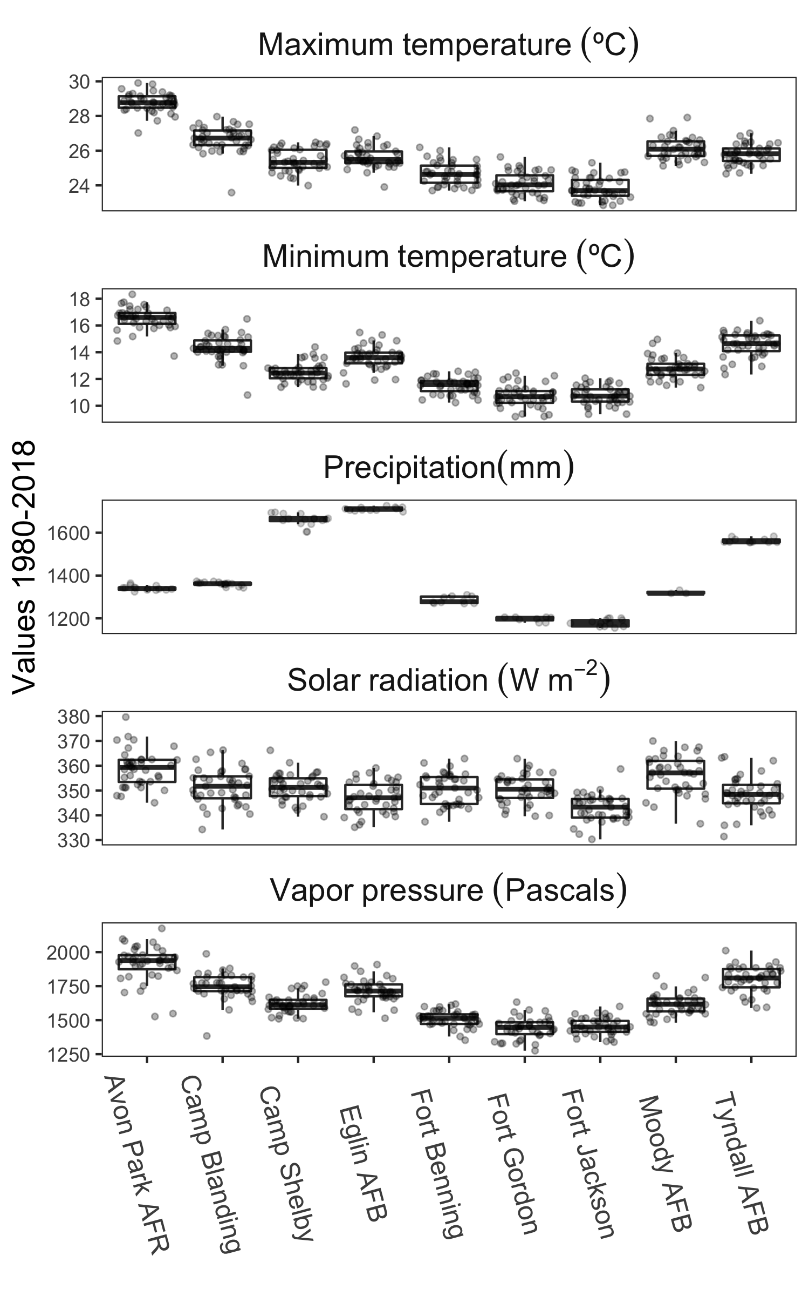**Figure 11.** Boxplots of annual averages (1980-2018) for Daymet climate variables at each installation.

Trees and shrubs

We recorded 38 different tree and shrub species. The vast majority of the 3633 trees recorded were either *Pinus* (pine) or *Quercus* (oak) genus, with pine making up more than 50% of all trees recorded (Figure 12). Overall, tree diversity, quantified as the number of distinct species, tended to be greater in uninvaded plots, and, regardless of invasion, higher with longer time since fire (Figure 13a). An ordinary least squares (OLS) regression model with additive effects of time since fire and cogongrass invasion resulted in an adjusted R2 of 0.29 (Table 4). Shrub and sapling density (stems over one meter tall but less than 3 cm DBH) measured in the center subplot ranged widely, but most plots had fewer than 40 stems per 100 m2 (Figure 13b). Plots with low overstory tree and shrub density are likely to be less hospitable for ticks because incoming solar radiation reaches the ground and herbaceous layer resulting in higher temperatures. Fewer trees and shrubs also results in less buildup of litter that can provide refuge for ticks from high temperatures and low humidity. The relationship between shrub and sapling density and time since last fire was not statistically significant. Recording the location of each tree (distance and azimuth from plot center) enabled generating stem maps for each plot (e.g., Figure 14). Stem maps were included in reports sent to each installation, and can be used to help relocate individual trees for future data collection.

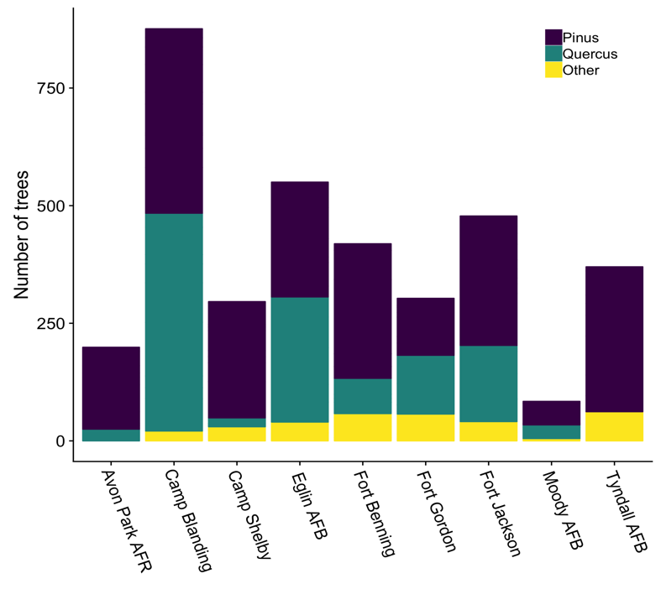

**Figure 12.** Number of trees recorded at each installation. The majority of trees belonged to the genus *Pinus* or *Quercus*.

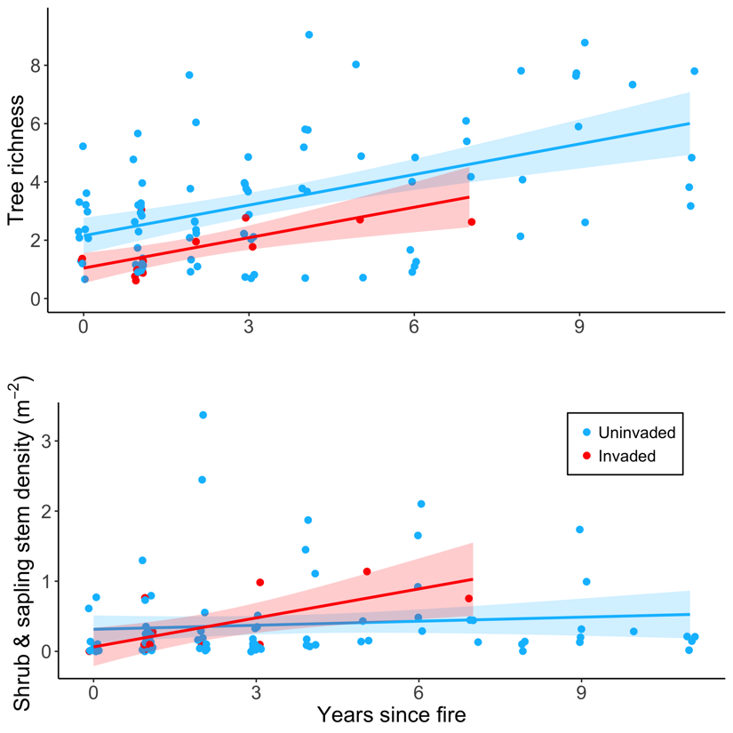

**Figure 13.** Tree species richness (a) and shrub and sapling density (b) plotted against time since fire in cogongrass invaded (red) and uninvaded (blue) plots. Points are jittered horizontally to reduce overlap.

**Table 4.** Tree richness linear model results.

|  |  |  |  |  |
| --- | --- | --- | --- | --- |
| Term | estimate | std.error | statistic | p.value |
| (Intercept) | 2.156 | 0.286 | 7.534 | 0.000 |
| years_since_fire | 0.350 | 0.061 | 5.772 | 0.000 |
| imcy_invInvaded | -1.116 | 0.535 | -2.087 | 0.039 |

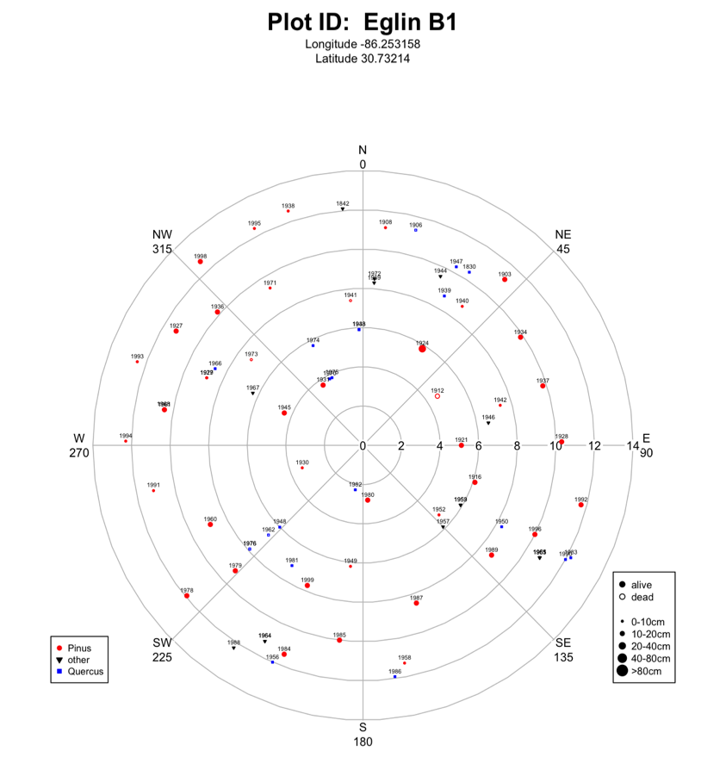

**Figure 14.** Example stem map for Eglin AFB plot B1.

Understory herbaceous cover and species

Percent cover of understory herbaceous vegetation measured at the 1 m2 quadrats tended to be lower with longer time since fire in the uninvaded plots, and higher with longer time since fire in the handful of cogongrass-invaded plots (Figure 15a). An OLS model with additive effects of time since fire and cogongrass invasion status resulted in an adjusted R2 of 0.10 (Table 5). The biomass of standing understory vegetation showed the same pattern as percent cover, but also ranged widely from 0.006 to over 1.6 kg m-2 (Figure 15b). Herbaceous vegetation cover may play an important role in regulating near-ground microclimate conditions that are experienced by ticks. Greater cover may provide more hospitable conditions that enhance tick survival.

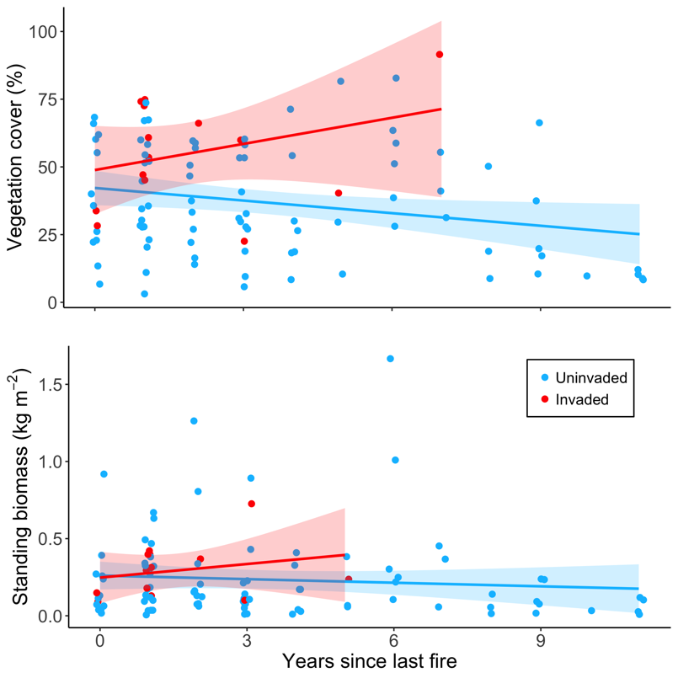

**Figure 15.** Understory herbaceous vegetation. (a) Percent cover versus time since fire and (b) dried mass versus time since fire. The light blue points and line are uninvaded plots and red points and line are invaded plots.

**Table 5.** Herbaceous vegetation cover model results.

|  |  |  |  |  |
| --- | --- | --- | --- | --- |
| Term | estimate | std.error | statistic | p.value |
| (Intercept) | 41.301 | 3.163 | 13.057 | 0.000 |
| years_since_fire | -1.284 | 0.670 | -1.917 | 0.058 |
| imcy_invInvaded | 16.220 | 5.911 | 2.744 | 0.007 |

Cogongrass-invaded plots didn’t have significantly different herbaceous understory diversity than uninvaded plots (Figure 16a), which is likely in part due to the relatively small sizes of invasions that we encountered. Most invasions did not cover the entire plot area, often resulting in two or three of the 1m2 quadrats placed in locations with little cogongrass cover. The variation in species richness decreased with increasing time since fire, changing most dramatically from three to four years since fire (Figure 16b).

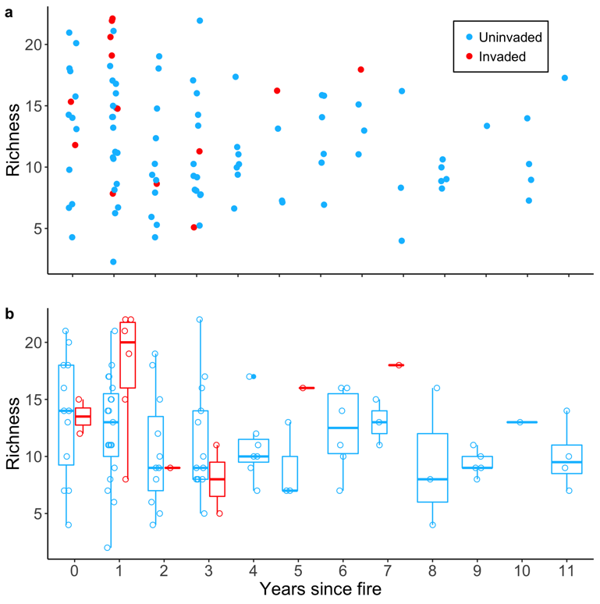

**Figure 16.** Understory species diversity. (a) Species richness versus time since fire with a small amount of noise added to the points to reduce overlap. (b) Box-plots of species richness illustrating that plots burned further in the past have lower variation in species richness. Open circles are the data points.

Litter cover, mass, and moisture content

Measurements of litter mass, percent cover, and moisture tended to increase with time since last fire, while only percent cover showed a significant difference in cogongrass-invaded versus uninvaded plots (Figure 16). Litter biomass tended to be a little higher in uninvaded plots (Figure 17a) and an OLS model with years since fire and cogongrass invasion status had an adjusted R2 of 0.24 (Table 6). Percent litter cover rapidly recovered following fires, reaching >50% within two years post-fire for most uninvaded plots (Figure 17b). An OLS model with years since fire and cogongrass invasion status had and adjusted R2 of 0.38 (Table 7). Litter moisture depends on the prevailing weather conditions, so these results must be interpreted within the context of our sampling time in the southeastern U.S. (June - October), when vegetation and litter can dry very rapidly following rainfall. Litter moisture was predominantly <50% across all samples (Figure 17c), and, given the daily variation that can occur in litter moisture, the lack of relationship between our point estimate of moisture content and years since last fire is unsurprising.

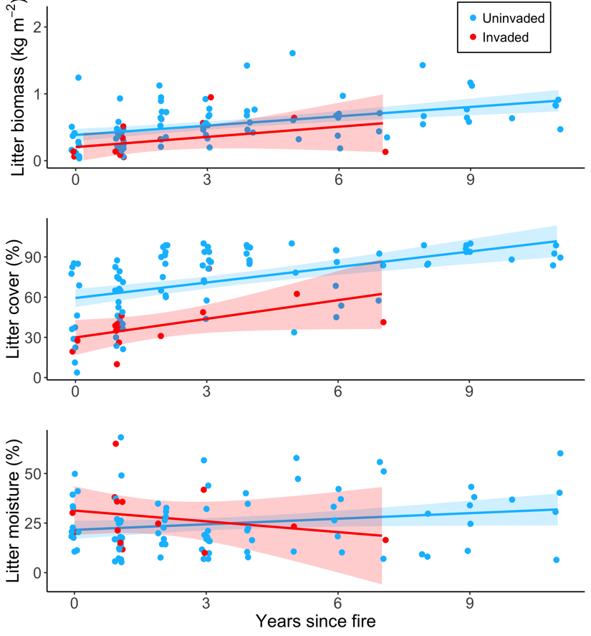

a

b

c

**Figure 17.** Litter conditions versus time since fire for (a) dry mass (R2 = 0.24), (b) percent cover (R2 = 0.38), and (c) percent moisture. The light blue color is for uninvaded plots and red is for cogongrass-invaded plots. A small amount of noise was added to the points to reduce overlap.

**Table 6.** Litter mass model results.

|  |  |  |  |  |
| --- | --- | --- | --- | --- |
| Term | estimate | std.error | statistic | p.value |
| (Intercept) | 0.384 | 0.045 | 8.613 | 0.000 |
| years_since_fire | 0.047 | 0.009 | 4.959 | 0.000 |
| imcy_invInvaded | -0.173 | 0.083 | -2.072 | 0.041 |

**Table 7.** Litter cover model results.

|  |  |  |  |  |
| --- | --- | --- | --- | --- |
| term | estimate | std.error | statistic | p.value |
| (Intercept) | 59.240 | 3.223 | 18.381 | 0 |
| years_since_fire | 3.891 | 0.682 | 5.702 | 0 |
| imcy_invInvaded | -27.869 | 6.023 | -4.627 | 0 |

Host abundances

We identified eight tick host species during dung surveys across all installations. White-tailed deer (*Odocoileus virginianus*) and eastern cottontail rabbit (*Sylvilagus floridanus*) were typically the most abundant host species at each installation (Figure 18). At Avon Park AFR, cow dung made up a substantial amount of dung encountered due to domestic cattle grazing leases, illustrating the multi-use character of this installation. Wild turkey (*Meleagris gallopavo*) made a notable contribution to host density at Camp Blanding and Eglin AFB during 2018 surveys. Total host densities did not significantly differ between cogongrass-invaded and -uninvaded areas, nor with time since last fire (Figure 19). All of these host species may influence tick abundances and the risk of exposure to tick-borne pathogens, but via different pathways as either hosts for different life stages of ticks or reservoirs for infectious agents. White-tailed deer and eastern cottontail rabbits are important hosts for nymph and adult life-stage *A. americanum* and both host species may serve as reservoirs for zoonotic diseases that threaten human health (Allan et al. 2010b). Though encountered at low relative abundance in our surveys, feral hogs (*Sus scrofa*) also are hosts for multiple tick species and reservoirs for tick-borne pathogens (Allan et al. 2001). Dung from domestic cattle were the only domesticated host species encountered in our surveys and are interesting hosts for their potential negative effect on tick abundances. Cattle typically are treated with topical acaricides to prevent ticks from feeding and, if present in sufficient densities, can reduce environmental tick abundance (Keesing et al. 2018).

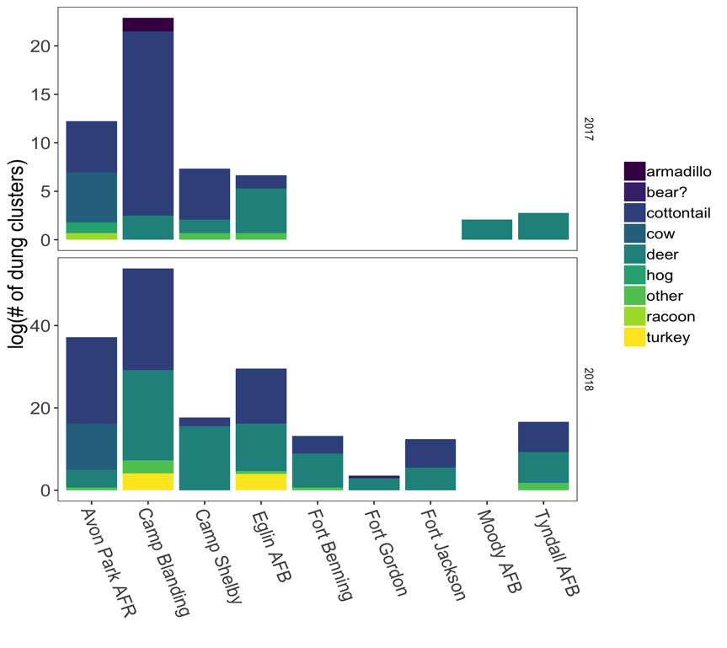

**Figure 18.** Evidence of host species densities at each installation (dung clusters 400 m-2). Note that the y-axis has different scales in each panel. Zeroes (no bars) are installations that weren’t visited during that year.

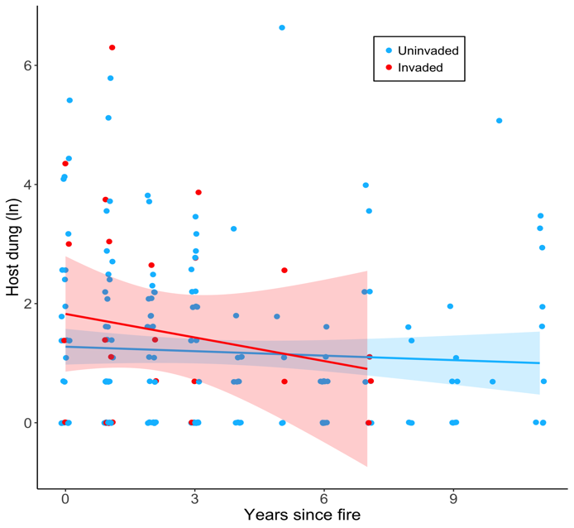

**Figure 19.** Host densities vs. time since fire in cogongrass-invaded and uninvaded plots. Blue indicates uninvaded plots and red indicates cogongrass-invaded plots. A small amount of noise was added to the points to reduce overlap. A constant of one was added to dung counts before log-transformation so that values of zero on the log-scale of the figure correspond to true zeroes in the original data.

Tick abundances

We collected four different tick species across all installations (Figure 20). The majority of ticks collected were in the nymph life stage during both sample seasons (Figure 21a) and belonged to the target species, *Amblyomma americanum* (Figure 21b). The small number of invaded areas had few ticks (Figure 21). The majority of ticks collected in 2017 were from Camp Blanding, FL and Eglin AFB, FL, while in 2018 most ticks collected were from Camp Blanding, FL, Fort Gordon, GA, and Tyndall AFB, FL (Figure 22). Among the lowest tick abundance observed for both sample years was at Avon Park AFR, which may be partly attributable to habitat management resulting in poor microclimates for ticks at this installation which also experiences the highest temperatures (Figure 11). An additional factor that may contribute to the low tick abundance at Avon Park AFR is the presence of cattle likely treated with acaricide. Tick abundances tended to increase with time since fire (Figure 23), indicating that, in general, tick abundance is reduced by more recent prescribed fire management across these installations. An OLS model using only years since fire to predict tick abundance resulted in an adjusted R2 of 0.10 (Table 8). Across all sampling, tick abundances were unrelated to host abundances (Figure 24; P-value = 0.87), suggesting that abiotic factors may be stronger drivers of tick abundance in these landscapes. For example, more recently burned areas usually have hotter and drier microclimates, as well as less litter that can provide refuge (Figure 25), resulting in poor conditions for tick survival. An OLS model regressing log-transformed tick abundance against dried litter biomass resulted in a significant adjusted R2 of 0.10 (Table 9).

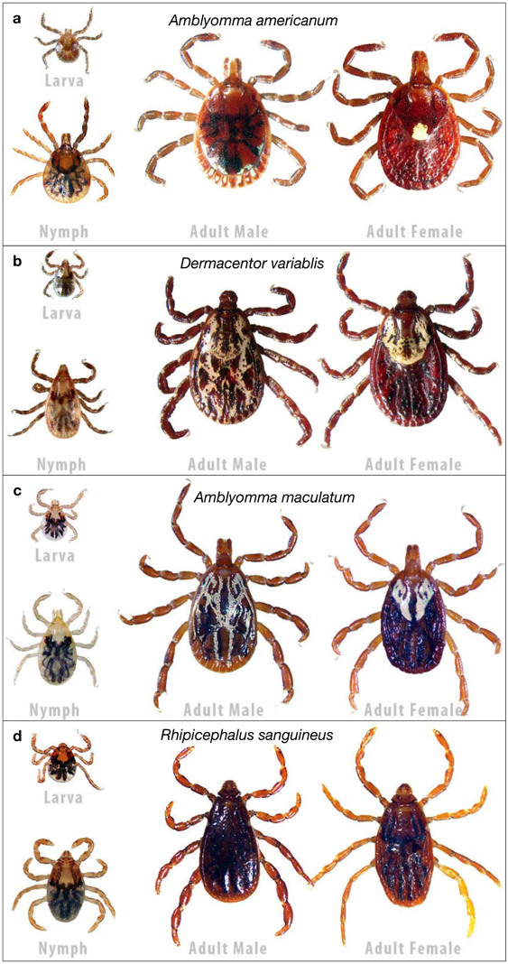

**Figure 20.** The four most commonly collected tick species. (a) *Amblyomma americanum* (lone star tick), (b) *Dermacentor variablis* (American dog tick), (c) *Amblyomma maculatum* (Gulf Coast tick), (d) *Rhipicephalus sanguineus* (brown dog tick).

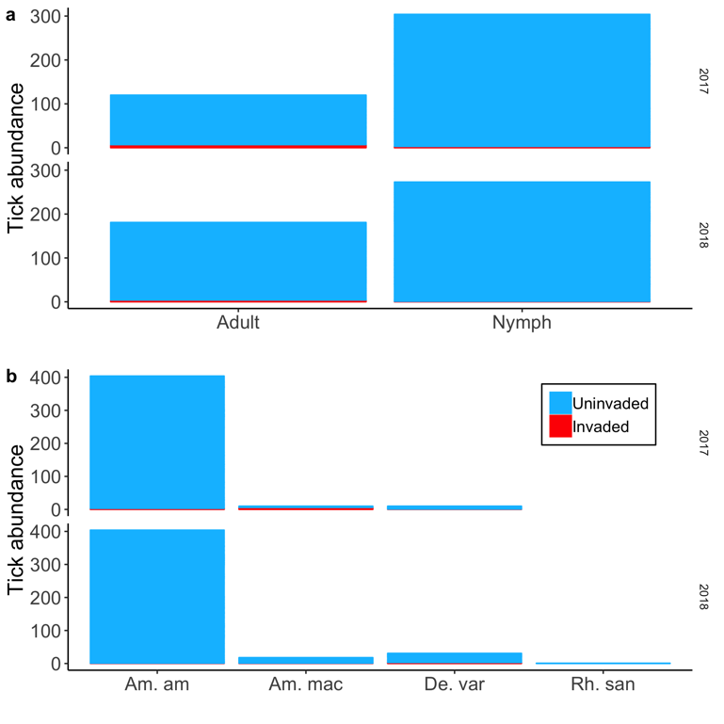

**Figure 21.** Tick abundances grouped by (a) life stage and (b) species in each sample year. Am. am: *Amblyomma americanum*, Am. mac: *Amblyomma maculatum*, De. var: *Dermacentor variablis*, Rh. san: *Rhipicephalus sanguineus*. Blue indicates uninvaded and red indicates cogongrass-invaded.

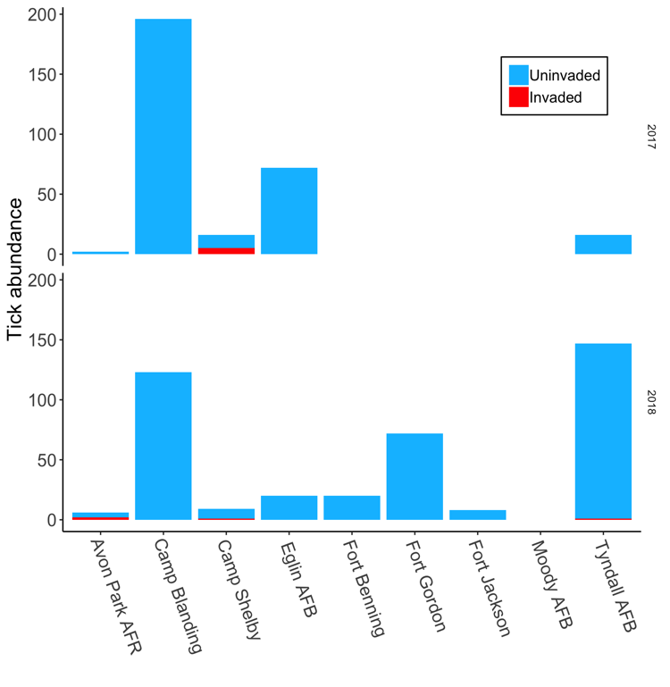

**Figure 22.** Tick abundances at each installation for each sample year. Blue indicates uninvaded and red indicates cogongrass-invaded.

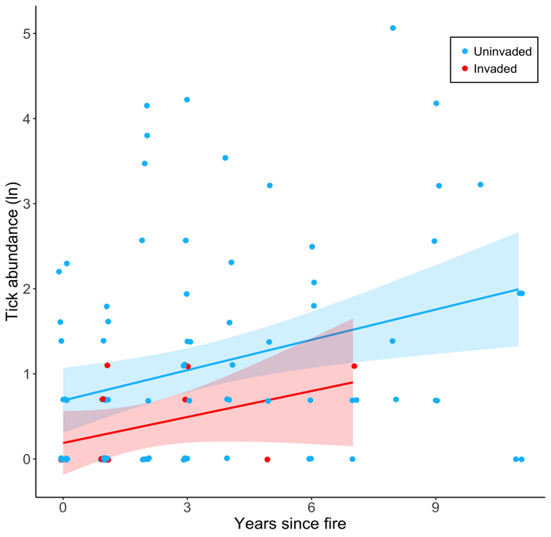

**Figure 23.** Natural-log transformed tick abundance and time since fire for cogongrass-invaded and uninvaded plots. A small amount of noise was added to the points to reduce overlap. A constant of one was added to tick abundance prior to the log-transformation so that values of zero on the log-scale correspond to true zeroes.

**Table 8.** Tick abundance versus fire model results.

|  |  |  |  |  |
| --- | --- | --- | --- | --- |
| Term | estimate | std.error | statistic | p.value |
| (Intercept) | 0.583 | 0.167 | 3.501 | 0.001 |
| years_since_fire | 0.128 | 0.037 | 3.423 | 0.001 |

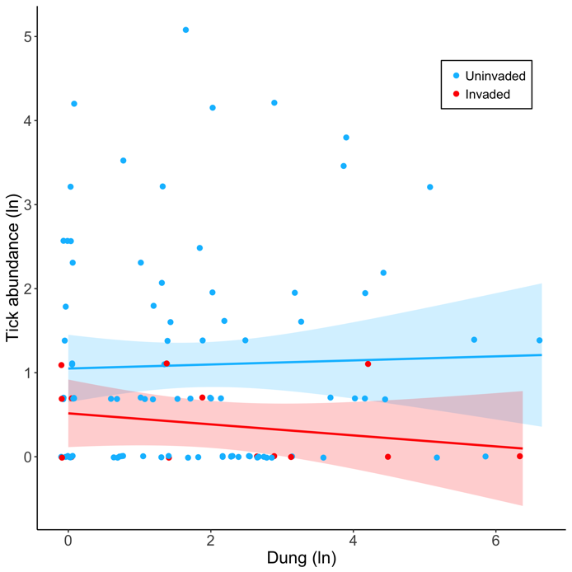

**Figure 24.** Natural-log transformed tick abundance plotted against natural-log transformed counts of host dung in cogongrass-invaded (red) and uninvaded (blue) plots. A small amount of noise was added to the points to reduce overlap. A constant of one was added to tick and host abundance values prior to the log-transformation so that values of zero on the log-scale correspond to true zeroes.

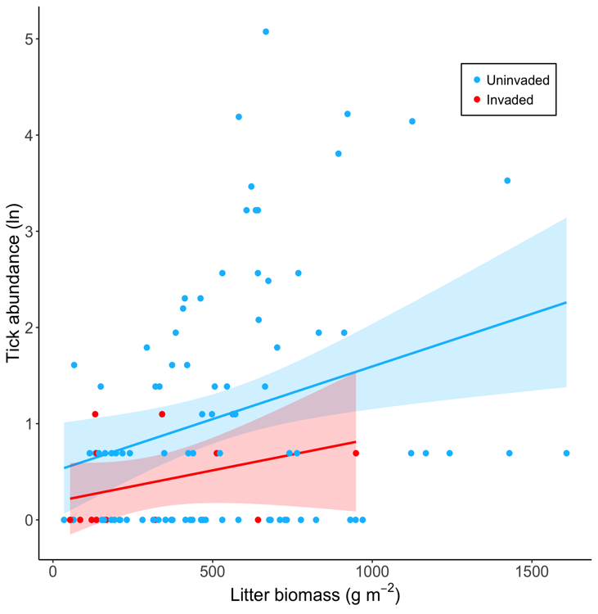

**Figure 25.** Natural-log transformed tick abundance and litter biomass in cogongrass-invaded (red) and uninvaded (blue) plots. A constant of one was added to tick abundance prior to the log-transformation so that values of zero on the log-scale correspond to true zeroes.

**Table 9.** Tick abundance versus litter biomass model results.

|  |  |  |  |  |
| --- | --- | --- | --- | --- |
| term | estimate | std.error | statistic | p.value |
| (Intercept) | 0.399 | 0.21 | 1.903 | 0.060 |
| avg_dry_litter_gm2 | 0.001 | 0.00 | 3.386 | 0.001 |

Summary

From data collected and analyzed thus far, fire management appears to be the strongest determinant of tick abundances in southeast pine habitats, with fewer ticks observed from more recently burned plots. The relationships between litter biomass and tick abundance and litter biomass and time since last fire also suggest there are both direct and indirect effects of prescribed fire management. Prescribed fires can directly reduce overall tick abundance through the destruction of ticks during fires. Fires also have an indirect effect by reducing the amount of litter and vegetation cover, which provide ticks with a daily refuge from inhospitable conditions. Thus far we have detected no effects of long-term aggregated climate variables on relationships between fire management, vegetation characteristics, and tick abundances. We have explored effects of long-term averages (30- and 15-years) and the coefficient of variation of the annual averages over these time periods for maximum and minimum temperature, and annual totals for precipitation. None of these aggregated variables had a statistically significant effect on tick abundances, host abundances, vegetation metrics, or time since fire. It may not be surprising that long-term aggregations of values did not explain much variation in tick or host abundances in these areas that are predominantly under intense management; management may be the driving factor and overrides any climate signal. In the same vein, the ability to apply prescribed fire depends on a complex combination of factors including current weather conditions that determine whether a fire falls within the prescription and can be conducted that day. Among these factors are relative humidity, smoke dispersion (wind speeds and atmospheric mixing), precipitation, and air temperature. We are currently working on aggregating variables in different combinations, such as seasonally and days per year that are potentially acceptable “burn days,” in order to link weather conditions to fire frequency and use this relationship to make projections under future climate scenarios. In current models of fire frequency, the installation accounts for the greatest amount of variation, which is indicative in part of the logistical capacity of an installation to use prescribed fire as a management technique. For example, we learned from communications with land managers that Fort Benning, one of the larger and busier installations in our study, maintains nearly every management unit on an 18- to 36-month fire return cycle and is equally capable of conducting prescribed fires during the dormant or growing season. In comparison, Moody AFB, the smallest installation, has a small natural resources management staff and are limited to conducting dormant season burns.

PART 2A: TESTIMG THE EFFECTS OF COGONGRASS FUEL STRUCTURE ON FIRE TEMPERATURE AND RESIDENCE TIME: AN EXPERIMENTAL METHOD

TECHNICAL APPROACH

Assessing the influence of fuel characteristics on fire behavior and resulting ecological effects is traditionally accomplished through either laboratory- or field-based experiments and measurements (Fig. 26). Laboratory experiments typically focus on how plant functional traits (fuel type characteristics) are related to plant flammability (e.g., ignitability, sustainability, combustibility; e.g., Simpson *et al.* 2016), and may inform how these characteristics influence fire intensity and effects. In wildland fire systems managed with prescribed fire, fuel type and fuel bed characteristics are commonly measured at multiple locations across the area to be burned and then related to fire effects by measuring aspects of fire intensity (e.g., temperature, rate of spread, fuel consumption, flame length) and severity (e.g., percent area burned, fuels consumed, vegetation mortality). Across the range of laboratory to field studies there are substantial tradeoffs between having many replicates with precise measurements (small-scale laboratory) and fewer replicates but more accurate measurements of natural fire behavior (field studies during prescribed fires). Ideally, a single method could simultaneously provide relatively high precision and replication while also approximating the realism and accuracy of measurements made during prescribed fires, and therefore provide fire measurements that could be used to predict potential ecological impacts (Fernandes and Cruz 2012).

The potential to scale from plant functional traits to natural fire behavior (Schwilk 2015) has spurred interest in methods to efficiently measure and compare the effects of characteristics of plant species on fire. Multiple laboratory methodologies have been developed that precisely measure flammability characteristics of different species for various parts of the plants (e.g., leaves or stems) under highly controlled settings (Etlinger and Beall 2004; Engstrom et al. 2004; Burger and Bond 2015; Wyse et al. 2016; Simpson et al. 2016). A more portable but less controlled method for rapidly measuring whole-plant flammability for plants has been demonstrated as well (Jaureguiberry et al. 2011). The small laboratory scale methods enable controlled experiments with many replicates and more precise flammability measurements; however, the lack of realistic fuel bed characteristics and natural conditions may limit insights into fire behavior and ecological effects at larger spatial scales (Fernandes and Cruz 2012; Varner et al. 2015), though often that may not be the objective of these studies (Pausas and Moreira 2012).At the opposite end of the experimental-realistic spectrum, field-based approaches measure effects of *in situ* fuel characteristics on fire effects during and following prescribed fires (e.g. Thaxton and Platt 2006; Loudermilk *et al.* 2012; Flory *et al.* 2015), or by burning of individual small-scale plots (Bowman et al. 2017). Either approach allows for fuel manipulations, but experiments in conjunction with prescribed fires have the additional logistical challenge in that they are dependent on appropriate weather conditions and availability of personnel and equipment. Finally, there may be situations where the risk of an undesired outcome of applying fire in the field is high, such as when areas dominated by an invasive species have very high fuel loads, thereby precluding measurements of how those fuel conditions alter fire characteristics and effects.

Fuel manipulations in the field can be either addition or removal treatments that alter fuel type, fuel load, or both (e.g., Thaxton and Platt 2006; Bowman et al. 2017). Fuel addition treatments are often piled for efficiency, similar to many lab-based experiments, but this approach alters fuel characteristics, such as vertical structure, that can critically affect fire behavior (Ganteaume et al. 2014). Vertical structure can affect multiple aspects of fire, including temperature residence time, flame length, and rate of spread (Keeley 2009) that are useful for understanding fire effects such as plant mortality and soil heating (e.g., Anderson 1982; Loudermilk *et al.* 2012). Field-based approaches more accurately represent natural fire behavior and effects, but are often limited in replication and fuel manipulations, thereby reducing measurement precision and statistical power.

Here, we describe a relatively low-cost method for experimentally assessing the effects of fuel characteristics on ecologically-important measurements of fire at a scale that is both logistically tenable and can capture natural fuel structure and fire characteristics. This methodology enables measuring temperature, residence time, flame height, rate of spread, and fuel consumption and can be employed to examine potential effects of fire fueled by problematic species (e.g. cogongrass) that raise the risk of negative impacts from fire beyond acceptable management levels. Moreover, fuel type and fuel bed characteristics can be manipulated to better represent natural conditions for fuel mixtures that include both standing fuel and piled litter. To demonstrate the utility of the method for evaluating effects of fuel structure and load on fire, we made measurements of temperature, flame height, rate of spread, and proportion of fuel load consumed, and calculated estimates of temperature residence time and maximum temperature, of fuels that were all piled, all standing, or a mixture both for various fuel loads. We then analyzed the effects of fuel load and fuel structure on these variables under the following hypotheses:

1) Temperature residence time would be greater for piled than standing fuels.

2) Maximum temperatures would be similar for both fuel structures.

3) Flame heights would be greater for standing fuels and positively related to fuel loads.

4) Rate of spread would increase with fuel load for standing but not piled fuels.

5) Proportion of fuel consumed would be greater for piled fuels, but increase with fuel load for standing fuels.

To assess the similarity between our experimental fires and fire in natural areas, we compared maximum temperature, temperature residence time, and flame height from the experimental fires to measurements made during a large-scale prescribed fire in a longleaf pine (*Pinus palustris* Mill.) forest with natural fuel conditions.



**Figure 26.** Conceptual diagram of laboratory and field methods used to experimentally manipulate fuel characteristics (fuel type and fuel bed) and their effects on fire intensity. Superscripts indicate aspects of fire intensity that each method is capable of accurately measuring: maximum temperature1, fuel consumption2, temperature duration3, rate of spread4, flame height5. Dashed box indicates areas where observational manipulations to fuel type characteristics can be made, but experimental manipulations are limited. Adapted from tables and figures in Whelan (1995), DeBano *et al.* (1998), Gill and Zylstra (2005).

Experimental apparatus

We developed the fine aboveground biomass incineration organizer (FABIO) as a freestanding, outdoor device to efficiently manipulate fuel structure and assess the effects on fire intensity (Figure 27). The small-scale (1 m2) experimental apparatus enabled repeated fires and measurements of fire characteristics across multiple fuel loads without the onerous task of establishing all experimental plots prior to a large-scale prescribed fire, which also may be logistically hampered by weather conditions and availability of personnel.

The FABIO was equipped with nine type K model TP875 braided steel insulated wire thermocouples (Extech Instruments, Nashua, NH, USA) that were 100 cm long and 2mm diameter. The wire thermocouples were connected to U12 HOBO J,K,S,T thermocouple loggers (Onset Computer Corporation, Bourne, MA, USA) capable of recording temperatures between 0 and 1250ºC at one second intervals on the K channel. The loggers were housed in Pelican cases (1010 Micro Case, Torrance, CA, USA) with foam inserts (1012 Pick N Pluck). A small hole was drilled in the lid of each case to pass through the thermocouple wire. To measure temperatures throughout the flaming area, three thermocouples were placed at each of three heights (ground level, 25 cm, and 50 cm). The tips of the thermocouples (i.e., where the temperature is recorded) were extended 3-5 cm away from the steel framing to minimize residual heat exposure and were secured with binder clips. Flame height was measured at two locations using passive flame height sensors consisting of twisted cotton string soaked in flame retardant (Phos-Chek LC-95, ICL Performance Products LC, Ontario, CA, USA) and dried for at least 24 hours. The strings were tied to a horizontal piece of steel conduit so that they hang vertically with approximately 25 cm between the strings and the edges of the FABIO frame (Figure 25a). Flame height sensors were capable of measuring heights up to 275 cm and could be quickly reset between experimental fires. Similar passive flame height sensors have been used previously for *in situ* fire behavior experiments and provide a reliable measurement for quantifying relative flame heights that is free from human biases (Ryan 1981, Kolaks et al. 2004, Flory et al. 2015).



**Figure 27.** Schematic of the fine aboveground biomass incineration organizer (FABIO) (a), and during an experimental burn (b). Schematic legend: 1. 3.18 cm (1-1/4”) punched angle iron holding welded 4 gauge wire with approx. 10 cm x 10 cm openings, 2. 1.91 cm (¾”) metal conduit, 3. flame retardant soaked cotton twine, 4. temperature data loggers (U12 HOBO J,K,S,T thermocouple loggers, Onset Computer Corporation, Bourne, MA, USA), inside of weatherproof cases (Pelican 1010 Micro Case, Torrance, CA, USA) with foam inserts (Pelican 1012 Pick N Pluck), and 5. type K thermocouples (Model TP875, Extech Instruments, Nashua, NH, USA) with braided steel wire leads.

Study site and weather measurements

Experimental burns were conducted at the Bivens Arm Research Site (BARS) in Gainesville, FL, USA (29.629° N, -82.353° W) on December 1st, 4th, and 5th 2017, under dry conditions during a period of typically favorable fire weather for dormant season prescribed fires in northern Florida. During all fires a weather station (Kestrel 5500 Fire Weather Pro, Nielsen-Kellerman, Boothwyn, PA) was mounted on a tripod at 1.5 m aboveground and approximately 5 m from each experimental fire. Relative humidity, wind speed, and air temperature were recorded every 2 seconds and were averaged for each experimental fire (Table A1).

Fuel type

We conducted fire experiments using cogongrass, a non-native invasive grass that is widespread in the southeastern United States (i.e., the study region of this project) and reported to increase fire intensity and mortality of longleaf pine trees (Lippincott 2000). Although cogongrassis as a problematic invader in part because of its potential to alter fire regimes (Lippincott 2000, Platt and Gottschalk 2001), no study has comprehensively evaluated how fire intensity (e.g., temperature residence time, flame heights) may be affected by different cogongrass fuel loads or fuel structures*.*

First, we collected approximately 50 kg of standing cogongrass from an invasion at the BARS and then air-dried plant material for 72 h to achieve a relatively consistent fuel moisture. We raked through the pile each day to increase drying while carefully maintaining stem orientation in the same direction, which made weighing and loading fuels vertically into the FABIO more efficient. We selected fuel loads that were representative of cogongrass in naturally occurring invasions ranging from 200 to 2000 g m-2 (biomass dried to constant weight) (based on measurements made during sampling at installations and Clark et al. 2017, unpublished data). We determined fuel moisture by collecting and weighing a small subsample of the fuel load (approximately 20 g), drying the sample for 72 h at 60°C to constant mass and reweighing. After the fuel moisture sample was taken, fuel loads were weighed and arranged in the FABIO with either piled or standing structure. Each fuel load was within 10 g of the reported values.

Experimental treatments

We conducted 32 experimental fires across five fuel load treatments (250, 500, 1000, 1500, and 2000 g) with either piled or standing fuel structure. Each fuel load-structure combination was replicated three times except 1000 g had four replicates. Piled fuels were loosely and evenly spread on the ground and plant material was trimmed so that the entire fuel load lay within the 1 m2 footprint of the FABIO. Standing fuels were evenly distributed across the entire FABIO footprint. To minimize potential effects of weather conditions when evaluating fuel structure effects, we utilized two FABIOs with piled and standing fuels of the same fuel load burned simultaneously. All fires were lit as head fires using a drip torch (Sure-Seal, Forestry Suppliers, Jackson, MS), with a 50:50 gasoline to diesel mixture. If the fire failed to carry on the first ignition attempt, three additional ignition attempts were made before determining that the fire failed to burn. Five other experimental fires included both standing and piled fuels all with 500 g of piled biomass and total biomass ranging from 900 g m-2 to 2000 g m-2.

*Prescribed fire*

To assess whether experimental fires conducted with the FABIO represented fires in nature, we measured fuel loads and fire intensity for a prescribed fire in a longleaf pine forest at Camp Blanding Joint Forces Training Center near Keystone Heights, FL, USA. The forest historically has prescribed fire applied regularly on an 18- to 36-month interval to promote an herbaceous understory dominated by wiregrass (*Aristida stricta* Michx.). We measured fuel loads for the prescribed fire ranging from 439 g m-2 to 667 g m-2. We recorded flame height and temperatures at seven locations across the 250 ha management unit using flame height sensors and one thermocouple probe at each height.

Fire intensity measurements

Maximum temperature for each fire was determined by first averaging the five highest temperatures for each probe and then averaging the values from the three probes at each height. This calculation produced a conservative estimate of maximum temperature and smoothed over brief temperature spikes. The temperature residence time >100ºC was calculated as the average of the total number of seconds above 100ºC from the three thermocouples at each height. The fire rate of spread was estimated by recording the time (seconds) it took for the base of the fire to travel between two visual markers on the edge of the FABIO spaced 50 cm apart. The visual markers were each placed 25 cm in from the edge of the FABIO so that the rate of spread was based on combustion of plant material and not influenced by fuel from the drip torch. Flame height for each fire was the average scorch height measured from ground level of both passive flame height sensors. This method would underestimate flame length if flames had significant horizontal angle but because flames were near vertical during our experimental fires, flame height was similar to flame length. After each fire, remaining intact biomass (not ash) was collected and weighed to estimate the proportion of biomass consumed.

Statistical analyses

We used ordinary least squares (OLS) linear regressions to model the response variables of maximum temperature, temperature residence time >100ºC at each height, flame height, and rate of spread. We used beta regression to model the proportion of biomass consumed because it is recommended for modeling proportional data (Ferrari and Cribari-Neto 2004). Fuel load (mass) and fuel structure (piled vs. standing) were used as explanatory variables in each model, and fuel load was entered as a continuous variable. We tested the main effects and interaction of fuel load and fuel structure along with weather covariates (e.g., air temperature, wind speed, relative humidity). Statistically insignificant weather variables were excluded from final models. Because our main goal was to assess the effect of fuel structure (piled vs. standing) on fire intensity and behavior we retained fuel structure and biomass as main effects in all models. In order to compare measurements from our small scale fires to fires in natural settings, we visually compared average values from the seven locations where we recorded measurements during the prescribed fire to the statistically modeled relationships of the measurements recorded during the experimental fires using the FABIO. We used R (R Core Team 2018) for all our analyses. OLS models were fit using the lm function included with the base installation of R. We used the betareg package (Cribari-Neto and Zeileis 2010) for the beta regression.

RESULTS AND DISCUSSION

Fuel conditions

Across all experimental fires, fuel moisture content ranged from 4.6 % to 19.6%. Fuel moisture for piled fuel fires ranged from 4.6 to 15.2% (mean = 11.2 ± 0.7% SE) and for standing fires from 6.8 to 19.6% (mean = 11.8 ± 0.9% SE). Fuel moisture of the experimental fires with both piled and standing fuels ranged from 13.5 to 20.6% (mean = 15.6 ± 1.3% SE). We did not estimate fuel moisture for the prescribed fire.

Fire intensity

Temperature residence time >100ºC during experimental fires ranged from 0 to 814 s (0-13.6 minutes), with the greatest duration recorded at ground level for 2000 g m-2 of piled fuels. Overall, residence time was greater for piled fuel structure than for standing fuel structure at all measured heights, and greater fuel loads resulted in significantly longer residence time (Table 10, Figure 28 a-c), except for the standing fuel structure at ground level (Figure 28c). Adjusted R2 of models for residence time were 0.67, 0.86, and 0.73 at 50, 25, and 0 cm, respectively. The fires with both piled and standing fuel structure showed a similar pattern in residence time to the piled-only structure at 50 cm height (Figure 28a), but was more similar to the standing fuel structure at ground level (Figure 28c). The residence time >100ºC during prescribed fires was closer to the values from the standing-only experimental fires than the piled-only at all heights for the range of measured fuel loads (Figure 28 a-c), with averages of 57, 36, and 33 s at ground-level (0 cm), 25 cm, and 50 cm heights, respectively.

**Table 10.** Time above 100ºC model coefficients.

|  |  |  |  |  |  |  |  |
| --- | --- | --- | --- | --- | --- | --- | --- |
| **Probe height** | | **Variable** | **Estimate** | **Std. Error** | **Crit. value** | | **P value** |
| 50 cm | Intercept | | 13.83 | 12.23 | 1.13 | 0.27 | |
| Biomass | | 0.06 | 0.01 | 6.27 | 0.00 | |
| Structure: standing | | 1.51 | 17.30 | 0.09 | 0.93 | |
| Biomass X Structure | | -0.04 | 0.01 | -2.71 | 0.01 | |
| 25 cm | Intercept | | 33.01 | 9.69 | 3.41 | 0.00 | |
| Biomass | | 0.08 | 0.01 | 9.77 | 0.00 | |
| Structure: standing | | -13.45 | 13.70 | -0.98 | 0.33 | |
| Biomass X Structure | | -0.05 | 0.01 | -4.60 | 0.00 | |
| 0 cm | Intercept | | -12.02 | 48.92 | -0.25 | 0.81 | |
| Biomass | | 0.28 | 0.04 | 6.88 | 0.00 | |
| Structure: standing | | 52.91 | 69.18 | 0.76 | 0.45 | |
| Biomass X Structure | | -0.26 | 0.06 | -4.60 | 0.00 | |

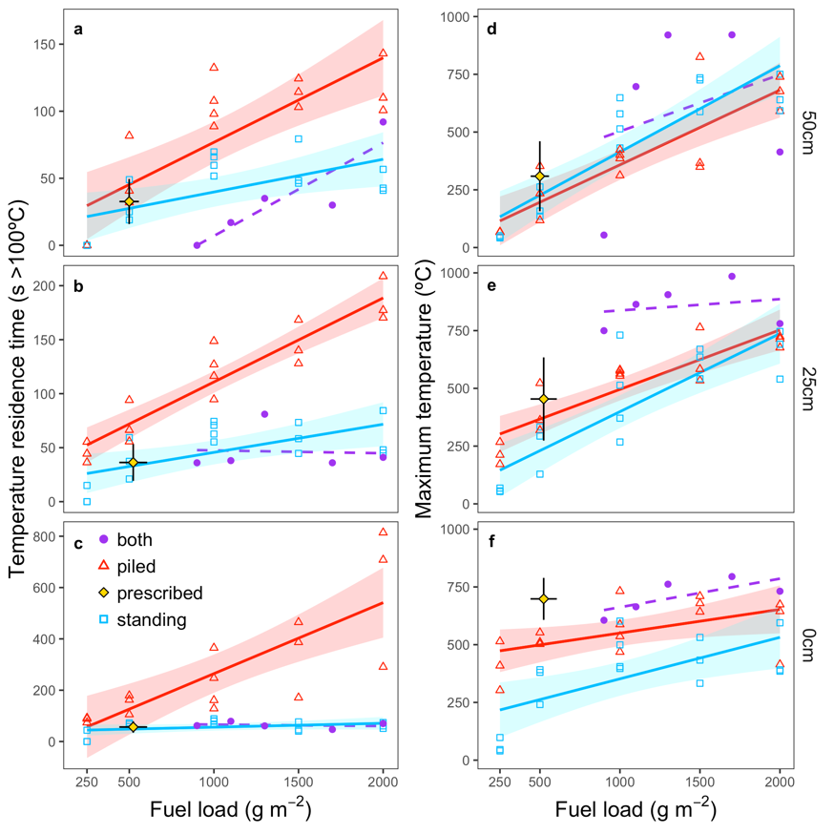

**Figure 28.** Fitted regression lines (solid lines) between time above 100ºC (a-c) or maximum temperature (d-f) and fuel load for piled and standing fuel structure at 50 cm, 25 cm, and 0 cm above ground level. The dashed line is the best fit line for the five fires that had both piled and standing fuel. Yellow diamond shows results from the prescribed burn while purple dots show the fuel structure of standing and piled fuels together with varying fuel loads.

The maximum temperature recorded during experimental fires of either piled-only or standing-only fuels ranged from “near-ambient” temperatures of 40ºC (standing fuel at 0 cm and 50 cm height) to a high of 824ºC (piled fuel at 50 cm). We assigned 40ºC as “near-ambient” due to heat retention of the ground and experimental apparatus making the thermocouple reading higher than the actual ambient air temperature. The overall highest maximum temperature of burning cogongrass recorded during this study was 985ºC at 25 cm during a fire that had a combined 1700 g m-2 of piled (500 g) and standing (1200 g) fuel. Maximum temperatures were greater with larger fuel loads, and piled fuels generated greater maximum temperatures at lower fuel loads and closer to the ground (Figure 28 d-f). Models of maximum temperature showed significant effects of fuel load and fuel structure at 0 and 25 cm, but only fuel load was significant at 50 cm (Table 11). Adjusted R2 of models were 0.76, 0.74, and 0.53 at 50, 25, and 0 cm heights respectively. During the prescribed fire, maximum recorded temperatures ranged from 72ºC to 800ºC with averages across the seven locations of 309ºC (SD = 151ºC), 454ºC (SD 180ºC), and 698ºC (SD = 90.9ºC) at 50 cm, 25 cm, and ground level respectively. Maximum temperatures recorded during the prescribed fire tended to be greater than the temperatures recorded during the experimental fires with similar fuel loads, with the greatest difference at ground level (Figure 28 d-f).

**Table 11.** Maximum temperature model coefficients

|  |  |  |  |  |  |
| --- | --- | --- | --- | --- | --- |
| **Probe height** | **Variable** | **Estimate** | **Std. Error** | **Crit. value** | **P value** |
| 50 cm | Intercept | 8.06 | 47.82 | 0.17 | 0.87 |
| Biomass | 0.35 | 0.04 | 9.96 | 0.00 |
| Structure: standing | 57.96 | 43.43 | 1.33 | 0.19 |
| 25 cm | Intercept | 196.03 | 44.40 | 4.41 | 0.00 |
| Biomass | 0.30 | 0.03 | 9.16 | 0.00 |
| Structure: standing | -92.67 | 40.32 | -2.30 | 0.03 |
| 0 cm | Intercept | 407.44 | 47.67 | 8.55 | 0.00 |
| Biomass | 0.14 | 0.03 | 4.04 | 0.00 |
| Structure: standing | -194.49 | 43.29 | -4.49 | 0.00 |

Flame heights were greater with higher fuel loads and for standing than piled fuel structure for fuel loads above 500 g m-2 (Figure 29a). The model of flame height had significant effects of fuel load, fuel structure, and the interaction of fuel load and fuel structure (Table 12) with an adjusted R2 of 0.77. Fires with both piled and standing fuel had flame heights intermediate between piled-only and standing-only fuel. The flame heights recorded during the prescribed fire were similar to those of the piled-only and standing-only fires.

Rate of spread increased with larger loads of standing fuel, but decreased slightly with greater loads of piled fuels (Figure 29b). The model for rate of spread had significant effects of air temperature and the interaction of fuel load and fuel structure (Table 12), with an adjusted R2 of 0.53. We did not estimate rate of spread for the prescribed fire or for the fire with both piled and standing fuel.

The model for proportion of biomass consumed had significant effects of fuel load, fuel structure, and the interaction of fuel load and fuel structure (Table 12), with an adjusted R2 of 0.73. Fires with piled fuels, both piled and standing fuels, or with standing fuel loads ≥1000 g m-2 all had >95% of fuel mass consumed (Figure 29c).

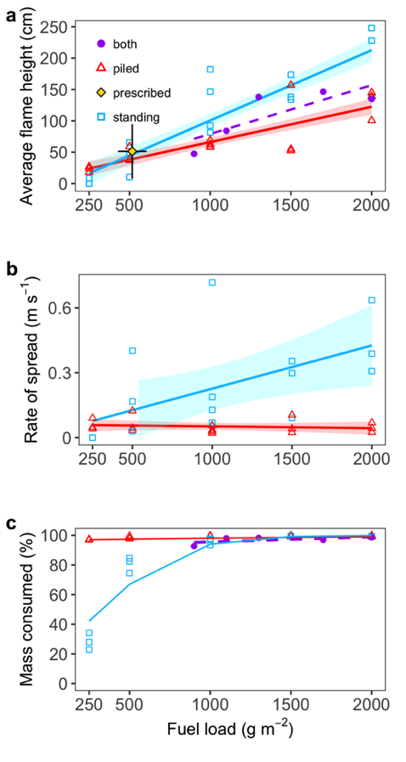

**Figure 29.** Fitted regression lines (solid lines) plotted over data points for flame heights (a), rate of spread (b), and percent of mass consumed (c) for piled or standing fuel structure across fuel load treatments. The dashed line is the best fit line for the five fires that had both piled and standing fuel. For comparison to natural (prescribed) fires, mean + SE for fuel loads and flame heights are shown in panel (a).

**Table 12.** Model coefficients for flame height, rate of spread, and proportion of mass consumed.

|  |  |  |  |  |  |
| --- | --- | --- | --- | --- | --- |
| **Response** | **Variable** | **Estimate** | **Std. Error** | **Crit. value** | **P value** |
| Flame height | Intercept | 9.91 | 15.70 | 0.63 | 0.53 |
| Biomass | 0.06 | 0.01 | 4.36 | 0.00 |
| Structure: standing | -21.47 | 22.21 | -0.97 | 0.34 |
| Biomass X Structure | 0.06 | 0.02 | 3.06 | 0.00 |
| Rate of spread | Intercept | -0.61 | 0.29 | -2.12 | 0.04 |
| Biomass | 0.00 | 0.00 | -0.02 | 0.99 |
| Structure: standing | -0.04 | 0.09 | -0.44 | 0.66 |
| Air temperature | 0.03 | 0.01 | 2.38 | 0.02 |
| Biomass X Structure | 0.00 | 0.00 | 2.87 | 0.01 |
| Percent consumed | Intercept | 3.30 | 0.40 | 8.22 | 0.00 |
| Biomass | 0.00 | 0.00 | 1.81 | 0.07 |
| Structure: standing | -4.64 | 0.46 | -10.08 | 0.00 |
| Biomass X Structure | 0.00 | 0.00 | 7.75 | 0.00 |

Fuel structure is a critical characteristic that can affect fire intensity and fire behavior. The experimental apparatus and methodology presented here for assessing the effects of fuel structure on fire behavior combines precision with realism, which may improve scaling small-scale fire experiments to natural settings. The FABIO enabled relatively rapid testing of how different fuel bed structure affected fire behavior. Our results indicate that not accounting for fuel structure in manipulative experiments may lead to inaccurate extrapolations to fire behavior in natural settings (Fernandes and Cruz 2012). We demonstrated our methodology with cogongrass, a widespread and problematic invader in the Southeast USA, and report the most precise and accurate measurements to date of fire intensity and behavior for this dominant fuel.

The recorded differences in temperature residence time and rate of spread between piled and standing fuel structure are directly related to the differences in compactness and continuity of the fuel structures. As fuel loading increases so does compactness and continuity for both fuel structures, but the increase is greater for standing than piled fuels (i.e., standing fuel is generally less compact and continuous than piled fuel for the same fuel load). These structural differences are reflected in the measurements of temperature residence time, rate of spread, and proportion of mass consumed. Piled fuels had notably greater temperature residence time than standing fuels across all fuel loads and temperature probe heights with the exception of the 250 g fuel load. The significantly longer temperature residence time of piled fuels (250% greater at 25 cm) suggests the potential for significant damage to plant tissues, especially near the soil surface (Bowman et al. 2017). However, in comparison to the fires with both fuel structures combined, which is more representative of natural fuel conditions for cogongrass, the relationship from the experimental fires using piled fuel likely isn’t representative of fires in natural settings. Therefore, experiments that manipulate fuel loads with disregard to vertical fuel structure may produce inaccurate predictions of the ecological effects of fire due to inaccurate estimates of how fuel loads affect fire temperatures and residence time (Fernandes and Cruz 2012).

Temperature metrics and flame height both increased with fuel load for piled and standing fuel structures, while fuel load affected the rate of spread and mass consumed only of standing fuels. Fuel load didn’t affect the rate of spread or mass consumed of piled fuels likely because these responses primarily depend on characteristics of continuity and compactness. Piled fuel had essentially the same continuity regardless of fuel load, hence the consistent mass consumed. It is known that increasing fuel-packing ratio reduces fuel bed aeration, thereby limiting oxygen and reducing fire rate of spread (Cruz and Fernandes 2008). The relatively small increase in compactness of piled fuel with increasing fuel load may have very slightly slowed the rate of spread, but this too was essentially constant across fuel loads and therefore the greater fuel load had no apparent effect on rate of spread. The overall slower rate of spread of piled fuels compared to standing fuels indicates that standing fuels were more aerated and the greater continuity of increasing fuel loads allowed for faster spreading fires. When the interest is in the ecological effects of fire, reconstruction of natural fuel structure is paramount in bridging the gap between field studies and laboratory flammability assessments (Fernandes and Cruz 2012). By controlling for standing fuel structure, our device provides a more realistic substitute for full-scale experimental fires.

To date, most reports on the effects of cogongrass on fire behavior in the USA have been qualitative. Only one peer-reviewed study we are aware of has compared temperatures from cogongrass fires to native vegetation fires in the same landscape (Lippincott 2000). They reported a maximum temperature of 458ºC in a cogongrass fuel bed versus 318ºC in native vegetation using temperature-indicating paints. Maximum temperatures >260ºC at 91 cm above ground level were reported by Enloe *et al.* (2013), also using temperature-indicating paint. In comparison, the highest maximum temperature we estimated was 985ºC at 50 cm above ground level. In addition to maximum temperature, we report the first estimates of temperature residence time for fires where cogongrass is the dominant fuel. Interestingly, the temperature residence time from our experimental fires with standing fuels was similar to that of the prescribed fire in a native long leaf pine ecosystem within the same range of fuel loads. This similarity suggests that the negative impacts of cogongrass via effects on fire behavior in the Southeast USA is driven by the higher fuel loads it generates compared to native vegetation.

Experimental measurements are subject to bias from their design and the tools and apparatuses used. In this experiment, there were multiple aspects that could bias the measurements. For example, thermocouples measure the surface temperature of the probe, so probe thickness and length may result in underestimating the actual flame temperature (Bova and Dickinson 2008). The FABIO design may affect measurements of residence time due to heat retention in the apparatus as well as the ground over repeated burns. Our 100ºC threshold temperature actually limited this bias because temperatures rapidly fell below 100ºC after the flame front passed and smoldering ceased.

The distinct differences in behavior of fires with piled versus standing fuel structure underscore the value of using realistic fuel structures in fire experiments where the purpose is to measure fire behavior and extrapolate findings to potential ecological effects in natural settings. The FABIO enables greater control of fine fuel structure and can be used for a variety of fuel complexes, with the only major limitation for the method being the physical size of a single vertical piece of fuel (max 10 cm diameter). The design could be adjusted and adapted to specific situations where larger grid spacing or measuring greater flame heights are desired, and therefore the FABIO can be used to make the same measurements across a wide range of systems. Using this method could increase consistency between measurements across field experiments and in and enable linking small-scale experiments to natural fire behavior (Fernandes and Cruz 2012, Varner et al. 2015).

PART 2B: GRASS INVASION ENHANCES SURVIVAL OF DISEASE VECTOR THROUGH ALTERATION OF MICROCLIMATE CONDITONS

TECHNICAL APPROACH

Experimental Design

To assess the effects of cogongrass invasion on tick survival, a total of 24 plots (1 m x 1 m) were established spaced approximately 10 m apart: 12 invaded and 12 uninvaded. At the center of each plot, mesh bags were deployed containing 10 nymph, 5 female adult, and 5 male adult life stage *Amblyomma americanum*. All ticks used in the experiment were reared and maintained under common laboratory conditions (RH and Temp) from the National Tick Research and Educational Resource (Department of Entomology and Plant Pathology, Oklahoma State University, Stillwater, OK). All ticks were of similar age among life stages. Bags were knotted tightly at one end and remained sealed until the end of the experiment. Cylindrical wire mesh exclosures to deter predation from wildlife 50 cm tall were constructed with lids containing the mesh bags. Each mesh bag containing ticks was oriented vertically and remained in contact with the litter layer to facilitate natural tick questing behavior throughout the experiment (Figure 30 a-b).

Site Description

The study site is a planted longleaf pine (*Pinus palustris*) stand with distinct invaded and uninvaded understory plant communities (Figure 30c). Invaded plant communities are monotypic stands of the invasive cogongrass (*Imperata cylindrica*) spanning approximately (140 m x 45 m), surrounded on all other sides by an uninvaded area. The uninvaded habitat features a typical native longleaf pine ecosystem with a native plant community including wiregrass (*Aristida stricta*), common dewberry (*Rubus flagellaris*), hickory (*Carya sp.*), and *Andropogon sp*. grasses.

Site Characteristics

At each of the 24 plots, the plant communities were surveyed within 1 m x 1 m quadrats on the first day of the experiment. Data were collected on overstory canopy cover, herbaceous plant height, standing biomass, and litter biomass. Light availability, photosynthetic photon flux density (PPFD), at ground level also were measured for each plot using an ACCUPAR LP-80 PAR/LAI ceptometer meter (Decagon Device Inc., Pullman, WA, USA). Microclimate data were collected by temperature/relative humidity (RH) loggers (HOBO U23 Pro v2, Onset Computer Corporation, Bourne, MA) adjacent to each exclosure and at a similar height as the mesh bags containing the ticks. Each logger was housed in a capped 45.7 cm length of 3.8 cm diameter PVC pipe to protect it from rainfall and direct sunlight. Holes were drilled on four sides six inches apart along the length of the pipe to allow airflow to better reflect ambient temperature and relative humidity (Figure 28b). The temperature/RH data loggers collected time points of the environmental conditions every five minutes during the full length of the study. Data were transferred off the loggers every 60 days to clear the memory and ensure proper functioning continued. The temperature/RH logger and tick cage were secured vertically in place by wiring them to a piece of rebar sunk 15 cm into the ground.



**Figure 30.** Tick bags and exclosures (wire mesh cages) along with PVC housing for temperature and humidity loggers in (a) invaded and (b) native plant communities. (c) Study site showing invaded to the left and native plant communities to the right, separated by managed boundary area to maintain distinct plant communities.

Assessing Tick Survival

Mesh bags containing *A. americanum* within the wire cage exclosures along with temperature/RH loggers were launched at all plots on June 21, 2018. Start date of the experiment was selected in order to mimic typical off-host periods for lone star ticks in this area (Davidson et al. 1994a, Gleim et al. 2014). Bags were examined approximately every 10-14 days to determine nymph and adult survival. At each visit, bags were removed from the cages but not opened. The survival of each individual tick was determined by assessing their response to stimulation. Ticks were blown on by a human observer to release CO2 to see any natural tick responses to a potential host stimulus. Ticks were recorded as living if there were any signs of movement in response to the stimulus. If there was no response by the tick, it was marked as dead and monitored in subsequent visits to assure the previous mortality designation was correct. Visits are ongoing, with the current plan to continue monitoring survival until all ticks have succumbed to mortality.

RESULTS AND DISCUSSION

Site Characteristics

We found no difference in the overstory canopy cover or the amount of litter biomass (g/25cm2) between invaded and uninvaded locations (Figure 31a, 31e). However, we did find significant differences in the vegetation height, standing biomass (g/25cm2), as well as the reduction in light availability at the soil surface, for invaded plots compared to the uninvaded plots (Figure 31b-d). These structural differences in the understory community can buffer harsh environmental conditions for ticks, which spend a large portion of their lives at or near the soil surface.

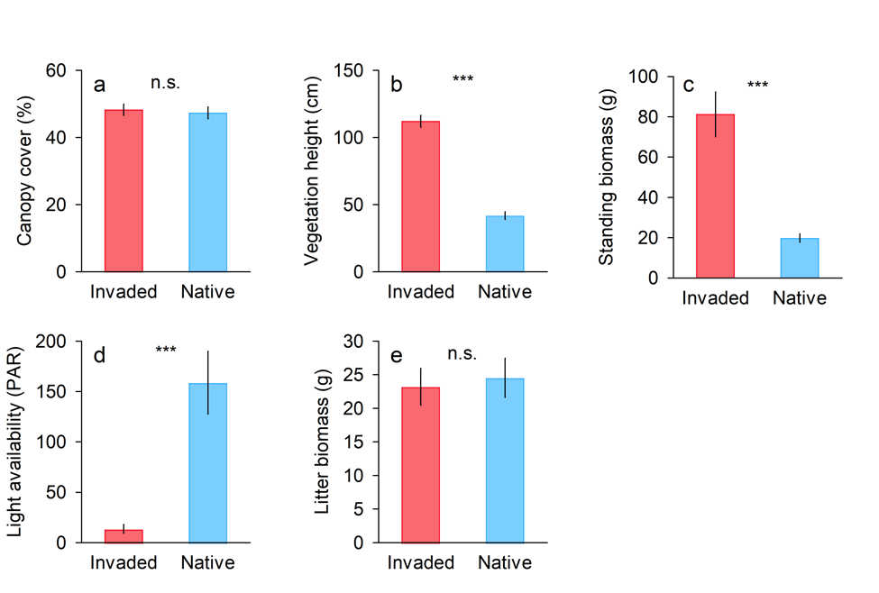

**Figure 31.** Site characteristics for native and invaded plots. (a) mean (± SE) overstory tree canopy cover, (b) understory vegetation height, (c) understory standing biomass per 25cm2, (d) light availability at the soil surface (μmoles m2 sec-1), and (e) litter biomass per 25cm2. Statistical significance between native and invaded plots was determined using analysis of variance, *** *P* < 0.001.

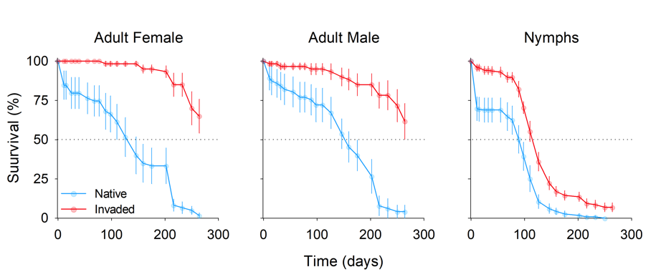

**Figure 32.** Mean (± SE) survival of adult female, adult male, and nymph *A. americanum* in native (blue) and invaded (red) plots over time.

Tick Survival

After 264 days, 63% of adult ticks were alive in the cogongrass invasion with only 3% surviving in the uninvaded area (Figure 32). The nymph life stage suffered greater mortality over this time period, but the effect of the invasion was similar, with 7% of nymphal ticks surviving in the invasion and all nymphs within the native treatment succumbing to mortality. Relative humidity was substantially higher in the invasion compared to adjacent native plant communities at the beginning of the experiment in June, but this difference decreased over time (Figure 33). Average daily temperature was lower in the invaded plots compared to the native plots throughout the study period to date (Figure 34).

In the absence of other causes of mortality ticks die due to desiccation, so the higher relative humidity likely is the critical mechanism by which cogongrass invasion extended tick survival time. For *A. americanum* it has been estimated that the critical equilibrium humidity (CEH) at which adult ticks start to lose water through their cuticle is between 80-82% RH (Hair et al. 1975) (Figure 33, 35). This research may reveal an additional mechanism by which plant invasion may alter tick abundance by directly impacting tick survival. However, potential indirect effects of plant invasion on tick abundance include changes in host density. The combined understanding of these direct and indirect effects will allow us to determine the net outcome for changes in tick-borne disease risk. While further study is needed to determine these relationships, we propose a list of possible scenarios of the potential impacts on tick abundance given an increase in tick survival (Figure 36).

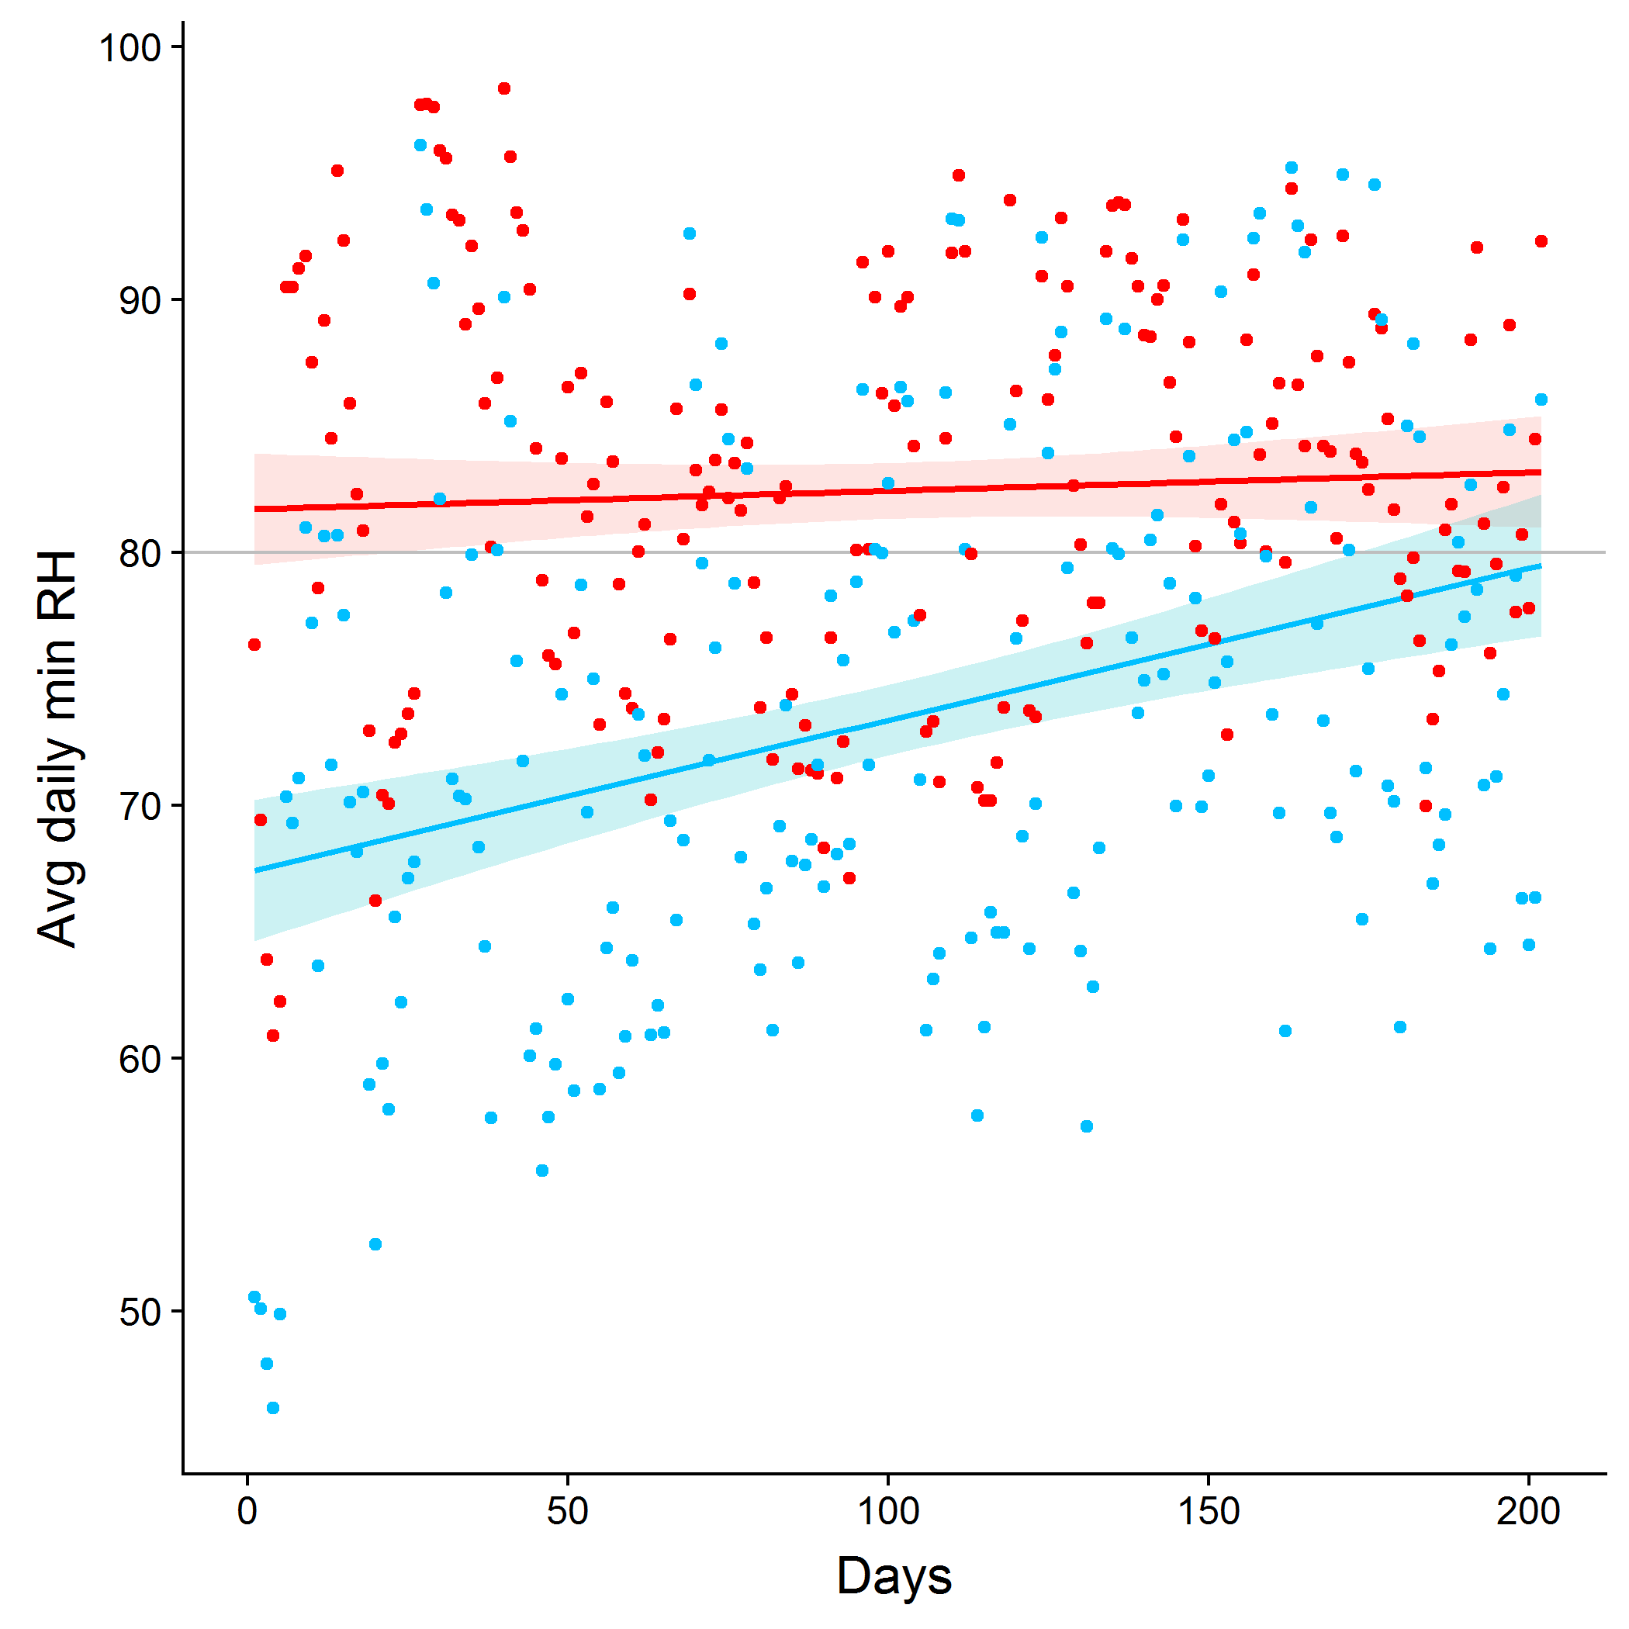

**Figure 33.** Average daily minimum relative humidity over time for invaded (red) and uninvaded (blue) plots n=12. Critical equilibrium humidity (CEH) for *A. americanium* (80%) is depicted with a gray line.

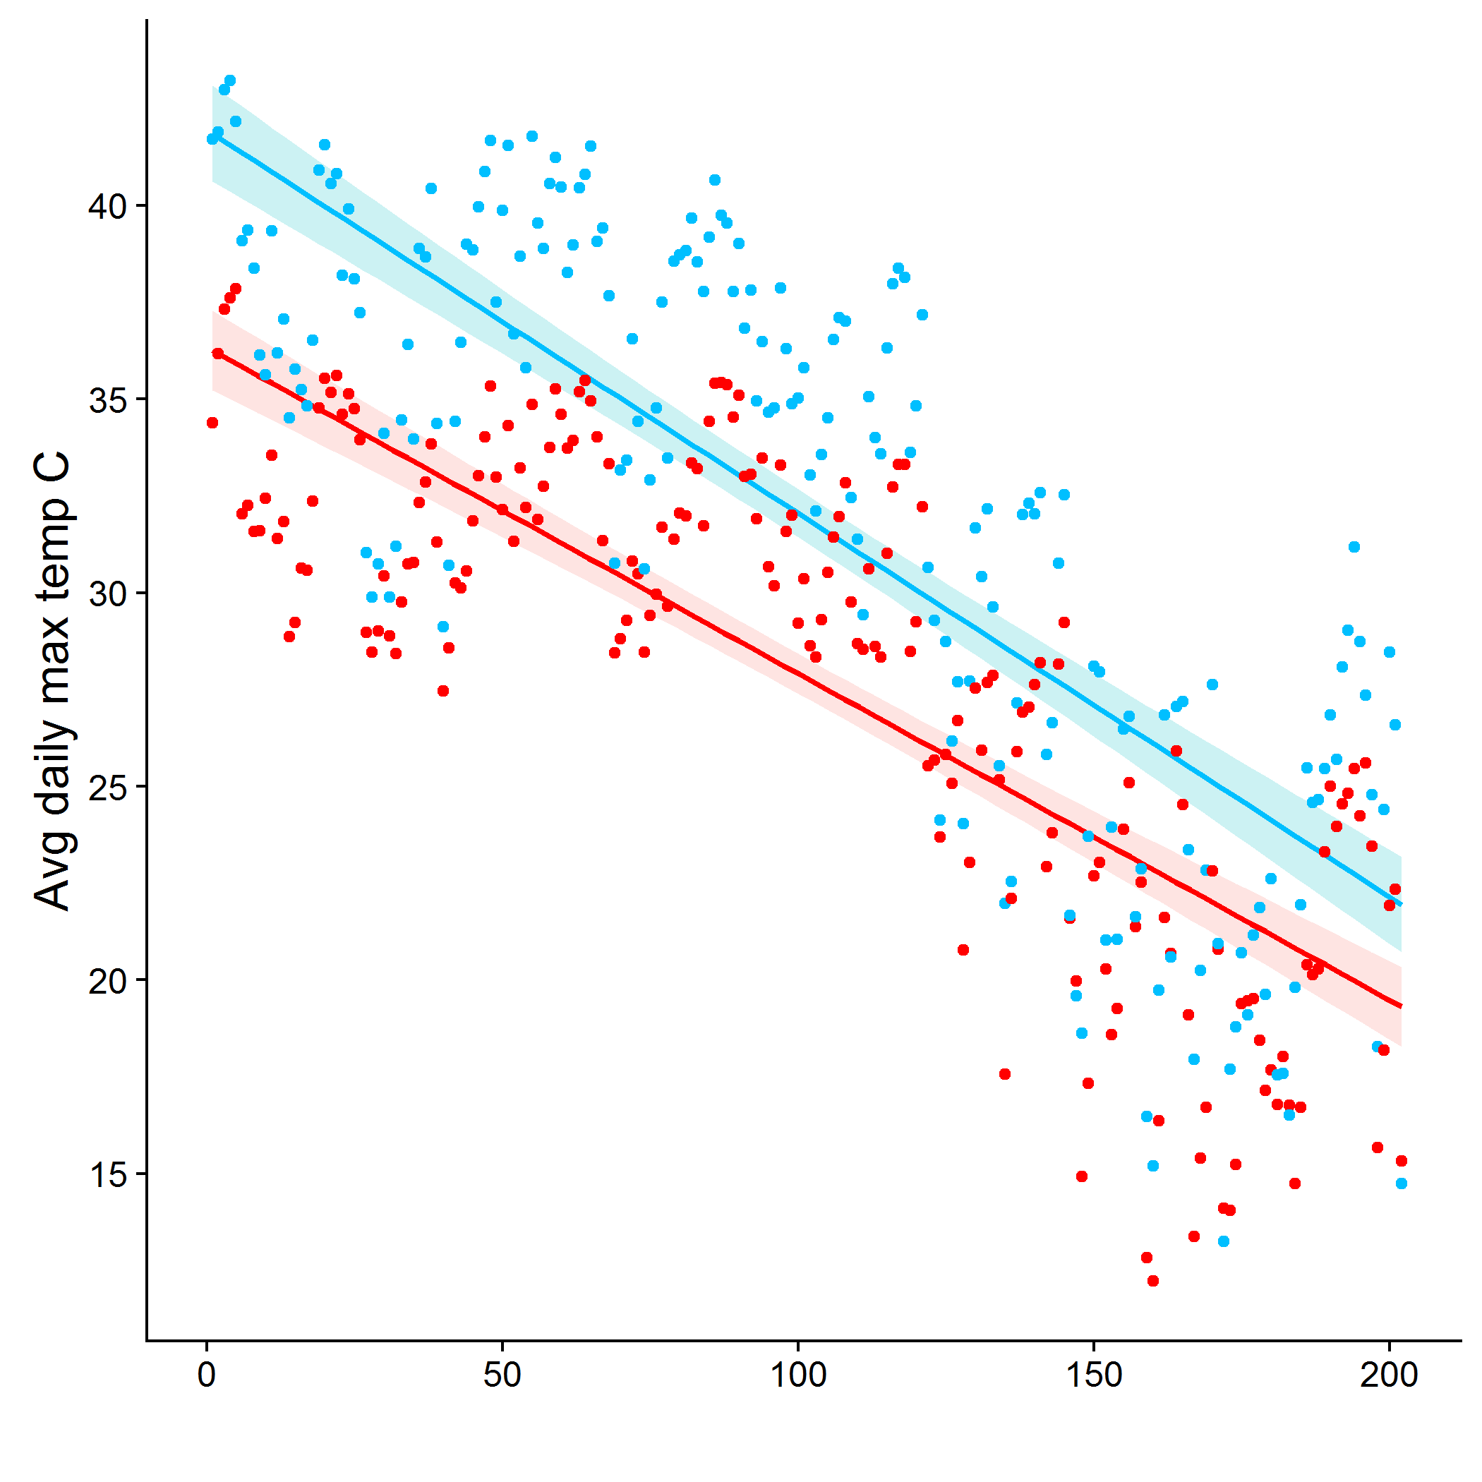

**Figure 34.** Average daily maximum temperature (°C) over time for invaded (red) and uninvaded (blue) plots n=12.

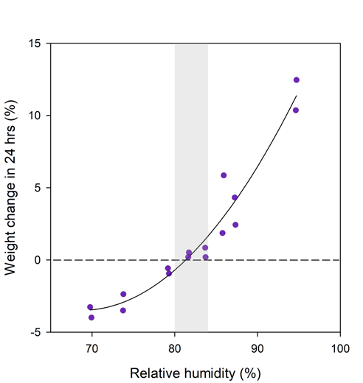

**Figure 35.** Weight change (%) of *A. americanum* ticks exposed to varying relative humidities for 24 hr intervals. Ticks were pre-desiccated at 0% relative humidity for 24 hrs prior to various humidity treatments. Redrawn from (Hair et al. 1975).



**Figure 36.** Conceptual diagram of possible effects of plant invasions on tick abundance. (a) increase in tick survival and host abundance, (b) increase in tick survival and no change to host abundance, and (c) increase in tick survival and a decrease in host abundance.

PART 3: PATHOGEN ANALYSIS OF TICKS

TECHNICAL APPROACH

Introduction

Several of the most rapidly emerging vector-borne diseases in the U.S. are caused by zoonotic pathogens transmitted by the lone star tick (*Amblyomma americanum*), including *Ehrlichia chaffeensis* and *E. ewingii*, both agents of ehrlichiosis, *Rickettsia rickettsii*, the agent of Rocky Mountain spotted fever (Stromdahl et al. 2011), and *Francisella tularensis*, the agent of tularemia (Childs & Paddock 2003). *Amblyomma americanum* is distributed broadly across the southeastern U.S. and along the eastern seaboard; in the southeastern U.S. it is the primary vector of TBDs to humans (Demma et al. 2005). Also occurring in the southeastern U.S. is the gulf coast tick (*Amblyomma maculatum*), an important vector of *R. parkeri*, the American dog tick (*Dermacentor variabilis*), an important vector of *R. rickettsii*, and the brown dog tick (*Rhipicephalus sanguineus*), a species capable of transmitting a variety of pathogens particularly affecting canids (Demma et al. 2005). The black-legged tick (*Ixodes scapularis*), vector of *Borrelia burgdorferi*, the causative agent of Lyme disease, also occurs in this region. However, this species is considerably less important in the southeastern U.S. as a disease vector, and is not efficiently sampled via carbon dioxide-baited traps. While several studies have assessed the distribution of some tick-borne agents (TBAs) in the species mentioned above across portions of the southeastern U.S. (e.g. Mixson et al. 2006), there has been no comprehensive analysis of field-collected tick specimens for all known TBAs due to the lack of an effective system for performing such an analysis. Here, we describe the development of a system using Fluidigm Access Array combined with Illumina HiSeq to analyze all nymph and adult life stage ticks collected in this study for an unprecedented diversity of TBAs that imperil human, domestic animal and wildlife health.

Tick Collections

Ticks were collected from nine military bases in the southeastern United States (Avon Park Air Force Range, Florida; Fort Benning, Georgia; Fort Gordon, Georgia; Camp Blanding, Florida; Eglin Air Force Base, Florida; Fort Jackson, South Carolina; Moody Air Force Base, Georgia; Camp Shelby, Mississippi; Tyndall Air Force Base, Florida) during the summers of 2017 and 2018 using carbon dioxide-baited traps (Kensinger & Allan, 2011). A total of 918 ticks were collected: 839 *Amblyomma americanum*, 46 *Dermacentor variabilis*, 31 *Amblyomma maculatum* and 1 *Rhipicephalus sanguineus*. All ticks were counted and preserved in 2 ml vials containing 70% ethanol. All ticks were identified to species using a Zeiss Stemi DV4 dissecting microscope. To date 471 ticks have been processed through DNA extraction and 466 ticks have been analyzed for TBAs. The five ticks not analyzed due to insufficient DNA were all *A. americanum* nymphs.

DNA Extraction

All ticks were rinsed in 70% ethanol, air dried, and individually homogenized in 30 μl digestion buffer (10 mM Tris HCl, ph 8; 5 mM EDTA; 100 mM NaCl; 0.2% SDS; 2 mg/ml protease K). Each tube contained a 5 mm steel bead (Qiagen). Ticks were homogenized twice at 25 Hz for 3 min each using a TissueLyzer II (Qiagen, Germantown, MD). A brief centrifugation was done between the two rounds of homogenization. DNA was extracted using a standard phenol-chloroform protocol in a total volume of 600 l followed by an ethanol precipitation, excluding the addition of sodium acetate to reduce the final salt concentration. We included the addition of glycogen to enhance DNA precipitation. After ethanol precipitation, samples were re-suspended in 30 μl elution buffer and stored at -20 degrees Celsius. All DNA samples were quantified on a Qubit 2.0 (Life Technologies) using the Qubit dsDNA HS Assay Kit. All but five samples contained enough DNA (at least 2 ng/l) and were submitted for Fluidigm and next generation sequencing (NGS).

Primers

Target regions of four bacterial and one protozoan gene were amplified using a subset of the primers from Keesing et al. (2018) (Table 13). We used five 16S rRNA primer sets: three universal eubacteria sets targeting different regions of the gene, one specific to the Rickettsiaceae, and one specifically targeting *Coxiella* spp. We also targeted the disulfide oxidoreductase (dsb) gene for *Anaplasma* and *Ehrlichia* for greater species specificity. As the 16S rRNA gene is highly conserved in the genus *Rickettsia* we used specific primers targeting the outer membrane protein B (*ompB*) (also known as *sca5*) for North American *Rickettsia* of interest and the 23S – 5S rRNA intergenic spacer region (23S-5S IGS), modified from Jado et al. (2006). All protozoan species of interest belong to the genera *Babesia* or *Theileria*. The Jado et al. (2006) primers BT18SF and BT18SR provide sufficient species-specific resolution within these two genera with little cross-reactivity. All primers designed for this study were created using the Primer3 option in Geneious (version 8, Auckland, New Zealand) and synthesized by IDT Corporation (Coralville, IA).

**Table 13.** Information on the amplicons used in this study.

|  |  |  |  |  |  |  |
| --- | --- | --- | --- | --- | --- | --- |
| **Primer (F)** | **Sequence 5'-3'** | **Primer (R)** | **Sequence 5'-3'** | **Gene Target** | **Product size** | **Target Species** |
| 116S8FE3 | AGAGTTTGATCCTGGCYCAG | 2B-GA1B2 | GGAGTTTGCCGGGACTTYTTCT | 16S rRNA | 441 - 474 | bacterial spp. |
| AMdsb1F | GCTAAGCCCCTAGTAGCGTC | AMdsb1R | GAAATGCGGAAGAAGGTGGC | *dsb1* | 431 | *A. marginalis* |
| APdsb1F | AGGGTTGATAAAATGCACGGC | APdsb1R | TAAGTCGCTGGGTCTCTGGA | *dsb1* | 392 | *A. phagocytophilum* |
| APdsb2F | AGGTCCCTAAGCATCACTCCT | APdsb2R | TCTGCCTGTTGAGTCTGGTG | *dsb1* | 370 | *A. phagocytophilum* |
| 3BT18SF | GACACAGGGAGGTAGTGACAAG | 3BT18SR | CTAAGAATTTCACCTCTGACAGT | 18S rRNA | 399 - 449 | *Babesia/Theileria spp.* |
| 2CB16S8FE3 | AGAGTTTGATTCTGGCTCAG | CB475seqR | CGTCAACGCCCAAGGATATT | 16S rRNA | 474 - 476 | *Coxiella spp.* |
| ECdsb1F | ACTAGTAGCAAGCTTTCCGT | ECdsb1R | AACAGCTTTCAGTGATGCTTCT | *dsb1* | 391 | *E. chaffeensis* |
| ECdsb2F | AACTAGAGGGCAAGCACAAG | ECdsb2R | ATAGTGTCGGAATTCTTGGC | *dsb1* | 429 | *E. chaffeensis* |
| EEdsb1F | GAAGCATCATTGAAAGCAGTACG | EEdsb1R | CCAACTATCATAGCAGGAGTTCC | *dsb1* | 269 | *E. ewingii* |
| ENdsb1F | GTTCTTTGATTACTCATGCGGCT | ENdsb1R | ATATCAGCTGCACCACCGAT | *dsb1* | 408 | *E. canis* |
| EWdsb1F | CTAGTAGCGAGCTTCCCATT | EWdsb1R | GATGCCTCGCCGAGTATAGG | *dsb1* | 377 | *E. muris subsp. eauclairensis,subsp. nov.* |
| EWdsb2F | ACAGGATGGCAAAGTACGTGT | EWdsb2R | ATATATCAGCTGCTCCACCGA | *dsb1* | 350 | *E. muris subsp. eauclairensis,subsp. nov.* |
| FBbslF | CGAGTTCGCGGGAGAGTA | FBbsl2b_R | TCCTAGGCATTCACCATAGACT | 5S-23S IGS | 249 - 253 | *Borrelia burgdorferi sensu lato* |
| 4FRK23-5_F1 | GATAGGTCRGGTGTGGAAG | 4FRICK23-5R1 | GGAYGGGATCGTGTGTTTCA | 23S-5S IGS | 384 | *Rickettsia spp.* |
| 4FRK23-5_F1 | GATAGGTCRGGTGTGGAAG | 4FRICK23-5R4 | CTCATGCTATAACCACCAAGC | 23S-5S IGS | 359 - 375 | *Rickettsia spp.* |
| RambOB1F | AGGTATTGGCKCTTCAMAGT | RambOB1R | AATAGCAGTAGTACCRCCGC | *ompB* | 442 - 448 | *Rickettsia amblyommatis* |
| RambOB2F | AATCMCGSTAACACTGCAGG | RambOB2R | AYTCGCATCAACAACGCCTG | *ompB* | 525 - 534 | *Rickettsia amblyommatis* |
| RbelOB1F | CCTAATGGTGTTGCTGCTGG | RbelOB1R | CCTTGCCCACTTGCTAAACC | *ompB* | 419 | *Rickettsia bellii* |
| RbelOB2F | AGTGCAGATAACCCACTTGCA | RbelOB2R | CTGTACCACCCGCAGCATTA | *ompB* | 352 | *Rickettsia bellii* |
| RcasOB1F | TCCCCATGTTGAAGTACCGC | RcasOB1R | TCAAGCAGGTGGTGTAGTCG | *ompB* | 401 | *Rickettsia canadensis* |
| RcasOB2F | CGACTACACCACCTGCTTGA | RcasOB2R | GTAACGGTCTGGTCGGTGAC | *ompB* | 364 | *Rickettsia canadensis* |
| RmasOB1F | TGAAGCATYAGGTRTCGGAG | RafOB1R | CCCGTACCGTCTGTTCCATT | *ompB* | 422 - 431 | *Rickettsia massilliae* |
| RparOB2F | ACCGGCGATATAGGGAAYGC | RparOB2R | TGACCRGCAGCATTTGTAGT | *ompB* | 449 - 455 | *Rickettsia parkeri* |
| RrhiOB2F | TAATCCTGGTGCTGCGACTG | RrhiOB2R | CCGTCAAAATCTGTTCCGGC | *ompB* | 522 | *Rickettsia rhipicephali* |
| 5V1-V3_F28 | GAGTTTGATCNTGGCTCAG | 5V1-V3_R519 | GTNTTACNGCGGCKGCTG | 16S rRNA | 462 - 527 | bacterial spp. |
| 5V4_515F_new | GTGYCAGCMGCCGCGGTAA | 5V4_806R_new | GGACTACNVGGGTWTCTAAT | 16S rRNA | 291 - 293 | bacterial spp. |
| 1Berggoetz et al., 2014; 2modified from Berggoetz et al., 2014; 3Schwartz et al., 1992; 4modified from Jado et al., 2006; 5W. M. Keck Center for Comparative and Functional Genomics at the University of Illinois at Urbana-Champaign. | | | | | | |

Fluidigm 2 Step Access Array Amplification

Following DNA extraction and quantification, DNA samples (Table 14) were sent to the W. M. Keck Center for Comparative and Functional Genomics at the University of Illinois at Urbana-Champaign where Fluidigm PCR and NGS were performed. Samples were diluted to 2 ng/****l as needed. A mastermix for amplification was prepared using the Roche High Fidelity Fast Start Kit and 20x Access Array loading reagent according to Fluidigm protocols. The mastermix was composed of: 0.5 ****l 10X FastStart Reaction Buffer without MgCl2; 0.9 ****l 25 mM MgCl2; 0.25 ****l DMSO; 0.1 ****l 10 mM PCR grade Nucleotide Mix; 0.05 ****l 5 U/ul FastStart High Fidelity Enzyme Blend; 0.25 ****l 20X Access Array Loading Reagent; 1.95 ****l Water. This mastermix (4 l) and 1 l DNA sample were added to each of 48 wells of a PCR plate. Primer pairs were prepared (20X primer master mix: 2** **l each forward and reverse primer (50 ****M each), 5 ****l 20X Access Array Loading Reagent, water to 100 ****l) and aliquoted into a separate plate. All primers were synthesized by IDT Corp. (Coralville, IA).

Samples (4 ****l) and primers (4 ****l) were loaded into their respective inlets of a previously primed Fluidigm LP48.48 IFC. The IFC was placed in a Fluidigm Juno for loading, PCR amplification and harvesting used the following PCR conditions: 50ºC 2 min; 70ºC 20 min; 95ºC 10 min; 10 cycles of 95ºC 15 sec, 55ºC 30 sec, 72ºC 1 min; 2 cycles of 95ºC 15 sec, 80ºC 30 sec, 60ºC 30 sec, 72ºC 1 min; 8 cycles of 95ºC 15 sec, 55ºC 30 sec, 72ºC 1 min; 2 cycles of 95ºC 15 sec, 80ºC 30 sec, 60ºC 30 sec, 72ºC 1 min; 8 cycles of 95ºC 15 sec, 55ºC 30 sec, 72ºC 1 min; 5 cycles of 95ºC 15 sec, 80ºC 30 sec, 60ºC 30 sec, 72ºC 1 min. The PCR product was diluted 1:100 and 1 ****l was placed in a new 96-well PCR plate. PCR was performed for amplification with (4 ****l) Illumina linker barcodes. To this was added master mix (15 ****l) containing (per sample): 2.0 ****l 10X FastStart Reaction Buffer without MgCl2; 3.6 ****l 25 mM MgCl2; 1.0 ****l DMSO; 0.4 ****l 10 mM PCR grade Nucleotide Mix; 0.2 ****l 5 U/****l FastStart High Fidelity Enzyme Blend; 7.8 ****l water. The PCR cycling program consisted of 1 cycle of 95ºC 10 min; 14 cycles of 95ºC 15 sec, 60ºC 30 sec, 72ºC 1 min; 72ºC 3 min.

Products were quantified on a Qubit fluorimeter and stored at -20 degrees Celsius. All samples were run on a Fragment Analyzer (Advanced Analytics, Ames, IA) and amplicon regions and expected sizes confirmed. Samples were then pooled in equal amounts according to product concentration. The pooled products were then size selected on a 2% agarose E-gel (Life Technologies) and extracted from the isolated gel slice with Qiagen gel extraction kit (Qiagen). Cleaned size selected products were run on an Agilent Bioanalyzer to confirm appropriate profile and determination of average size.

**Table 14.** The number of ticks (and percent of total) analyzed for tick-borne agent DNA as of March, 2019, with information on tick species collected from each site.

|  |  |  |  |  |  |  |  |  |  |
| --- | --- | --- | --- | --- | --- | --- | --- | --- | --- |
|  | **Site** | **Avon Park** | **Benning** | **Blanding** | **Eglin** | **Moody** | **Shelby** | **Tyndall** | **TOTAL** |
| **Tick Species** | **Life Stage** |
| *Amblyomma americanum* | Adult |  | 7 (32%) | 90 (32%) | 4 (4.5%) |  |  | 12 (39%) | 113 (24%) |
|  | Nymph |  | 15 (68%) | 188 (66%) | 71 (81%) | 7 (100%) | 30 (77%) | 11 (35%) | 322 (69%) |
| *Amblyomma maculatum* | Adult | 1 (14%) |  | 1 (0.35%) |  |  | 8 (21%) | 5 (16%) | 15 (3.2%) |
| *Dermacentor variabilis* | Adult | 6 (86%) |  | 4 (1.4%) | 2 (2.3%) |  | 1 (2.6%) | 3 (10%) | 16 (3.4%) |
| TOTAL |  | 7 (1.5%) | 22 (4.7%) | 283 (61%) | 88 (19%) | 7 (1.5%) | 39 (8.4%) | 31 (6.7%) | 466 |

High Throughput Sequencing

Library construction and sequencing were performed at the Roy J. Carver Biotechnology Center, University of Illinois at Urbana-Champaign. Approximately 1ng of DNA was used for amplification of the targeted regions in the Fluidigm Access Array (Fluidigm, CA) as previously described (Muturi et al., 2016). The pooled amplicons were sequenced on one lane with 2 x 250nt paired-reads on a HiSeq 2500 with a Rapid sequencing kit version 2 (Illumina, CA). Fastq files were generated and demultiplexed with the bcl2fastq v2.17.1.14 Conversion Software (Illumina®).

Sequence Analysis

A customized HiSeq analysis pipeline was created by the High Performance Computing in Biology (HPCBio) group at the University of Illinois at Urbana-Champaign. In brief, raw sequences were 1. assessed for quality with FastQC (Andrews, 2010); 2. trimmed with Trimmomatic (Bolger, et al., 2014); 3. stitched together when applicable with PEAR (Zhang et al, 2014); and 4. converted to FASTA format. Paired reads were not stitched together, and only the trimmed R1 (forward) read was used, when the expected size of the PCR products were either too large for forward and reverse sequences to overlap sufficiently (>450 nt) or were of variable length. Variable lengths occurred due to amplification in TBAs whose target regions varied in size by more than 10bp.

After processing, vsearch (Rognes et al., 2016) was used to compare these sequences against a custom database (Fredericks et al., in preparation). A maximum of 50 reads per query were reported when these conditions were met: a minimum percent identity of 93% and an alignment length of 50%. Due to the lack of species specific DNA sequence arrays for TBAs in available datasets, we created a custom DNA database using target sequences from expected or closely related TBAs obtained from published sequences in the National Center for Biotechnology Information’s (NCBI) Basic Local Alignment Search Tool (BLAST) (https://blast.ncbi.nlm.nih.gov/Blast.cgi) (access date: November 2017).

Reads were considered positive identifications to genus when a minimum average percent identity of 97% to a database sequence was achieved, and were assigned to species when a minimum of 99% identity was achieved. With the exception of *Rickettsia akari*, *R. bellii* and *R. felis*, no Rickettsia was distinguishable to species using any of the 16S rRNA primer sets (V1-V3_F28/V1-V3_R519, V4_515F_new/V4_806F_new or 16S8FE3/B_GA1B2), and were reported only to genus when hits occurred with these targets only. Otherwise, species-level identification of *Rickettsia* species was accomplished using hits obtained from the amplification of the 23S-5S IGS and *ompB* targeted regions. The most useful criteria for determining the quality of the match were the 1. total number of hits; 2. average percent identity; 3. average alignment length; and 4. fifth percentile of the percent identity, which gave an estimate of the variance in the percent identity.

RESULTS AND DISCUSSION

Identification of Tick-borne Agents

Using a next-generation sequencing approach, we have identified thus far DNA from 23 unique TBAs in these field-collected ticks: 16 to species, four to genus, and three which best matched to known sequences with 97% - 98.9% identity were designated as “-like” the closest species (Table 15). These encompassed eight different genera and known human pathogens included *Anaplasma phagocytophilum*, *Ehrlichia ewingii*, *Rickettsia parkeri* and *E. muris eauclariensis subsp. nov.* (Figure 37). These are causative agents of important tick-borne diseases in humans in the southeastern U.S., including anaplasmosis, ehrlichiosis, and spotted-fever rickettsiosis.

There were distinct differences between military installations in the abundance, species distribution (Table 14, Figure 37), and infection rates of collected ticks (Table 15). Camp Blanding and Eglin Air Force Base had the largest diversity of identified TBAs, while Avon Park Air Force Range had the fewest including no ticks with a *Coxiella* endosymbiont (Figure 37). We found no *Theileria spp.* in the ticks collected at Avon Park Air Force Range, Fort Benning or Tyndall Air Force Base, and only *Theileria cervi*, the most common *Theileria* species found, at Moody Air Force Base.

The majority (86%; 402/466) of the ticks carried a *Coxiella* endosymbiont. The second most common TBA was *R. amblyommatis sp. nov.* at 37% (171/466) prevalence, followed by *E. muris subsp. eauclairensis subsp. nov.* at 13% (60/466). This is the first report of *E. muris eauclairensis subsp. nov.* DNA in a tick other than *Ixodes scapularis*; here we detected it in *A. americanum* with average percent identities from 99.1 – 99.7 and a maximum of 100%. Sequence hits to the V4 region of *E. muris subsp. eauclairensis subsp. nov.* 16S rRNA ranged from 10 – 28,279 with an average of 1939. This TBA was first discovered in Wisconsin in human patients exhibiting ehrlichiosis subsequent to a tick bite (Pritt et al., 2017) and has been reported to date only in Wisconsin and Minnesota (Pritt et al., 2017). *Rickettsia bellii* was found in 54 (12%) ticks: 12% (52/435) of *A. americanum* and 13% (2/16) of *D. variabilis*, but only with small numbers (10 – 102; average = 20) of sequence hits. Of the 31 *D. variabilis* and *A. maculatum* ticks, 27 expressed an unknown *Francisella sp.* DNA (13/16 *D. variabilis* and 14/15 *A. maculatum*). *Rickettsia parkeri* (3/4) and *R. rhipicephali* (2/3) associated with the unknown *Francisella sp.*, but not with any *Coxiella* endosymbiont. An unknown *Babesia sp.* was detected in one *A. americanum* nymph. The closest match is to *Babesia sp. H10* with an average percent identity of 96%.

**Summary and Interpretation of Preliminary Results**

Extractions and analysis of DNA from ticks collected in 2017 and 2018 is ongoing. Collectively this will generate a robust dataset across which to analyze the effects of time since fire and fire return interval, plant invasions, wildlife host densities, and climate, on the density of ticks, tick infection rates, and their product, the density of infected ticks. Together these dependent variables represent entomological estimates of disease risk. Our preliminary results indicate a high diversity but low prevalence of human pathogens, suggesting that entomological exposure risk will be more strongly driven by tick abundance than tick infection rates. However, several important pathogens have been detected thus far that may cause serious morbidity or mortality in humans, including *E. ewingii* (a causative agent of ehrlichiosis), *A. phagocytophilum* (a causative agent of anaplasmosis), and *R. parkeri* (a causative agent of rickettsiosis). We also detect a surprisingly high prevalence of “*E. muris subsp. eauclairensis subsp. nov.*” in *A. americanum*, which thus far has been reported only in *I. scapularis*, and likely is an important emerging agent of ehrlichiosis in humans. Finally, among potential human pathogens, as expected we detect a high prevalence of *R. amblyommatis* in *A. americanum*, although this TBA likely only causes disease in humans rarely despite presumably high exposure rates. We also detect a high prevalence of wildlife pathogens, such as *Theileria* spp., and as expected a very high prevalence of non-pathogenic endosymbionts such as the *Coxiella* endosymbiont of *A. americanum*. Through this study, the precise identification of a diversity of TBAs will create an unprecedented knowledge of tick-borne disease risk for military installations in the southeastern U.S.

**Figure 37.** Diversity and abundance of tick-borne agents detected at each collection site. Most ticks contain more than one tick-borne agent, including nonpathogenic endosymbionts, human pathogens, wildlife pathogens, and microbes of unknown pathogenicity.

**Table 15**. The number of ticks of each species that expressed specific tick-borne agent DNA.

|  |  |  |  |  |  |
| --- | --- | --- | --- | --- | --- |
|  | *Amblyomma americanum* | *Amblyomma maculatum* | *Dermacentor variabilis* |  | Disease or Pathogenicity |
| TOTAL Ticks | 435 (93%) | 15 (3.2%) | 16 (3.2%) | Total |  |
| *Anaplasma phagocytophilum* | 2 (0.46%) |  |  | 2 (0.43%) | granulocytic anaplasmosis |
| *Ehrlichia ewingii* | 2 (0.46%) |  |  | 2 (0.43%) | granulocytic ehrlichiosis |
| *E. muris subsp. eauclairensis subsp. nov.* | 60 (14%) |  |  | 60 (13%) | ehrlichiosis |
| *Borrelia lonestari* | 5 (1.1%) |  |  | 5 (1.1%) | non-pathogenic |
| *Rickettsia amblyommatis sp. nov.* | 170 (39%) | 1 (6.7%) |  | 171 (37%) | possible rickettsiosis |
| *Candidatus Rickettsia andeanae* |  | 1 (6.7%) |  | 1 (0.21%) | unknown |
| *Rickettsia bellii* | 52 (12%) |  | 2 (13%) | 51 (11%) | non-pathogenic |
| *Rickettsia parkeri* |  | 4 (27%) |  | 4 (0.86%) | R. parkeri rickettsiosis |
| *Rickettsia rhipicephali* |  |  | 3 (19%) | 3 (0.64%) | rickettsiosis |
| *Rickettsia akari* | 1 (0.23%) | 2 (13%) | 3 (19%) | 6 (1.3%) | rickettsialpox |
| *Rickettsia sp.* | 7 (1.6%) |  |  | 7 (1.5%) | unknown |
| *Babesia sp.* | 1 (0.23%) |  |  | 1 (0.21%) | unknown |
| *Theileria cervi* | 20 (4.6%) |  |  | 20 (4.3%) | theileriosis |
| *Theileria cervi-like* | 1 (0.23%) |  |  | 3 (0.64%) | unknown |
| *Theileria cervi iso. WI elk 1 clone 28* | 3 (0.69%) |  |  | 1 (0.21%) | unknown |
| *Theileria sp. H8* | 7 (1.6%) |  |  | 7 (1.5%) | unknown |
| *Theileria sp. H8-like* | 1 (0.23%) |  |  | 1 (0.21%) | unknown |
| *Theileria sp. KCS-2015* | 1 (0.23%) |  |  | 1 (0.21%) | unknown |
| *Theileria sp. North Texas white-tailed deer* | 2 (0.46%) |  |  | 2 (0.43%) | unknown |
| *Theileria sp.* | 20 (4.6%) |  |  | 20 (4.3%) | unknown |
| *Francisella sp.* |  | 14 (93%) | 13 (81%) | 27 (5.8%) | non-pathogenic |
| *Coxiella endosymbiont of Amblyomma americanum* | 370 (85%) | 1 (6.7%) | 1 (6.3%) | 372 (80%) | non-pathogenic |
| *Coxiella endosymbiont of Amblyomma americanum-like* | 73 (17%) |  |  | 30 (6.4%) | non-pathogenic |

PART 4: ED2 MODELING

TECHNICAL APPROACH

Modeling Objectives

The fourth objective of this project is to connect modeled responses of vegetation, especially invasive cogongrass, fire regimes, land management under future climate scenarios to our understanding of the environmental controls on tick abundance and TBD risk (vegetation, climate, fire). Modeling future vegetation in the southeastern U.S. under different climate, fire, management, and invasion scenarios requires the development of new tools and techniques. To organize how each development contributes to our ultimate goal, we subdivide this task into six sub-objectives. Specifically, because the possible number of scenarios to consider under all factorial combinations of native vegetation, invasive vegetation, climate, management, and fire is exceedingly large (both to produce and understand), we approach the problem by adding each factor incrementally, analyzing the key dimensions of ecosystem response and sensitivity, and then carrying forward a reduced set of scenarios when adding the next factor.

4A) Analyze ED2 projections for southeastern pine forests under different climate scenarios

4B) Develop and validate cogongrass Plant Functional Type (PFT)

4C) Use ED2 to explore different invasion & climate scenarios

4D) Couple ED2 to a more advanced fire model and run ED2 under different fire scenarios

4E) Upgrade the representation of management techniques in ED2 and test effects on forests, invasion, fire, and climate

4F) Produce an interactive tool for land managers to interactively explore effects.

The Ecosystem Demography Model

The Ecosystem Demography 2 model (ED2) is a spatially implicit cohort-based dynamic vegetation model (DVM). It has a closed energy, water, and carbon budget, and can be coupled to atmospheric models or products (Figure 38; objective 4A, C, E). Versions of ED2 exist with explicit nitrogen cycles, but as of yet have not been incorporated for this project. ED2 keeps track of individual-plant-level biogeochemical fluxes and aggregates this information into cohorts. Different patches allow for abiotic heterogeneity like differences in slope or soil type. ED2’s spatially implicit cohort and patch representations capture ecological processes across scales: individual competition for light and water through whole-forest demography (Moorcroft et al. 2001, Medvigy 2006, Medvigy et al. 2009; objectives 4A-C). Multi-scale processes emerge in part because spatially implicit representations are more computationally tractable. ED2 is one of many DVM’s that exist (Fisher et al. 2018). It is well suited for this project because it is able to capture ecological dynamics that span scales, has a history of validation in the southeastern US, and is incorporated into global modeling frameworks (Walker and Hanson 2014, Miller, Dietze, Delucia, et al. 2016, Fisher et al. 2018).

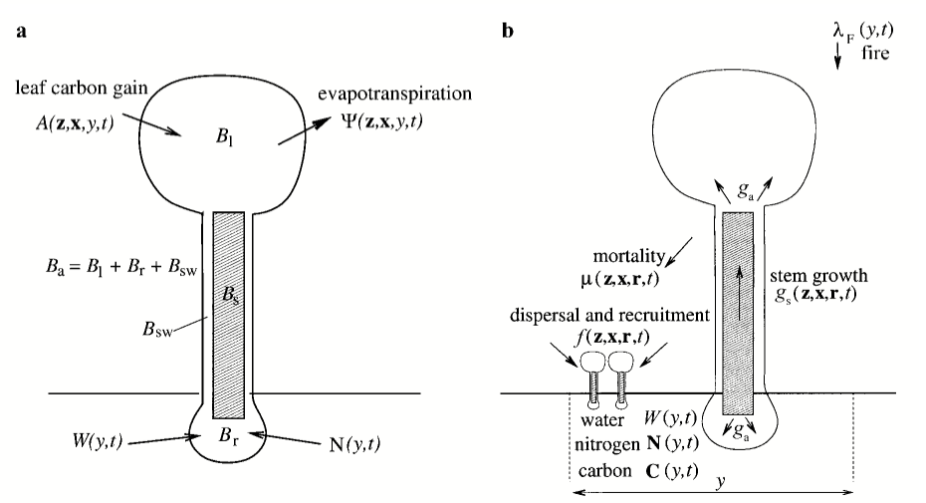

**Figure 38:** Representation of individual-level fluxes within ED2 from Moorcroft et al 2001. Left is the partitioning of carbon and water among tissues (Ba is active tissue, Bs is structural tissue). *y* is the patch and *t* is time, g is growth rate, **x** is the plant functional type, **z** is the size, and **r** is the resources available to the plant. The lambda represents the fire scheme implemented in the original ED version, which we are not using for reasons discussed below.

The Predictive Ecosystem Analyzer: PEcAn

PEcAn provides a common toolbox for working with and analyzing ecosystem models as well as accessible web-based tools for model execution (Lebauer et al. 2013). PEcAn has a workflow for parameterizing new vegetation types by compiling field and literature data to constrain individual model parameters. These data are synthesized within PEcAn in an automated Hierarchical Bayes meta-analysis that estimates each model parameter as a probability distribution (Lebauer et al. 2013). We are running the Ecosystem Demography 2 model through the PEcAn toolbox for four reasons: 1) the PEcAn web interface and associated database creates an accessible archive of results and a reproducible workflow (objective 4F), 2) several climate-scenario downscaling tools already exist within PEcAn, allowing for easier coupling to climate scenarios (objective 4A, C, E), 3) the Hierarchical Bayesian meta-analysis enables developing a cogongrass Plant Functional Type (PFT) by combining the field data from this project with existing literature (objective 4B).

Objective 4A: Southern Pine Forest Under Different Climate Scenarios

One of the advantages of using a model like ED2 is the ability to separate and quantify individual effects (i.e., the effect of just elevated CO2, elevated CO2 by drought or by temperature) on ecosystem responses. In reality, elevated CO2 levels aren’t observed independently from other changes to climate regimes.

The initial set of climate scenarios considered were run at Duke Forest, a southern pine site in North Carolina with flux towers monitoring carbon, water, and energy fluxes from 1997-2008. The Duke forest site co-occurred with the site of a Free-Air CO2 Enrichment (FACE) experiment, which artificially elevated the CO2 concentrations in a pine forest to 200ppm above ambient. This allowed us to ask if ED2 could reproduce real fluxes and ecology both under contemporary conditions and when exposed to elevated CO2. Duke Forest also allowed more direct comparison of findings with other modeling and experimental studies (De Kauwe et al. 2013, Walker and Hanson 2014, Miller, Dietze, DeLucia, et al. 2016).

We began by exploring how climate alone could affect the long-term successional trajectory of southern pine forests. To separate the effects of elevated CO2 from elevated temperatures ED2 was run from 2006-2099 under four separate scenarios: 1) RCP4.5 CO2 concentrations and climate, 2) RCP4.5 climate only, with constant CO2 concentrations, 3) RCP4.5 Elevated CO2 only, with climate randomly selected from 2006-2026, 4) Present Day, made from randomly selected measures of CO2 and radiative forcing from 2006-2026 (Figure 39). We evaluated output for changes in successional trajectory, carbon sequestration, and water use efficiency.

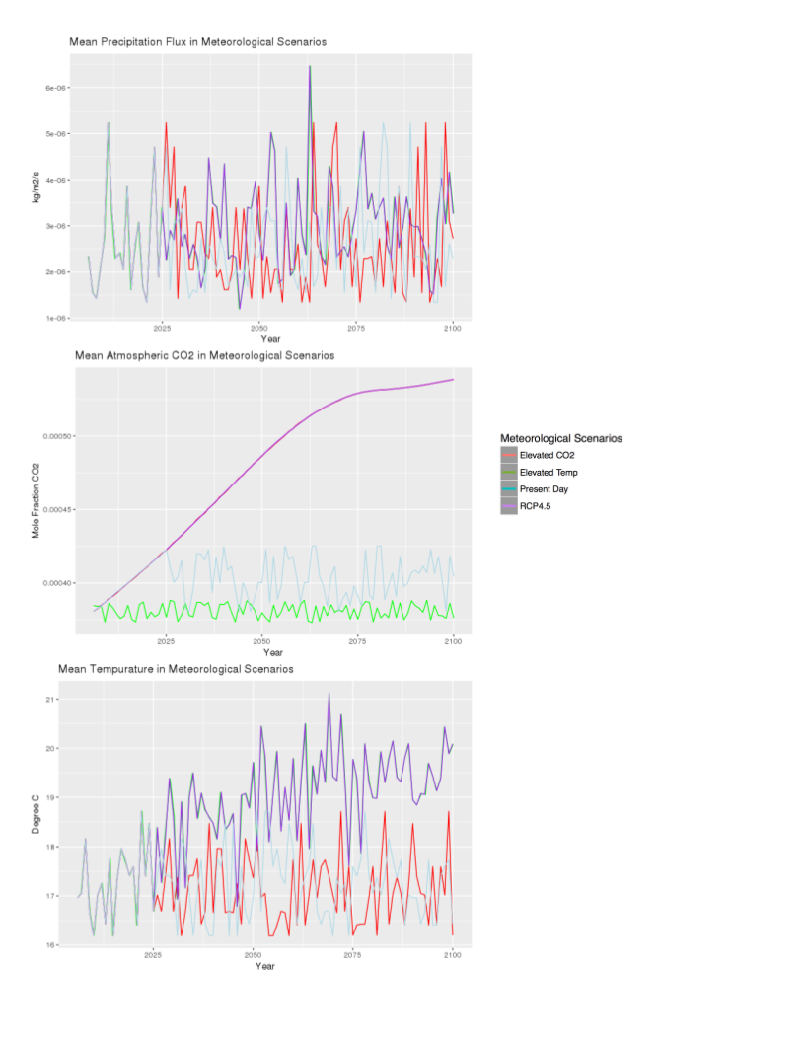

**Figure 39**: Projected meteorological drivers for projections into 2100. With the exception of CO2, all meteorological drivers are identical up until 2026. In the mean precipitation flux and temperature panels, “Elevated Temp” scenarios and “RCP4.5” scenarios are identical, and closely overlaid. In the CO2 panel, “RCP4.5” and “Elevated CO2” are identical. Drivers that are not plotted include: specific humidity, northward and eastward wind, shortwave flux, longwave flux, and air pressure. Meteorology used to drive ED2 is at 3-hour resolution, plotted here with yearly means.

Objectives 4B/4C: Cogongrass Plant Functional Type Development and Analysis

To evaluate the effects of cogongrass on pine ecosystems and tick habitat suitability, we first need to represent cogongrass in ED2. We began our development of the cogongrass PFT by first incorporating our knowledge of a similar PFT developed for a grass from the same family, Poaceae, and with the same photosynthetic strategy (switchgrass; *Panicum virgatum*), into a new PFT that included cogongrass-specific knowledge (LeBauer et al. 2013). We then modeled the cogongrass PFT based upon conditions and field measurements obtained at Avon Park AFR under a range of parameter sets until to identify parameter ranges that produced appropriate levels of biomass that matched field observations.

After this initial tuning, we ran an uncertainty and sensitivity analysis to quantify how uncertainty in different cogongrass traits contributes to uncertainty in state variables including evapotranspiration, net primary production, and biomass. This laid the groundwork for targeted constraint of cogongrass traits using field measurements and existing datasets. The cogongrass uncertainty analysis pointed to a range of different parameters in need of constraint (Figures 46-50; Cogongrass Uncertainty Results Section; objective 4B). Some parameters are constrainable via existing cogongrass datasets or databases (Kattge et al. 2011, Alba et al. 2017). However, both stomatal slope and root respiration were parameters that emerged as relevant to the overall carbon budget of the system (Figures 46, 49, 50). Root respiration is a difficult parameter to constrain because it is often measured in conjunction with soil respiration, and the partitioning between fine roots, rhizosphere, and soil aggregates is ill-defined and difficult to separate physically (Kelting et al. 1998, Kuzyakov 2006).

We conducted a pilot measurement of root respiration in cogongrass by adapting previously developed methods (Makita et al. 2009, Abramoff and Finzi 2016). We sampled root respiration in an old field at the University of Florida Bivens Arm Research Site (BARS) in Gainesville, Florida (29°37′42.4″N, 82°21′14.4″W). In our methodology, we used a LI-COR 6400 to measure CO2 concentrations of root respiration by interrupting the flow through the incoming air stream with a mason jar filled with roots (Figure 40). The roots were excavated from a cogongrass invasion and placed into the jar. After the jar was sealed, and with the LI-COR leaf chamber closed, the LI-COR was matched to a reference level of CO2, and the CO2 concentration of the inflow tube along with temperature and humidity were measured for at least 5 minutes (Figure 40C). Concurrently, a temperature logger was buried at approximately root depth (Figure 40B). After CO2 rates were measured, the roots were weighed for dry biomass. Dry biomass was acquired after drying roots in an oven set to 130 ºC for at least 24 hours. At each sampling, fine roots and rhizomes were measured and weighed separately. Samples were collected from a range of areas at BARS, but still could have been the same clonal population.



**Figure 40**: Preliminary Root Respiration measurement technique using LI-COR 6400

Objectives 4D/4E: Representation of Disturbance and Management in ED2

Southeastern pine forests are fire adapted and experience a range of fire severities, but primarily experience frequent low intensity fires that contribute to maintenance of biodiversity and control carbon fluxes (Kirkman et al. 2004, Mitchell et al. 2006, Starr et al. 2015). As described in Part 2A, cogongrass has significant effects on fire intensity, so capturing fire regime and cogongrass interactions requires a fire model that distinguishes between the understory and overstory, and allows for a mechanistic understanding of fire severity. The fire module currently implemented in ED2 is simple and fully stand-replacing (Figure 38). Previous research has modified ED2 to simulate specific fire effects (e.g., fire effect on bark thickness), but no fully mechanistic fire module has been coupled to ED2 (Trugman et al. 2018). Many candidate fire models (e.g., FARSITE, SPITFIRE) come from a spatially explicit framework (Finney 2004). However, coupling this class of model with ED2 requires translation between the spatially explicit framework of mechanistic fire models and the spatially implicit scaling of ED2 (objective 4D). To facilitate this translation, we developed, tested, and compared to data a method for scaling contagious disturbances in a spatially implicit way. A more complete accounting of the method is available in the paper “*Scaling Contagious Disturbance: A Spatially-Implicit Dynamic Model*”. We used observed disturbance maps for Florida as our test data. We characterized the differences between naturally occurring disturbances (e.g. wildfires) and different forms of management (e.g. prescribed fire, herbicide) across Florida. We summarize our methodology below.

We developed this method in roughly three parts: first, we sought to approximate spatial disturbance by updating a dynamically changing landscape using an evolving adjacency matrix and evolving fractional areas. Second, we validated our approximation against a simulation after 1000 years of growth and disturbance. Our model suggested that two metrics could describe disturbance regimes: the size distribution of disturbances, and the relationship between the size distributions and the ratio of interior edges to total edges of the disturbance shape. Finally, we explored how our derivation’s description of disturbance regimes compared to observations of disturbances in Oregon and Florida. Oregon was chosen as a contrast to Florida because both states have active timber industries and are strongly influenced by fire but have distinct disturbance regimes.

We examined the size distributions and interior to total ratios of all of the disturbances in Florida and Oregon that were in the 2014 LANDFIRE disturbance product. The LANDFIRE disturbance product is a raster of disturbances at 30-by-30 meter resolution for the entire contiguous U.S. We compared the size distributions of disturbance type, U.S. states, and ecoregions using a two-sided Kolmogorov–Smirnov test. For the interior to total ratio, we fit and statistically compared curves corresponding to null models and different hierarchy levels. The curves were fitted using a modified Michaelis-Menten curves of the form $y=\frac{{ax}^{c}}{b+x^{c}}$ using a maximum-likelihood approach assuming Gaussian error. Comparing curves of interior to total ratios meant comparing different hierarchical levels. We fit two hierarchies, one starting at the U.S. state level, and one at the disturbance-type level. In the U.S. state hierarchy, an all-data null model was compared to a model where Oregon and Florida were fit separately. The U.S. state-model was then compared to a model where each ecoregion was fit separately. In the second hierarchy, an all-data null model was compared to a model where each disturbance type was fit separately. The disturbance-model was then compared to a disturbance-by-U.S. state model. Because all single-pixel, double-pixel, and triple-pixel configurations produce the same interior ratio (Figure 54), curves were fit only to disturbances over 3 pixels (0.27 ha) large. To meet requirements of likelihood ratio tests, the data were subset to include only the disturbance types that were common among all ecoregions. To contextualize modeled curves, we included hexagonal density plots, representing the spread and overall shape of all the data used to generate curves (ggplot2, 3.0.0; Wickham et al., 2011). To aid in interpretation, the upper and lower bounds for the interior ratio were also visualized based on calculations of the theoretical minimum (linear disturbance) and maximum (round disturbance) interior ratios for a given disturbance size. All analyses were performed in R version 3.5.0 (R Core Team, 2018) with adjacency calculations performed using the raster package (2.6-7; Hijmans, 2018)

With this framework in place, we are now analyzing the set of available fire models in the broader community and will then couple a selected fire model to ED2.

**Objective 4F: Produce an Interactive Tool for Land Managers to Interactively Explore Effects**

An upcoming task is the development of a decision support tool to enable the exploration of the suite of scenarios considered in our modeling analyses that can affect land management decisions under climate change. This tool will build on existing tools within the PEcAn framework, and in particular will leverage R’s Shiny technology. Because of the time and computation cost of running ED2, the initial version of this tool will focus on exploring the outputs of existing runs, rather than executing new runs in real-time, though PEcAn does already facilitate this through simple, intuitive web- and map-based interfaces.

RESULTS AND DISCUSSION

Objective 4A: Southern Pine Forest Under Different Climate Scenarios

Different meteorological scenarios had different effects on the successional trajectory of forest. The combined elevated CO2 and elevated temperature scenario (equivalent to the RCP4.5 scenario) had the largest gross primary production (Figure 41). Higher growth with higher CO2 concentrations is consistent with a “Carbon dioxide enrichment” hypothesis stating that because C3 photosynthesis becomes more energetically efficient when the atmospheric carbon dioxide levels are higher, C3 plants will be able to uptake more carbon (Ainsworth and Long 2004). The elevated carbon dioxide scenario also assimilated more carbon compared to the other scenarios, but with less dramatic gains. This could be because the combination of elevated CO2 and temperature is metabolically favorable, or because elevated temperatures favor different species with higher carbon uptake potential. The present-day scenario had the smallest gross primary productivity overall but similar gross primary production levels as elevated temperature around year 2099.

To separate causes of differences in scenarios, we plotted gross primary production by temperature (Figure 42). Scenarios with elevated temperatures had peak gross primary productivity at warmer temperatures, but elevated carbon dioxide scenarios had peaks at higher levels of gross primary production (better carbon assimilated to temperature ratio). The elevated temperature scenario had a lower carbon assimilated to temperature ratios than the present-day scenario, but the combined temperature and elevated carbon dioxide scenario had a higher carbon to temperature ratio than just elevated carbon dioxide. This suggests either that there is an interaction between elevated temperatures and elevated carbon dioxide that is not detectable in either of these treatments alone, or a species composition shift.

One potential interaction is a change in water-use-efficiency, where the ratio of carbon gained per water lost during photosynthesis changes as a result of higher atmospheric carbon. Globally, forests could be experiencing an increase in water-use-efficiency due to rising CO2 concentrations (Keenan et al. 2013). Figure 43 shows plots of gross primary production by transpiration. Elevated temperatures use more water, while elevated carbon dioxide levels increase the level of carbon assimilated per unit transpiration. There were differences in water-use-efficiency between scenarios, but those differences don’t explain why the combined RCP4.5 scenario had higher gross primary production levels.

Figure 44 shows the daily leaf area index for Duke Forest. The contribution of deciduous species and coniferous species is visible, and with it you can begin to see changes in species composition. The lower “trend” is the leaf area index of the coniferous species in the winter, and the upper trend is the combination of coniferous species and deciduous species. Figure 45 shows the difference in biomass between the two PFTs formally separated. In Figure 45, it’s clear that different scenarios have different compositional structures. Elevated temperatures increase the biomass of late temperate deciduous trees while decreasing the relative biomass of southern pine. Elevated carbon dioxide has almost the opposite effect, increasing southern pine biomass but not deciduous biomass. The combined scenario, RCP4.5, could have the highest gross primary production because both PFTs increase in biomass. Figure 45 suggests that changes in physiology (like water use efficiency and optimal photosynthetic temperature) need to be evaluated separately for each PFT.

These scenarios are explorations of different climate effects, and not projections of the likely successional trajectory of southeastern US forests. One of the hypotheses of the Free-air concentration enrichment experiment at Duke suggests that while sites experience an initial boost in gross primary production from elevated carbon dioxide levels, it would become limiting as time went on. The Duke Free-air concentration enrichment experiment maintained elevated levels of growth for over 10 years without signs of dramatic nitrogen limitation, but may not have been nitrogen limited (Ellsworth et al. 2012). That hypothesis is consistent with an ED2 experiment by Miller et al., which found that the nitrogen cycle affected the successional trajectory (Miller, Dietze, DeLucia, et al. 2016). In addition, similar model-based explorations of meteorological scenarios by Thomas et al. found that nutrient availability and precipitation levels have a large effect on the carbon cycling of the system (Quinn Thomas et al. 2017). Finally, this area frequently experiences management and fire (Platt et al. 2015, Abatzoglou et al. 2018), so a full projection would require exploration of other RCP scenarios, management, as well as a better accounting of the nitrogen cycle.

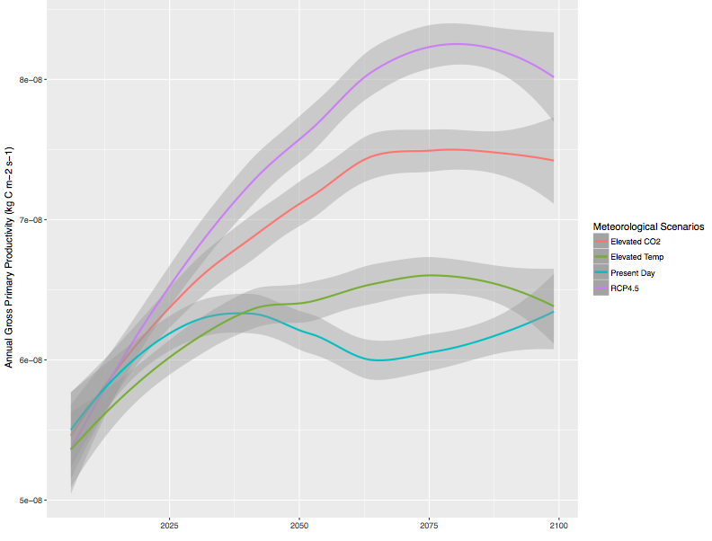

**Figure 41**. Effect of meteorological scenarios on Gross Primary Production in Duke Forest, North Carolina. Fluxes smoothed with ggplot loess function for ease of interpretation (Wickham 2011).

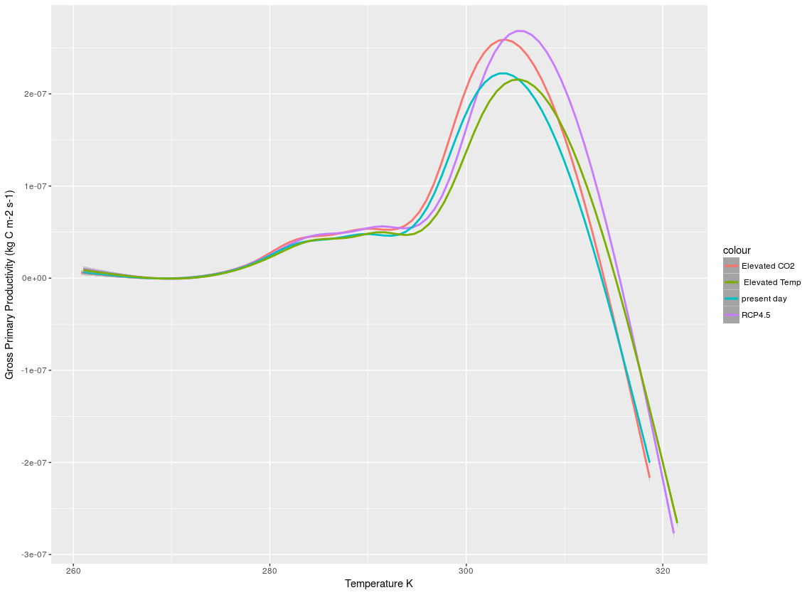

**Figure 42.** Temperature Sensitivity by Meteorological Scenario at Duke Forest.

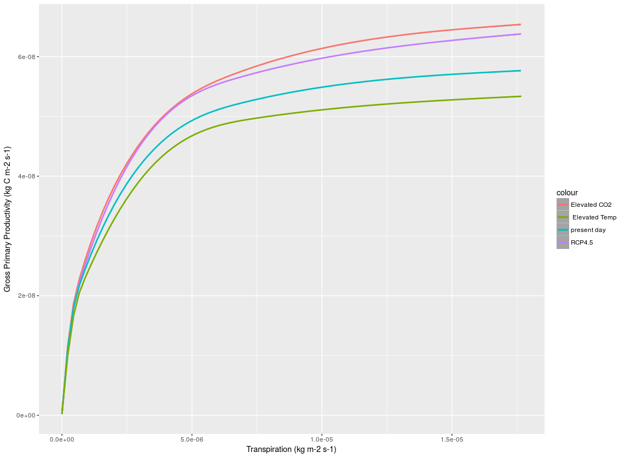

**Figure 43**. Water Use Efficiency by Meteorological Scenario at Duke Forest.

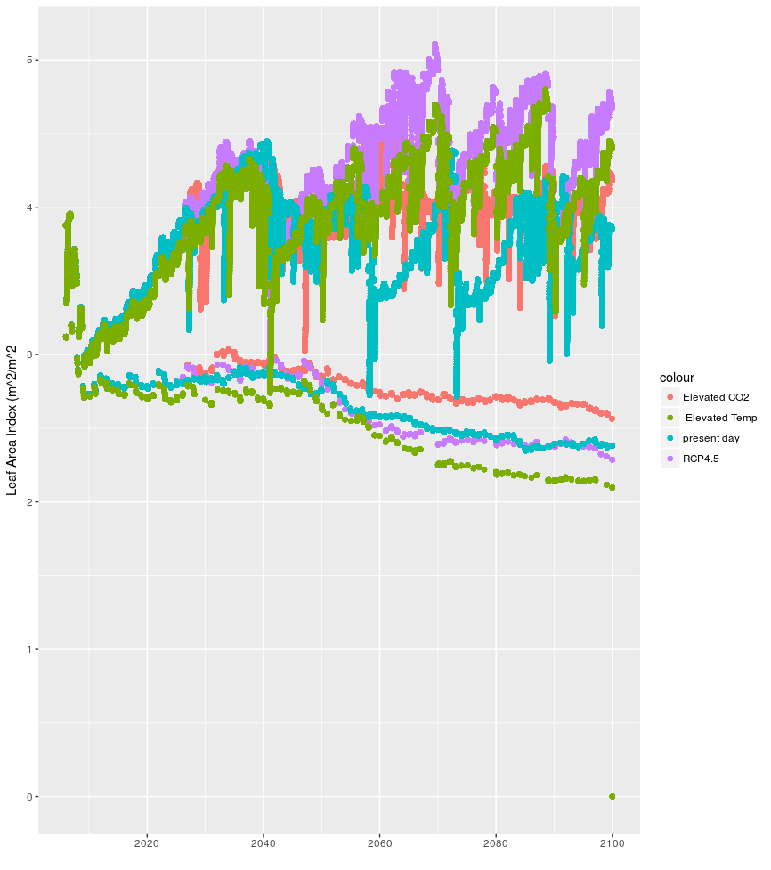

**Figure 44**. Daily Leaf Area Index by Meteorological Scenario.

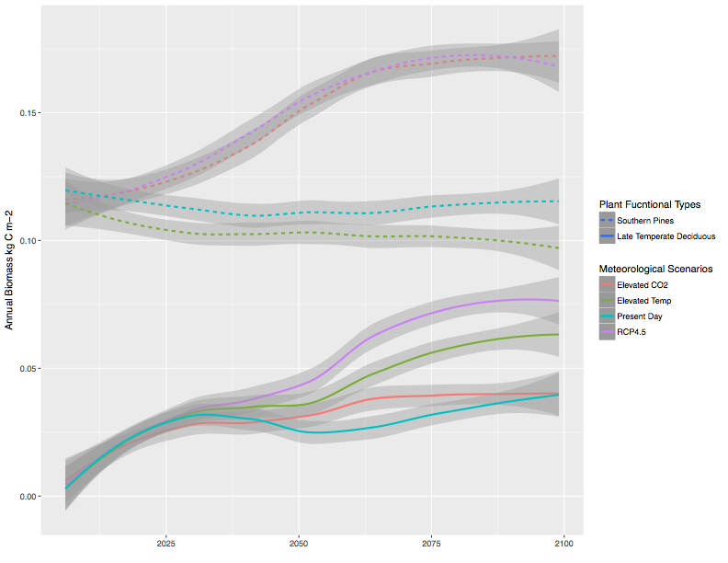

**Figure 45**. Annual Biomass by Meteorological Scenario. Line textures distinguish the two different plant functional types, Late Temperate Deciduous (ie: *Quercus*) and Southern Pines (ie: *Pinus taeda*, *Pinus elliottii*, and *Pinus palustris*). Lines were smoothed using the ggplot loess function (Wickham 2011).

Objectives 4B/4C: Cogongrass Plant Functional Type Development and Analysis

Our uncertainty analysis of the cogongrass plant functional type outlines areas where cogongrass can be constrained. Figures 46-50 all show how either the variance around parameters (rightmost column), or the model’s elastic response to parameters (middle column) combine to contribute to the overall uncertainty in a model variable (the leftmost column). Different parameter uncertainties have different effects depending on the model variable in question. Looking at the uncertainty breakdown for different variables water conductance consistently emerges as the largest source of uncertainty (Figures 46-50). Other visible sources of uncertainty include specific leaf area (Figures 46, 48-50), quantum efficiency (Figures 47 -50), root respiration (Figures 46, 49, 50), stomatal slope (Figures 47-50), and fine root allocation (Figures 47, 50).

Constraining water-conductance directly poses a challenge, because in the current version of ED2 water conductance is a hydraulics term that is not directly analogous to any measurable quantity. Because methods of direct constraint don’t exist for water conductance, we can proceed with two parallel strategies. We can use indirect constraint and we can experiment with adopting a model with a more realistic hydraulic scheme. ED HYDRO is a version of ED developed to better represent hydraulic diversity in PFTs (Xu et al. 2016). Using it would allow for direct measurement of hydraulic parameters, but could come at the cost of uncertainty around other parameters. In a recent presentation by Cowdery et al. (2018), authors examined uncertainty at tropical sites for both ED2 and ED HYDRO. They found that while ED HYDRO was able to reduce hydraulic uncertainty, it could increase the uncertainty around carbon dynamics – particularly belowground (Cowdery et al. 2018). This suggests that pursuing a direct hydraulic calibration requires more constraint on several carbon-sensitive parameters.

In addition, not all of the new parameters introduced by ED HYDRO are analogous to cogongrass. For example, ED HYDRO requires parameters from a xylem vulnerability curve – a curve representing the risk of embolism in the stem/trunk of a plant as pressure increases. For a grass, it is unknown whether risk of embolism strongly dictates hydraulics, or if it does, if this occurs in the xylem or in the root system. Translating ED HYDRO’s parameters to grasses requires care.

The choice between implementing ED HYDRO and constraining carbon also presents a difficult question: If the model of our system can be better only at carbon or water fluxes, which should it be? Moving forward, our emphasis is to constrain carbon parameters that are likely to affect either model, and to explore the feasibility of hydraulic parameter constraint. We began this process in the summer of 2018 with preliminary constraint of root respiration (see below).



**Figure 46**. Variance Decomposition of Net Primary Production in a Cogongrass Stand



**Figure 47**. Variance Decomposition of Gross Primary Production for Cogongrass Stand



**Figure 48**. Variance Decomposition of Transpiration in a Cogongrass Stand



**Figure 49**. Variance Decomposition of Leaf Area Index in a Cogongrass Stand



**Figure 50**. Variance Decomposition of Respiration in Cogongrass Stand

As a trial of the methodology our preliminary fieldwork around root respiration was a success. We were able to answer questions about the feasibility of respiration measurements from attached fine roots (possible for rhizomes, not for fine roots), identify pitfalls in methodology (exposure to sun and heat before respiration measurements can damage the fine roots). We were also able to obtain 31 samples and 25 complete (fine root and rhizome pair) measurements of root respiration. Figure 51 shows two samples with fine-root measurements and rhizomes separated. We have yet to make corrections for changes in temperature and humidity that occurred during the measurement process, and both fluctuated drastically. The general shapes of the graphs of CO2 measured over time vary. In addition, we have some concerns about the signal to noise ratio for small signals – particularly with regard to fine roots, that had consistently smaller biomass amounts. More correction and quality control is required before these measures can be used to constrain ED2 and fulfill our goal to generate a realistic cogongrass PFT (4 B).



**Figure 51**. Examples of CO2 Measurements from two cogongrass root samples taken from BARS

Objectives 4D/4E: Representation of Disturbance and Management in ED2

Our full derivation for representing spatial disturbances in a spatially implicit way is described in McCabe & Dietze (2019). To summarize our results here, we represent a spreading disturbance as a function of its shape, which means it is a function of the probability of a size of the disturbance, and the probability of having a ratio of interior edges to total edges at a specific size (Figure 52). To test the performance of the analytical adjacency approximation, we compared the adjacency matrix predicted by this model to that generated by a fully spatial stochastic simulation. In both the analytical model and stochastic simulation we initiated the landscape from bare ground (age = 0) and ran the model for 1000 years to reach a steady-state (Figure 53). The analytical adjacencies and stochastic adjacencies were similar, although the analytical model over-predicted the adjacency of new disturbances, $A_{0,0}(Figure 53)$. However, the error propagation from $A_{0,0}$ is consistent with having the underlying structure for updating the matrix correctly, because it means that structural elements are preserved as the landscape ages.

When we compared the disturbance type size distributions to one another we found that the majority of disturbance types had significantly distinct distributions (p << 0.001) (Figure 54). The three exceptions were clearcut, wildland fire, and harvest, which had non-significant differences with roughly half of the disturbance classes. Finally, mastication had no significant difference from wildfire or chemical disturbance types.

The disturbance type size distributions for Florida and Oregon were significantly different, as well as for the two ecoregions nested within Oregon (p < 0.001). The two ecoregions size distributions nested within Florida were not found to be significantly different. The size distributions have a large range in sample sizes. U.S. state-level size distributions were based on very large sample sizes (Oregon N = 27,137; Florida N = 20,329). Disturbance sample sizes ranged from harvest with N = 22 to unknown N = 34,560. Unknown disturbances accounted for the majority of disturbance events in the overall dataset, and a large proportion of the area (20%). Disturbance plots show more varied patterns: wildfire and prescribed fire distributions have long tails, reflecting the influence of rare but large disturbances. In contrast, thinning and mastication have distinct peaks and sharper drop-offs, suggesting more standardized anthropogenic disturbances and smaller sizes.

We found a significant effect of U.S. state (p < 0.001) and ecoregion nested within state (p < 0.01). Oregon had a wider range of interior ratios, with a higher occurrence of linear disturbances than Florida (Figure 55). Within Oregon, small disturbances were more compact in Marine West Coast forests than in the Western Cordillera small disturbances, but this relationship crosses, such that Marine West Coast disturbances were less round at large disturbance sizes. The curves fit for the two ecoregions in Florida are nearly identical (Figure 55).

In our second hierarchy, there was a significant effect of disturbance type (p < 0.0001), but not U.S. state nested within disturbance (p > 0.1). Herbicide is the most distinctively linear, followed by other mechanical, and then unknown. Fire disturbance types (prescribed and wildfire) were closer to the maximum interior ratio curve, suggesting that fires tended to be compact and burned pixels were predominantly adjacent to other burned pixels (Figure 56). Disturbance-level curves show that prescribed fires are less compact at smaller and larger sizes than natural fires, but at the most frequent size are similarly shaped. Thinning resembles other compact disturbances, but begins to become more linear at large sizes relative to wildfire. Clearcut follows a similarly compact pattern to wildfire.

We developed a method for taking spreading disturbances and modeling them in a spatially implicit way. In the paper we derived a way to represent spreading disturbances, which performed well against a stochastic simulation (Figure 53). Our derivation suggested that size distributions and ratio of interior to total edges captured how a specific disturbance spread. We were able to use these two sources of information to distinguish between the disturbance regimes of Florida and Oregon, and to distinguish between different disturbance metrics. Florida is influenced by small and large disturbances, and fewer mid-sized disturbances than Oregon. Anthropogenic disturbances tend to spread with different ratios than natural disturbances. This work will allow us to couple existing spreading fire models to ED2 (objective 4D).



**Figure 52.** Adjacency for small disturbances. Edges are labeled as (E)xterior and (I)interior. For size 1, there is 0 probability of self-adjacency (disturbed patches adjacent to other disturbed patches). For size 2 and 3 it is 1/4 and 1/3 respectively, while for size 4 the adjacency is either 1/2 (square configuration) or 3/8 (all other configurations).



**Figure 53**. Comparison between adjacency matrices for a stochastic spatial simulation analytical approximation (top), and analytical approximation where a correction was applied to A00. All adjacency matrices are after 1,000 years (steady state). To the right are difference matrices between the simulation matrix and the two analytical matrices. Age class aggregated into 10-year bins ([0 − 9] = 0, [10 − 19] = 1, etc.) with all patches 100 years or older in bin 10. The 10th column of the error matrices was removed because of a summing to 1 constraint.



**Figure 54**. Size density plots contrasting ecoregion/state and disturbance type. Colored boxes next to disturbance size density curves show what ecoregion contains the respective disturbance.

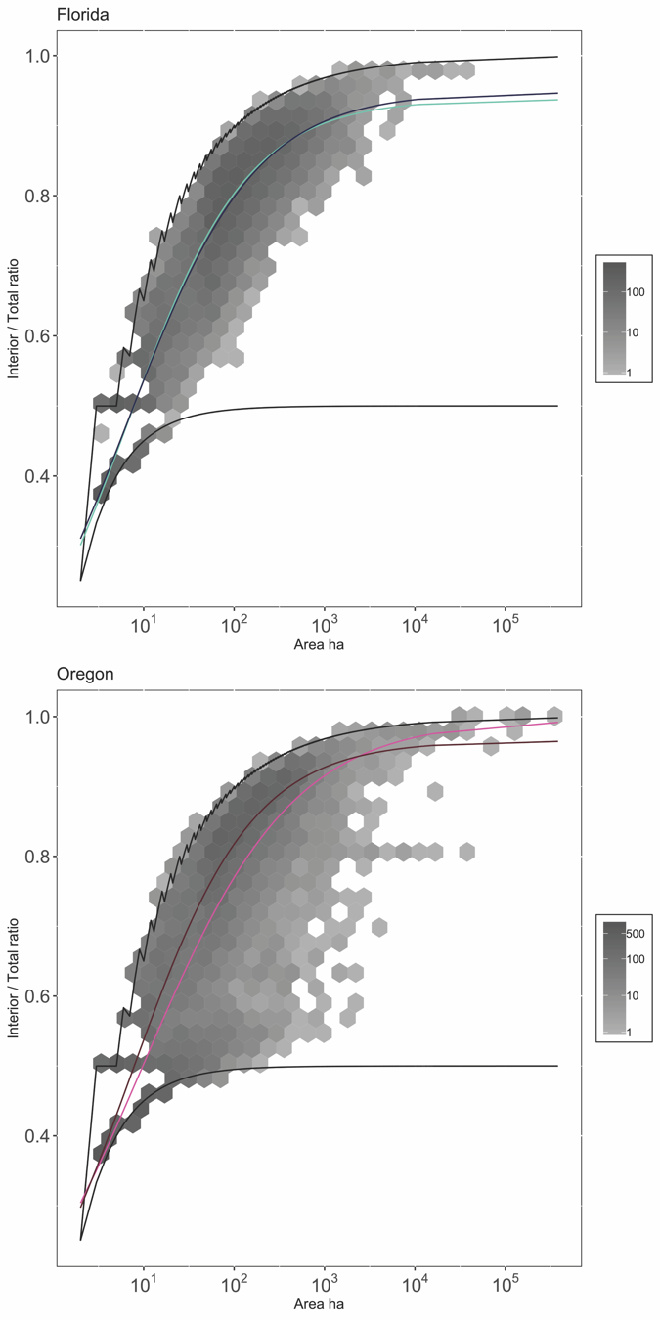

**Figure 55.** Mean trends of ecoregion within State. Gray hexes are binned-counts of number of disturbance events. Black lines are core and linear bounding cases.

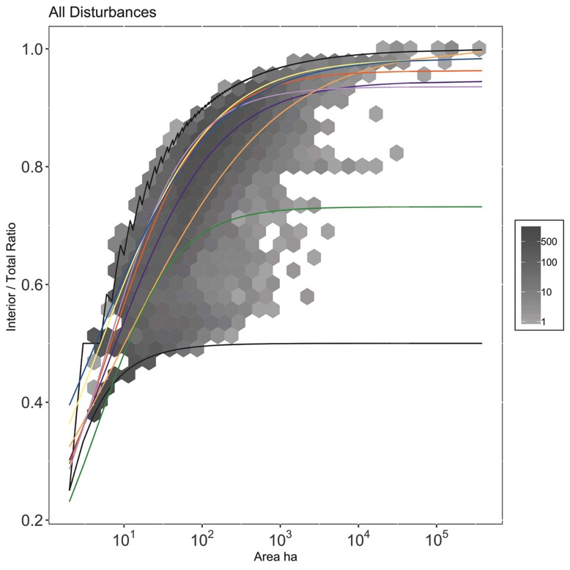

**Figure 56.** Mean trends of disturbance type. Gray hexes are binned-counts of number of disturbance events. Black lines are linear bounding cases.

CONCLUSIONS TO DATE

The overall objective of this research is to investigate the consequences of climate change, including altered fire regimes and plant communities, and their interactions with wildlife, for human risk of exposure to TBDs in the southeastern U.S. Through field surveys conducted in 2017 and 2018 spanning nine DoD installations and 92 sampled plots across a climate gradient, we have investigated the effects of time since fire and cogongrass invasion on tree and shrub cover, understory herbaceous cover and species diversity, ground cover and litter layer, wildlife host abundance, and tick abundance. We find that tree species richness and shrub and sampling density both increase with time since fire, which is consistent with previous research that suggests the maintenance of longleaf pine ecosystems requires frequent application of prescribed fire. Our sampling of understory herbaceous cover and species diversity suggests that percent cover of herbaceous vegetation does not change with time since fire in uninvaded plots, but shows a trend toward increasing over time in invaded plots, though these are limited in our analyses due to active management of cogongrass on DoD installations. Analysis of litter biomass and litter cover indicates that both increase with time since fire in both invaded and uninvaded plots, and litter cover is higher in uninvaded plots. Analysis of host abundance based upon surveys of host dung indicate no relationship with time since fire for all host species surveyed combined. Tick abundances, however, significantly increase with time since fire in both invaded and uninvaded plots, suggesting that abiotic conditions related to fire management, canopy cover, and litter cover are the primary drivers of tick abundance in fire-managed longleaf pine habitats. Our next steps include identifying and sampling more cogongrass-invaded areas since these are limited to-date in our dataset and require additional sampling to tease out effects on, for example, tick abundance and herbaceous cover.

Two major experimental objectives of this research are to more precisely measure the fire characteristics of invasive cogongrass and to determine its direct effects on off-host tick survival. Several studies have previously investigated the effects of cogongrass on fire dynamics. For example, research in Florida sandhill found cogongrass to burn at a maximum temperature of 458 °C with a mean of 260.9 ± 13.7 °C, and native areas burned at a maximum of 318 °C with a mean of 218.3 ± 14.5 °C (Lippincott 2000). However, this research was performed under natural conditions within the context of prescribed burns, which are subject to considerable variation due to environmental conditions. We sought to measure more directly the range and duration of fire temperatures and flame heights across a gradient in cogongrass biomass, the latter of which is particularly relevant to potential longleaf pine mortality. Thus, we developed the fine aboveground biomass incineration organizer (FABIO) as a freestanding, outdoor device to efficiently manipulate fuel structure and assess the effects on fire intensity metrics. These outdoor, small-scale (1 m2), experimental fires allowed for repeated measurements of fire temperatures and flame heights across multiple fuel loads. The maximum temperature recorded during experimental fires of either piled-only or standing-only cogongrass fuels ranged from “near-ambient” temperatures of 40ºC (standing fuel at 0 cm and 50 cm height) to a high of 824ºC (piled fuel at 50 cm). Maximum temperatures were greater with larger fuel loads, and piled fuels generated greater maximum temperatures at lower fuel loads and closer to the ground. Models of maximum temperature showed significant effects of fuel load and fuel structure at 0 and 25 cm, but only fuel load was significant at 50 cm.

Additionally, ongoing is an experiment to determine the effects of cogongrass invasion on the off-host survival of *A. americanum*. To assess the effects of cogongrass invasion on tick survival, a total of 12 invaded and 12 uninvaded plots were established and at the center of each plot, mesh bags were deployed containing 10 nymph, 5 female adult, and 5 male adult life stage ticks. After 264 days, 63% of adult ticks were alive in the cogongrass invasion with only 3% surviving in the uninvaded area. Relative humidity was substantially higher in the invasion compared to adjacent native plant communities. In the absence of other causes of mortality ticks die due to desiccation, so the higher relative humidity likely is the critical mechanism by which cogongrass invasion is extending tick survival time. While this experiment is ongoing, a recent burst of tick mortality (as of March 26th, 2019) indicates the majority of the remaining ticks will soon succumb to desiccation. These data indicate already an extraordinary effect of cogongrass in extending tick survival relative to native vegetation.

To assess the prevalence of a diversity of tick-borne pathogens and other microbes (collectively termed “tick-borne agents”), we have developed an NGS protocol using the Fluidigm Access Array system. Thus far we have analyzed 466 ticks collected as part of the field surveys across DoD installations in 2017 and 2018, and have identified the presence of numerous pathogens, including the causative agents in humans of anaplasmosis, ehrlichiosis, and spotted fever rickettsiosis. Using the NGS approach, thus far we have identified DNA from 23 unique TBAs in these field-collected ticks: 16 to species, four to genus, and three which best matched to known sequences with 97% - 98.9% identity were designated as “-like” the closest species. Extractions and analysis of DNA from ticks collected in 2017 and 2018 is ongoing, and additional ticks collected as part of field surveys in field season 2019 will be subjected to the same assays described above. Collectively this will generate a robust dataset across which to analyze the effects of time since fire and fire return interval, plant invasions, wildlife host densities, and climate, on the density of ticks, tick infection rates, and their product, the density of infected ticks. Together these dependent variables represent entomological estimates of disease risk, and the precise identification of a diversity of TBAs will create an unprecedented knowledge of tick-borne disease risk for military installations in the southeastern U.S.

Through our development of a spatially explicit model, ED2, we are taking advantage of southeastern DoD sites as an ecological system that have several interesting interacting dynamics. In our field sampling and experimental sections we have outlined how we are refining our understanding of how these dynamics behave under current climate conditions. By translating our experimental understanding into a model, we hope to forecast how this system will behave under future climate scenarios. With this wider goal in mind we have been building and validating a model that can capture the interaction between successional changes, cogongrass, and fire that can be used to explore different scenarios. Using the ED2 model, we laid out a theoretical derivation for spatially implicit scaling of disturbances, and explore the descriptive capacity of metrics that emerge from our derivation. We found that we were able to capture how different spread probabilities alter a landscape, and could update adjacency dynamically with new disturbances and stand age. We note the implications of this technique apply widely to multiple problems in scaling through the improvement of ecosystem models, development of null models and characterization of disturbance regimes. This lays the groundwork for coupling existing fire models to the ED2 model, as well as opening up fire models to computationally efficient, spatially implicit frameworks. Next steps in this research include a further calibration of a cogongrass PFT based upon field-collected and previously published data, and incorporate ticks and TBAs as outputs from the model.

Literature Cited

**Abatzoglou, J. T., A. P. Williams, L. Boschetti, M. Zubkova, and C. A. Kolden**. **2018**. Global patterns of interannual climate-fire relationships. Global Change Biology.

**Abramoff, R. Z., and A. C. Finzi**. **2016**. Seasonality and partitioning of Root allocation to rhizosphere soils in a midlatitude forest. Ecosphere. 7.

**Ainsworth, E. A., and S. P. Long**. **2004**. What have we learned from 15 years of free-air CO2 enrichment (FACE)? A meta-analytic review of the responses of photosynthesis, canopy properties and plant production to rising CO2. New Phytologist. 165: 351–372.

**Alba, C., J. E. NeSmith, C. Fahey, C. Angelini, and S. L. Flory**. **2017**. Methods to test the interactive effects of drought and plant invasion on ecosystem structure and function using complementary common garden and field experiments. Ecology and Evolution. 7: 1442–1452.

**Allan, S.A., L.A. Simmons and M.J. Burridge. 2001.** Ixodid ticks on white-tailed deer and feral swine in Florida. Journal of Vector Ecology 26(1): 93-102.

**Allan, B.F. 2009.** Influence of prescribed burns on the abundance of Amblyomma americanum (Acari: Ixodidae) in the Missouri Ozarks. Journal of Medical Entomology 46:1030-1036.

**Allan, B.F., H.P. Dutra, L.S. Goessling, K. Barnett, J.M. Chase, R.J. Marquis, G.C. Pang, G.A. Storch, R.E. Thach and J.L. Orrock. 2010a.** Invasive honeysuckle eradication reduces tick-borne disease risk by altering host dynamics. Proceedings of the National Academy of Sciences 107:18523-18527.

**Allan, B.F., L.S. Goessling, G.A. Storch and R.E. Thach. 2010b.** Blood meal analysis to identify reservoir hosts for *Amblyomma americanum* ticks. Emerging Infectious Diseases 16: 433-440.

**Anderson, H. E. 1982.** Aids to determining fuel models for estimating fire behavior (No. INT- GTR-122). Ogden, UT: U.S. Department of Agriculture, Forest Service, Intermountain Forest and Range Experiment Station. Retrieved from https://www.fs.usda.gov/treesearch/pubs/6447

**Berggoetz, M., M. Schmida, D. Stona, V. Wyssa, C. Chevillonb, A.-M. Pretoriusc, L. Gern. 2014.** Tick-borne pathogens in the blood of wild and domestic ungulates in South Africa: interplay of game and livestock. Ticks & Tick-Borne Diseases 5: 166–175.

**Bolger, A. M., Lohse, M., & Usadel, B. 2014.** Trimmomatic: a flexible trimmer for Illumina sequence data. *Bioinformatics*, 30: 2114-2120.

**Bova, A. S., and M. B. Dickinson**. **2008**. Beyond “fire temperatures”: calibrating thermocouple probes and modeling their response to surface fires in hardwood fuels. Canadian Journal of Forest Research. 38: 1008–1020.

**Bowman, D. M. J. S., C. Haverkamp, K. D. Rann, and L. D. Prior**. **2017**. Differential demographic filtering by surface fires: How fuel type and fuel load affect sapling mortality of an obligate seeder savanna tree. Journal of Ecology. 1–13.

**Boyer, W. D.** **1990**. Pinus palustris Mill. Silvics of North America. 1: 405–412.

**Brewer, S.** **2008**. Declines in plant species richness and endemic plant species in longleaf pine savannas invaded by Imperata cylindrica.

**Burger, N., & Bond, W. J. 2015.** Flammability traits of Cape shrubland species with different post-fire recruitment strategies. *South African Journal of Botany*, 101: 40–48.

**Chapman, H. H.** **1932**. Is the Longleaf Type a Climax? Ecology. 13: 328–334.

**Childs, J.E., and C.D. Paddock. 2003.** The ascendancy of *Amblyomma americanum* as a vector of pathogens affecting humans in the United States. Annual Review of Entomology 48: 307-37.

**Christensen, N. L.** **1981**. Fire regimes in southeastern ecosystems, pp. 112–136. *In* Fire Regimes and Ecosystem Properties.

**Cowdery, E., Meunier, F., Xu, X., Dietze, M. C.** 2018. The Downside of Detail: Quantifying the Uncertainty Surrounding the Implementation of a Mechanistic Plant Hydraulic Module in a Dynamic Vegetation Model. Annual Meeting of American Geophysical Union. Poster Presentation. Washington, District of Columbia.

**Cribari-Neto, F., and A. Zeileis**. **2010**. Beta Regression in R. Journal of Statistical Software. 34: 1–24.

**Cruz, M. G., and P. M. Fernandes**. **2008**. Development of fuel models for fire behaviour prediction in maritime pine (Pinus pinaster Ait.) stands. Int. J. Wildland Fire. 17: 194–204.

**Davidson, W. R., D. A. Siefken, and L. H. Creekmore**. **1994a**. Seasonal and annual abundance of *Amblyomma americanum* (Acari: Ixodidae) in central Georgia. Journal of medical entomology. 31: 67–71.

**Davidson, W. R., Siefken, D. A., & Creekmore, L. H. 1994b.** Influence of annual and biennial prescribed burning during March on the abundance of Amblyomma americanum (Acari: Ixodidae) in central Georgia. *Journal of medical entomology*, 31: 72-81.

**DeBano, L. F., DeBano, L. F., Neary, D. G., Ffolliott, P. F., 1998.** *Fire effects on ecosystems*. John Wiley & Sons.

**Demma, L.J., R.C. Holman, J.H. McQuiston, J.W. Krebs and D.L. Swerdlow. 2005.** Epidemiology of Human Ehrlichiosis and Anaplasmosis in the United States, 2001-2002. American Journal of Tropical Medicine and Hygiene 73:400-9.

**Ellsworth, D. S., R. Thomas, K. Y. Crous, S. Palmroth, E. Ward, C. Maier, E. Delucia, and R. Oren**. **2012**. Elevated CO 2 affects photosynthetic responses in canopy pine and subcanopy deciduous trees over 10 years: A synthesis from Duke FACE. Global Change Biology. 18: 223–242.

**Engstrom, J. D., Butler, J. K., Smith, S. G., Baxter, L. L., Fletcher, T. H., & Weise, D. R. 2004.** Ignition behavior of live California chaparral leaves. *Combustion Science and Technology*, 176: 1577–1591.

**Enloe, S. F., N. J. Loewenstein, D. W. Held, L. Eckhardt, and D. K. Lauer**. **2013**. Impacts of Prescribed Fire, Glyphosate, and Seeding on Cogongrass, Species Richness, and Species Diversity in Longleaf Pine. Invasive Plant Science and Management. 6: 536–544.

**Etlinger, M. G., & Beall, F. C. 2004.** Development of a laboratory protocol for fire performance of landscape plants. *International Journal of Wildland Fire*, 13: 479.

**Fernandes, P. M., and M. G. Cruz**. **2012**. Plant flammability experiments offer limited insight into vegetation-fire dynamics interactions. New Phytologist. 194: 606–609.

**Ferrari, S., and F. Cribari-Neto**. **2004**. Beta Regression for Modelling Rates and Proportions. Journal of Applied Statistics. 31: 799–815.

**Finney, M. A.** **2004**. FARSITE : Fire Area Simulator — Model Development and Evaluation, USDA Forest Service.

**Fisher, R. A., C. D. Koven, W. R. L. Anderegg, B. O. Christoffersen, M. C. Dietze, C. E. Farrior, J. A. Holm, G. C. Hurtt, R. G. Knox, P. J. Lawrence, J. W. Lichstein, M. Longo, A. M. Matheny, D. Medvigy, H. C. Muller-Landau, T. L. Powell, S. P. Serbin, H. Sato, J. K. Shuman, B. Smith, A. T. Trugman, T. Viskari, H. Verbeeck, E. Weng, C. Xu, X. Xu, T. Zhang, and P. R. Moorcroft**. **2018**. Vegetation demographics in Earth System Models: A review of progress and priorities. Global Change Biology.

**Flory, S. L., K. Clay, S. M. Emery, J. R. Robb, and B. Winters**. **2015**. Fire and non-native grass invasion interact to suppress tree regeneration in temperate deciduous forests. Journal of Applied Ecology. 52: 992–1000.

**Frost, C.** **2007**. History and Future of the Longleaf Pine Ecosystem, Springer series on environmental management. Springer, New York.

**Ganteaume, A., Jappiot, M., Curt, T., Lampin, C., & Borgniet, L. 2014.** Flammability of litter sampled according to two different methods: comparison of results in laboratory experiments. *International Journal of Wildland Fire*, 23: 1061–1075.

**Gill, A. M., & Zylstra, P. 2005.** Flammability of Australian forests. *Australian Forestry*, 68: 87–93.

**Gleim, E. R., L. M. Conner, R. D. Berghaus, M. L. Levin, G. E. Zemtsova, and M. J. Yabsley**. **2014**. The Phenology of Ticks and the Effects of Long-Term Prescribed Burning on Tick Population Dynamics in Southwestern Georgia and Northwestern Florida. PLoS ONE. 9: e112174.

**Hair, J. A., J. R. Sauer, and K. A. Durham**. **1975**. Water Balance and Humidity Preference in Three Species of Ticks1. Journal of Medical Entomology. 12: 37–47.

**Hijmans, R. J.,** 2019. raster: Geographic Data Analysis and Modeling. R package version 2.9 -23. https://CRAN.R-project.org/package=raste**r**

**Holm, L. G., D. L. Plucknett, J. V. Pancho, and J. P. Herberger**. **1977**. The world’s worst weeds. Distribution and biology. University press of Hawaii.

**Holzmueller, E. J., and S. Jose**. **2012**. Response of the invasive grass imperata cylindrica to disturbance in the southeastern forests, USA. Forests. 3: 853–863.

**Jado, I., Escudero, R., Gil, H., Jiménez-Alonso, M. I., Sousa, R., García-Pérez, A. L., ... & Anda, P. 2006.** Molecular method for identification of Rickettsia species in clinical and environmental samples. Journal of Clinical Microbiology, 44: 4572-4576.

**Jaureguiberry, P., Bertone, G., & Díaz, S. 2011.** Device for the standard measurement of shoot flammability in the field. *Austral Ecology*, 36: 821–829.

**Kattge, J., S. Díaz, S. Lavorel, I. C. Prentice, P. Leadley, G. Bönisch, E. Garnier, M. Westoby, P. B. Reich, I. J. Wright, J. H. C. Cornelissen, C. Violle, S. P. Harrison, P. M. Van Bodegom, M. Reichstein, B. J. Enquist, N. A. Soudzilovskaia, D. D. Ackerly, M. Anand, O. Atkin, M. Bahn, T. R. Baker, D. Baldocchi, R. Bekker, C. C. Blanco, B. Blonder, W. J. Bond, R. Bradstock, D. E. Bunker, F. Casanoves, J. Cavender-Bares, J. Q. Chambers, F. S. Chapin Iii, J. Chave, D. Coomes, W. K. Cornwell, J. M. Craine, B. H. Dobrin, L. Duarte, W. Durka, J. Elser, G. Esser, M. Estiarte, W. F. Fagan, J. Fang, F. Fernández-Méndez, A. Fidelis, B. Finegan, O. Flores, H. Ford, D. Frank, G. T. Freschet, N. M. Fyllas, R. V. Gallagher, W. A. Green, A. G. Gutierrez, T. Hickler, S. I. Higgins, J. G. Hodgson, A. Jalili, S. Jansen, C. A. Joly, A. J. Kerkhoff, D. Kirkup, K. Kitajima, M. Kleyer, S. Klotz, J. M. H. Knops, K. Kramer, I. Kühn, H. Kurokawa, D. Laughlin, T. D. Lee, M. Leishman, F. Lens, T. Lenz, S. L. Lewis, J. Lloyd, J. Llusià, F. Louault, S. Ma, M. D. Mahecha, P. Manning, T. Massad, B. E. Medlyn, J. Messier, A. T. Moles, S. C. Müller, K. Nadrowski, S. Naeem, Ü. Niinemets, S. Nöllert, A. Nüske, R. Ogaya, J. Oleksyn, V. G. Onipchenko, Y. Onoda, J. Ordoñez, G. Overbeck, W. A. Ozinga, S. Patiño, S. Paula, J. G. Pausas, J. Peñuelas, O. L. Phillips, V. Pillar, H. Poorter, L. Poorter, P. Poschlod, A. Prinzing, R. Proulx, A. Rammig, S. Reinsch, B. Reu, L. Sack, B. Salgado-Negret, J. Sardans, S. Shiodera, B. Shipley, A. Siefert, E. Sosinski, J.-F. Soussana, E. Swaine, N. Swenson, K. Thompson, P. Thornton, M. Waldram, E. Weiher, M. White, S. White, S. J. Wright, B. Yguel, S. Zaehle, A. E. Zanne, and C. Wirth**. **2011**. TRY - a global database of plant traits. Global Change Biology. 17: 2905–2935.

**De Kauwe, M. G., B. E. Medlyn, S. Zaehle, A. P. Walker, M. C. Dietze, T. Hickler, A. K. Jain, Y. Luo, W. J. Parton, I. C. Prentice, B. Smith, P. E. Thornton, S. Wang, Y. P. Wang, D. Wårlind, E. Weng, K. Y. Crous, D. S. Ellsworth, P. J. Hanson, H.- Seok Kim, J. M. Warren, R. Oren, and R. J. Norby**. **2013**. Forest water use and water use efficiency at elevated CO2: A model-data intercomparison at two contrasting temperate forest FACE sites. Global Change Biology. 19: 1759–1779.

**Keenan, T. F., D. Y. Hollinger, G. Bohrer, D. Dragoni, J. W. Munger, H. P. Schmid, and A. D. Richardson**. **2013**. Increase in forest water-use efficiency as atmospheric carbon dioxide concentrations rise. Nature. 499: 324–327.

**Keesing, F., R.S. Ostfeld, S. Okanga, S. Huckett, B.R. Bayles, R. Chaplin-Kramer, L.P. Fredericks, T. Hedlund, V. Kowal, H. Tallis, C.M. Warui, S.A. Wood and B.F. Allan. 2018.** Consequences of integrating livestock and wildlife in an African savanna. Nature Sustainability 1: 566-573.

**Keeley, J. E. 2009.** Fire intensity, fire severity and burn severity: a brief review and suggested usage. *International Journal of Wildland Fire*, 18: 116-126.

**Kelting, D. L., J. A. Burger, and G. S. Edwards**. **1998**. Estimating root respiration, microbial respiration in the rhizosphere, and root-free soil respiration in forest soils. Soil Biology and Biochemistry.

**Kensinger, B.J. and B.F. Allan. 2011.** Efficacy of dry-ice baited traps for sampling Amblyomma americanum (Acari: Ixodidae) varies with life-stage but not habitat. Journal of Medical Entomology 48: 708-711.

**Kirkman, L. K., P. C. Goebel, B. J. Palik, and L. T. West**. **2004**. Predicting plant species diversity in a longleaf pine landscape. Ecoscience.

**Kirkman, L. K., R. J. Mitchell, R. C. Helton, and M. B. Drew**. **2001**. Productivity and species richness across an environmental gradient in a fire-dependent ecosystem. American Journal of Botany. 88: 2119–2128.

**Kolaks, J. J., B. E. Cutter, E. F. Loewenstein, K. W. Grabner, G. Hartman, and J. M. Kabrick**. **2004**. Evaluation of passive flame height sensors for the central hardwoods region. In: Yaussy, Daniel A.; Hix, David M.; Long, Robert P.; Goebel, P. Charles, Eds. Proceedings, 14th Central Hardwood Forest Conference; 2004 March 16-19; Wooster, OH. Gen. Tech. Rep. NE-316. Newtown Square, PA: US Department of Agriculture, Forest Service, Northeastern Research Station: 520.

**Kuzyakov, Y.** **2006**. Sources of CO2 efflux from soil and review of partitioning methods. Soil Biology and Biochemistry.

**Lebauer, D. S., D. Wang, K. T. Richter, C. C. Davidson, and M. C. Dietze**. **2013**. Facilitating feedbacks between field measurements and ecosystem models Facilitating feedbacks between field measurem and ecosystem models. Source: Ecological Monographs Ecological Monographs. 83: 133–154.

**Lippincott, C. L.** **2000**. Effects of Imperata cylindrica(L.) Beauv.(Cogongrass) Invasion on Fire Regime in Florida Sandhill(USA). Natural Areas Journal. 20: 140–149.

**Loudermilk, E. L., Achtemeier, G. L., O’brien, J. J., Hiers, J. K., & Hornsby, B. S. 2014.** High-resolution observations of combustion in heterogeneous surface fuels. *International Journal of Wildland Fire*, 23: 1016–1026.

**Loudermilk, E. L., O’Brien, J. J., Mitchell, R. J., Cropper, W. P., Hiers, J. K., Grunwald, S., Fernandez-Diaz, J. C. 2012.** Linking complex forest fuel structure and fire behaviour at fine scales. *International Journal of Wildland Fire*, 21: 882–893.

**MacDonald, G. E.** **2004**. Cogongrass ( *Imperata cylindrica* )—Biology, Ecology, and Management. Critical Reviews in Plant Sciences. 23: 367–380.

**Makita, N., Y. Hirano, M. Dannoura, Y. Kominami, T. Mizoguchi, H. Ishii, and Y. Kanazawa**. **2009**. Fine root morphological traits determine variation in root respiration of Quercus serrata. Tree Physiology. 29: 579–585.

**Matlack, G. R.** **2002**. Exotic plant species in Mississippi, USA: Critical issues in management and research. Natural Areas Journal. 22: 241–247.

**McCabe, T. D., & Dietze, M. C.** 2019. Scaling Contagious Disturbance: A Spatially-Implicit Dynamic Model. Frontiers in Ecology and Evolution, 1–17.

**Medvigy, D. M.** **2006**. The state of the regional carbon cycle: results from a constrained coupled ecosystem-atmosphere model.

**Medvigy, D., S. C. Wofsy, J. W. Munger, D. Y. Hollinger, and P. R. Moorcroft**. **2009**. Mechanistic scaling of ecosystem function and dynamics in space and time: Ecosystem Demography model version 2. Journal of Geophysical Research. 114: G01002.

**Miller, A. D., M. C. Dietze, E. H. Delucia, and K. J. Anderson-Teixeira**. **2016**. Alteration of forest succession and carbon cycling under elevated CO2. Global Change Biology. 22: 351–363.

**Mitchell, R. J., J. K. Hiers, J. J. O’Brien, S. B. Jack, and R. T. Engstrom**. **2006**. Silviculture that sustains: the nexus between silviculture, frequent prescribed fire, and conservation of biodiversity in longleaf pine forests of the southeastern United States. Canadian Journal of Forest Research.

**Mixson, T.R., S.R. Campbell, J.S. Gill, H.S. Ginsberg, M.V. Reichard, T.L. Schulze, and G.A. Dasch. 2006.** Prevalence of Ehrlichia, Borrelia, and Rickettsial agents in *Amblyomma americanum* (Acari: Ixodidae) collected from nine states. *Journal of medical entomology*, 43: 1261-1268.

**Moorcroft, P. R., G. C. Hurtt, and S. W. Pacala**. **2001**. A method for scaling vegetation dynamics: The ecosystem demography model (ED). Ecological Monographs. 71: 557–586.

**Noss, R. F., E. T. LaRoe, and J. M. Scott**. **1995**. Endangered ecosystems of the United States: a preliminary assessment of loss and degradation. US Department of the Interior, National Biological Service Washington, DC, USA.

**Oswald, B.P. and the Association for Fire Ecology. 2007.** San Diego Declaration on climate change and fire management: ramifications for fuels management. In: Butler, B.W. and W. Cook, Comps. the fire environment innovations, management, and policy conference proceeding. 26-30 March 2007, Destin, FL.

**Pausas, J. G., & Moreira, B. 2012.** Flammability as a biological concept. *New Phytologist*, *194:* 610–613.

**Platt, W. J., and R. M. Gottschalk**. **2001**. Effects of exotic grasses on potential fine fuel loads in the groundcover of south Florida slash pine savannas. International Journal of Wildland Fire. 10: 155–159.

**Platt, W. J., S. L. Orzell, and M. G. Slocum**. **2015**. Seasonality of fire weather strongly influences fire regimes in south Florida savanna-grassland landscapes. PLoS ONE. 10: e0116952.

**Pritt, B. S., Allerdice, M. E., Sloan, L. M., Paddock, C. D., Munderloh, U. G., Rikihisa, Y., ... & Schiffman, E. 2017.** Proposal to reclassify Ehrlichia muris as Ehrlichia muris subsp. muris subsp. nov. and description of Ehrlichia muris subsp. eauclairensis subsp. nov., a newly recognized tick-borne pathogen of humans. International Journal of Systematic and Evolutionary Microbiology, 67: 2121.

**Quinn Thomas, R., E. B. Brooks, A. L. Jersild, E. J. Ward, R. H. Wynne, T. J. Albaugh, H. Dinon-Aldridge, H. E. Burkhart, J. C. Domec, T. R. Fox, C. A. Gonzalez-Benecke, T. A. Martin, A. Noormets, D. A. Sampson, and R. O. Teskey**. **2017**. Leveraging 35 years of Pinus taeda research in the southeastern US to constrain forest carbon cycle predictions: Regional data assimilation using ecosystem experiments. Biogeosciences. 14: 3525–3547.

**R Core Team**. **2018**. R: A Language and Environment for Statistical Computing. R Foundation for Statistical Computing, Vienna, Austria.

**Rognes, T., Flouri, T., Nichols, B., Quince, C., & Mahé, F. 2016.** VSEARCH: a versatile open source tool for metagenomics. *PeerJ*, *4*, e2584.

**Ryan, K. C.** **1981**. Evaluation of a passive flame-height sensor to estimate forest fire intensity. United States Department of Agriculture, Portland, OR.

**Sajise, P. E.** **1973**. Evaluation of cogon (Imperata cylindrica (L.) Beauv.) as a serial stage in Philippine vegetational succession: I. The cogonal serial stage and plant succession. II. Autecological studies on cogon.

**Scholze, M., W. Knorr, N. Arnell and I.C. Prentice. 2006.** A climate-change risk analysis for world ecosystems. Proceedings of the National Academy 103:13116-20.

**Schwartz, J. J., A. Gazumyan, and I. Schwartz. 1992.** rRNA gene organization in the Lyme disease spirochete, Borrelia burgdorferi. J. Bacteriol. 174: 3757–3765.

**Schwilk, D. W. 2003.** Flammability Is a Niche Construction Trait: Canopy Architecture Affects Fire Intensity. *The American Naturalist*, 162*:* 725–733.

**Simpson, K. J., Ripley, B. S., Christin, P. A., Belcher, C. M., Lehmann, C. E., Thomas, G. H., & Osborne, C. P. 2016.** Determinants of flammability in savanna grass species. *Journal of Ecology*, 104: 138-148.

**Starr, G., C. L. Staudhammer, H. W. Loescher, R. Mitchell, A. Whelan, J. K. Hiers, and J. J. O’Brien**. **2015**. Time series analysis of forest carbon dynamics: recovery of Pinus palustris physiology following a prescribed fire. New Forests. 46: 63–90.

**Stromdahl, E. Y., J. Jiang, M. Vince and A. L. Richards. 2011.** Infrequency of Rickettsia rickettsii in Dermacentor variabilis Removed from Humans, with Comments on the Role of Other Human-Biting Ticks Associated with Spotted Fever Group Rickettsiae in the United States. Vector-Borne and Zoonotic Diseases 11:969-977.

**Thaxton, J. M., & Platt, W. J. 2006.** Small‐scale fuel variation alters fire intensity and shrub abundance in a pine savanna. *Ecology*, 87: 1331-1337.

**Thornton, P.E., M.M. Thornton, B.W. Mayer, Y. Wei, R. Devarakonda, R.S. Vose, and R.B. Cook. 2016.** Daymet: Daily Surface Weather Data on a 1-km Grid for North America, Version 3. ORNL DAAC, Oak Ridge, Tennessee, USA. https://doi.org/10.3334/ORNLDAAC/1328

**Trugman, A. T., D. Medvigy, W. A. Hoffmann, and F. A. Pellegrini**. **2018**. Sensitivity of woody carbon stocks to bark investment strategy in Neotropical savannas and forests. Biogeosciences.

**Varner, J. M., J. K. Hiers, R. D. Ottmar, D. R. Gordon, F. E. Putz, and D. D. Wade**. **2007**. Overstory tree mortality resulting from reintroducing fire to long-unburned longleaf pine forests: the importance of duff moisture. Canadian Journal of Forest Research. 37: 1349–1358.

**Varner, J. M., J. M. Kane, J. K. Kreye, and E. Engber**. **2015**. The Flammability of Forest and Woodland Litter: a Synthesis. Current Forestry Reports. 1: 91–99.

**Wade, D. D., J. D. Lunsford, M. J. Dixon, and H. E. Mobley**. **1989**. A guide for prescribed fire in southern forests. Technical publication R8-TP-US Department of Agriculture, Forest Service, Southern Region (USA).

**Walker, A., and P. Hanson**. **2014**. Comprehensive ecosystem model‐data synthesis using multiple data sets at two temperate forest free‐air CO2 enrichment experiments: Model performance at. Journal of Geophysical Research: Biogeosciences 119: 937–964.

**Walker, J., and R. K. Peet**. **1984**. Composition and species diversity of pine-wiregrass savannas of the Green Swamp, North Carolina. Vegetation 55: 163–179.

**Whelan, R. J. 1995.** *The ecology of fire*. Cambridge university press.

**Wickham, H.** **2011**. ggplot2. Wiley Interdisciplinary Reviews: Computational Statistics.

**Wyse, S. V., Perry, G. L. W., O’Connell, D. M., Holland, P. S., Wright, M. J., Hosted, C. L., Curran, T. J. 2016.** A quantitative assessment of shoot flammability for 60 tree and shrub species supports rankings based on expert opinion. *International Journal of Wildland Fire*, 25: 466–477.

**Xu, X., Medvigy, D., Powers, J. S., Becknell, J. M., & Guan, K. 2016.** Hydrological niche separation explains seasonal and inter-annual variations of vegetation dynamics in seasonally dry tropical forests. In *AGU Fall Meeting*.

APPENDICES

APPENDIX A – WEATHER DURING EXPERIMENTAL FIRES

**Table A1.** Weather during experimental fires. Date of fire, fuel structure, amount of biomass, means ± SE of air temperature, relative humidity, and wind speed.

|  |  |  |  |  |  |
| --- | --- | --- | --- | --- | --- |
| Date | Structure | Biomass | Air temperature (ºC) | RH (%) | Wind speed (m s-1) |
| 2017-12-01 | piled | 250 | 27.9 ± 0.1 | 36.8 ± 0.1 | 0.9 ± 0.1 |
| 2017-12-01 | standing | 250 | 28.1 ± 0.1 | 36.3 ± 0.1 | 0.8 ± 0.1 |
| 2017-12-01 | piled | 500 | 27.8 ± 0.1 | 37.5 ± 0 | 0.4 ± 0.1 |
| 2017-12-01 | standing | 500 | 27.8 ± 0.1 | 37.2 ± 0.1 | 0.4 ± 0.1 |
| 2017-12-01 | piled | 1000 | 22.8 ± 0 | 64.4 ± 0.1 | 0 ± 0 |
| 2017-12-01 | standing | 1000 | 26.1 ± 0 | 44.8 ± 0.1 | 0.4 ± 0 |
| 2017-12-01 | piled | 1500 | 22.3 ± 0 | 67.7 ± 0.1 | 0 ± 0 |
| 2017-12-01 | standing | 1500 | 22.8 ± 0 | 66 ± 0.1 | 0 ± 0 |
| 2017-12-04 | piled | 2000 | 26.7 ± 0.1 | 55.9 ± 0.1 | 0.6 ± 0.1 |
| 2017-12-04 | standing | 2000 | 28.2 ± 0.1 | 54.3 ± 0.2 | 0.4 ± 0.1 |
| 2017-12-04 | piled | 250 | 25.8 ± 0 | 55.2 ± 0.1 | 0 ± 0 |
| 2017-12-04 | standing | 250 | 25.8 ± 0 | 55.2 ± 0.1 | 0 ± 0 |
| 2017-12-04 | piled | 500 | 25.3 ± 0.1 | 57.4 ± 0.1 | 0.3 ± 0.1 |
| 2017-12-04 | standing | 500 | 25.3 ± 0.1 | 57.4 ± 0.1 | 0.3 ± 0.1 |
| 2017-12-04 | piled | 1000 | 24.2 ± 0 | 60 ± 0.1 | 0.4 ± 0 |
| 2017-12-04 | standing | 1000 | 23.6 ± 0 | 61.6 ± 0.1 | 0.8 ± 0 |
| 2017-12-04 | piled | 1000 | 25.4 ± 0 | 59.7 ± 0.1 | 0.1 ± 0 |
| 2017-12-04 | standing | 1000 | 25.8 ± 0 | 58.3 ± 0.1 | 0 ± 0 |
| 2017-12-04 | piled | 2000 | 24.3 ± 0 | 63.5 ± 0.2 | 0 ± 0 |
| 2017-12-04 | standing | 2000 | 24.2 ± 0 | 62.5 ± 0 | 0 ± 0 |
| 2017-12-05 | piled | 250 | 26.9 ± 0.1 | 60.6 ± 0.1 | 1.1 ± 0.1 |
| 2017-12-05 | standing | 250 | 27.1 ± 0.1 | 60.5 ± 0.1 | 1.1 ± 0.1 |
| 2017-12-05 | piled | 500 | 28.7 ± 0.1 | 56.6 ± 0.1 | 0.7 ± 0.1 |
| 2017-12-05 | standing | 500 | 29.3 ± 0.1 | 55.9 ± 0.2 | 0.7 ± 0.1 |
| 2017-12-05 | piled | 1000 | 28.2 ± 0.1 | 56 ± 0.2 | 0.5 ± 0.1 |
| 2017-12-05 | standing | 1000 | 27.7 ± 0.1 | 57 ± 0.1 | 0.6 ± 0.1 |
| 2017-12-05 | piled | 1500 | 27.1 ± 0 | 59.6 ± 0.1 | 1 ± 0 |
| 2017-12-05 | standing | 1500 | 27.1 ± 0 | 59.6 ± 0.1 | 1 ± 0 |
| 2017-12-05 | piled | 2000 | 28.5 ± 0.1 | 52 ± 0.1 | 0.7 ± 0.1 |
| 2017-12-05 | standing | 2000 | 28.3 ± 0.2 | 52.2 ± 0.1 | 0.4 ± 0.2 |
| 2017-12-05 | piled | 1500 | 30.3 ± 0 | 47.6 ± 0 | 0 ± 0 |
| 2017-12-05 | standing | 1500 | 30.3 ± 0 | 47.6 ± 0 | 0 ± 0 |